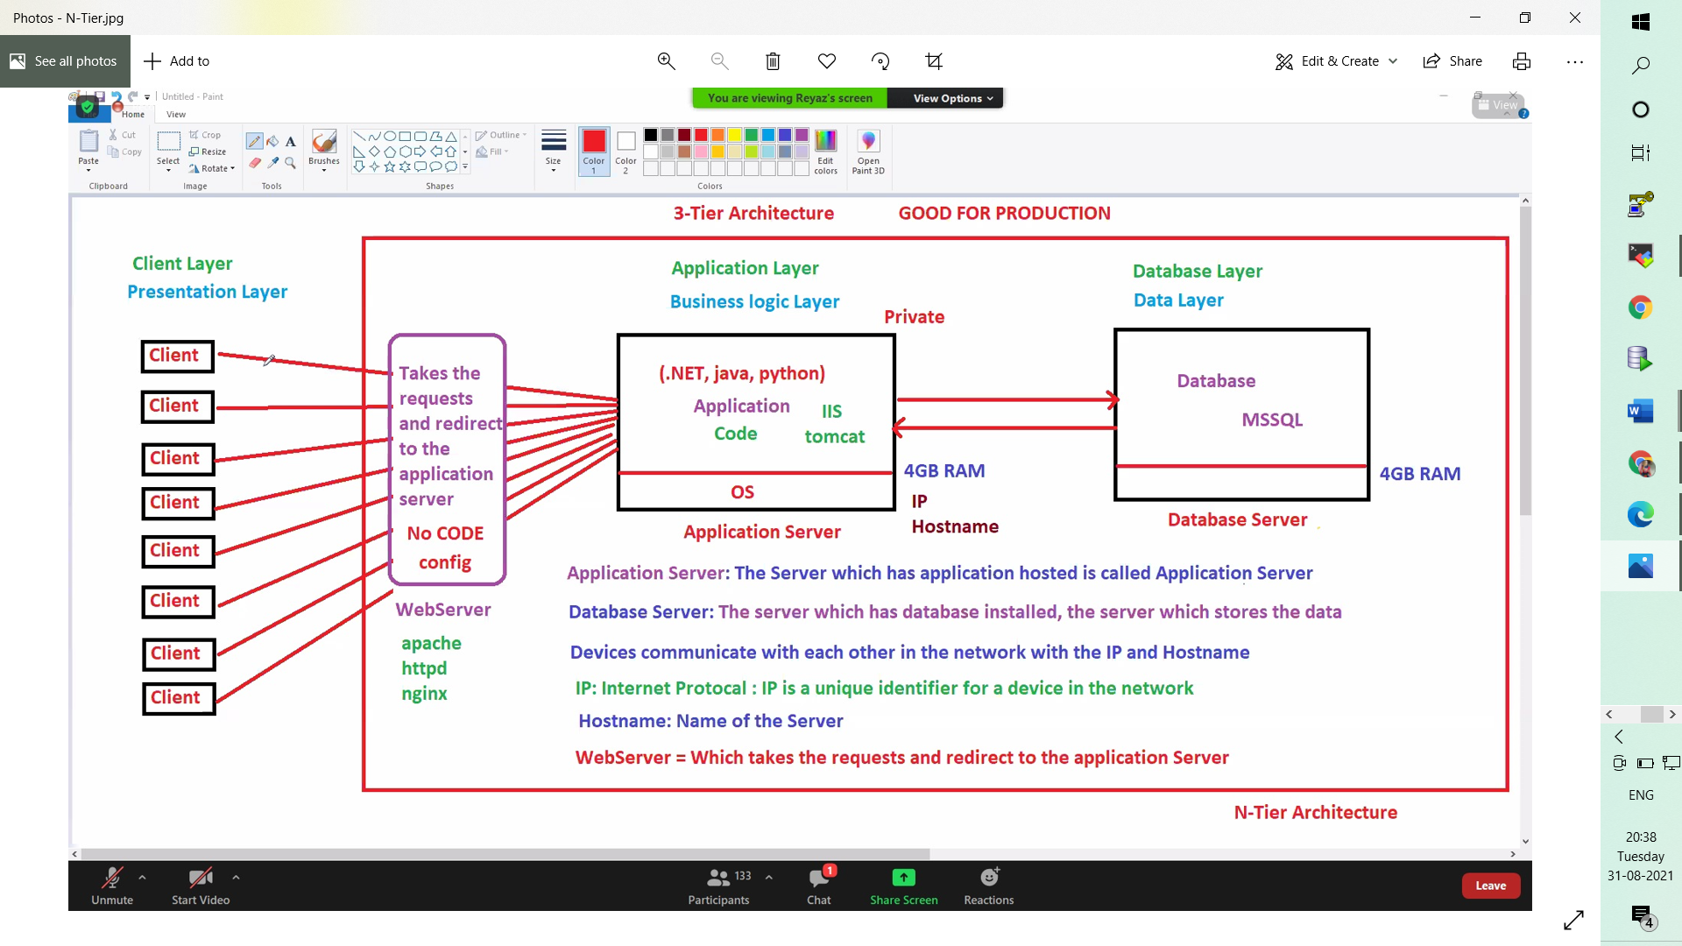

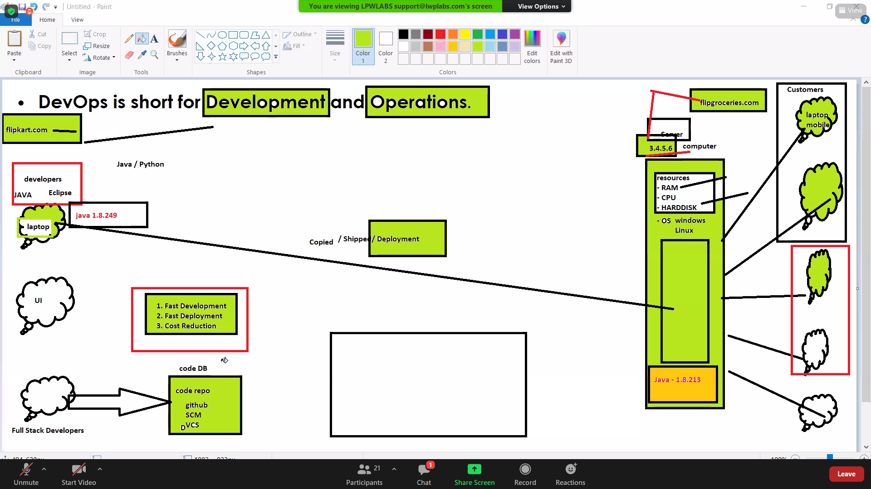

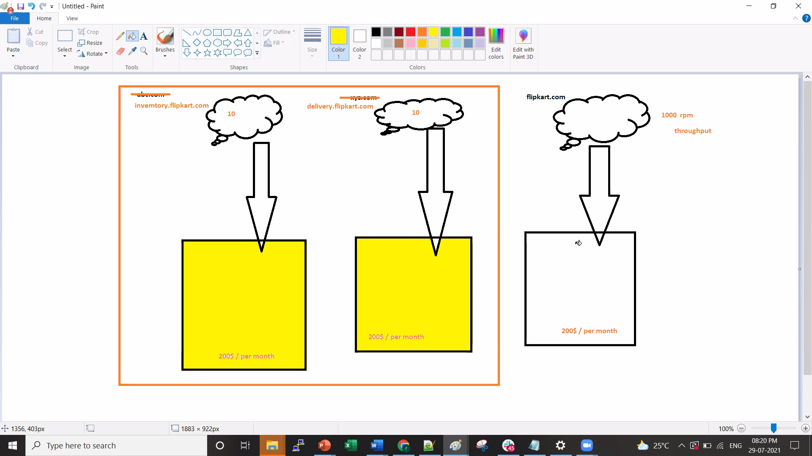

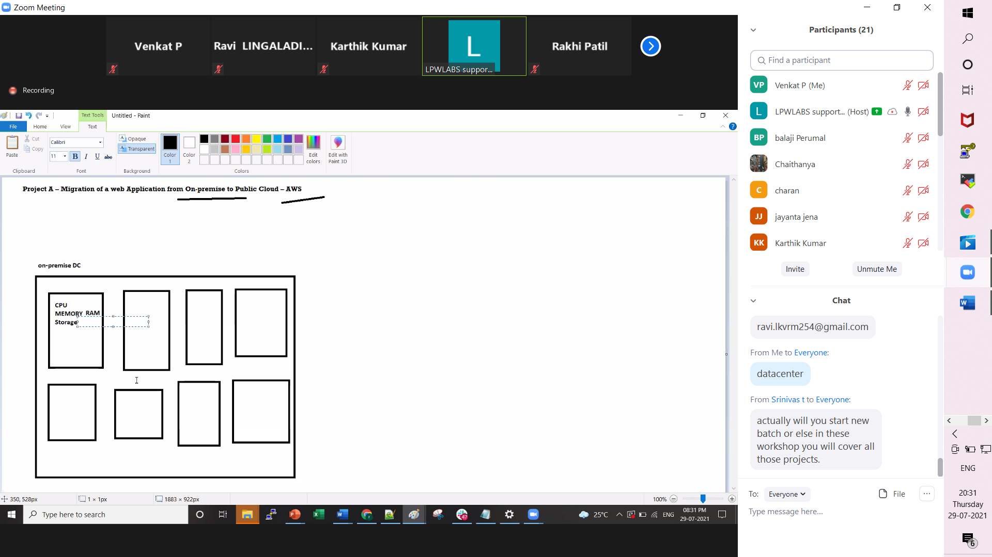

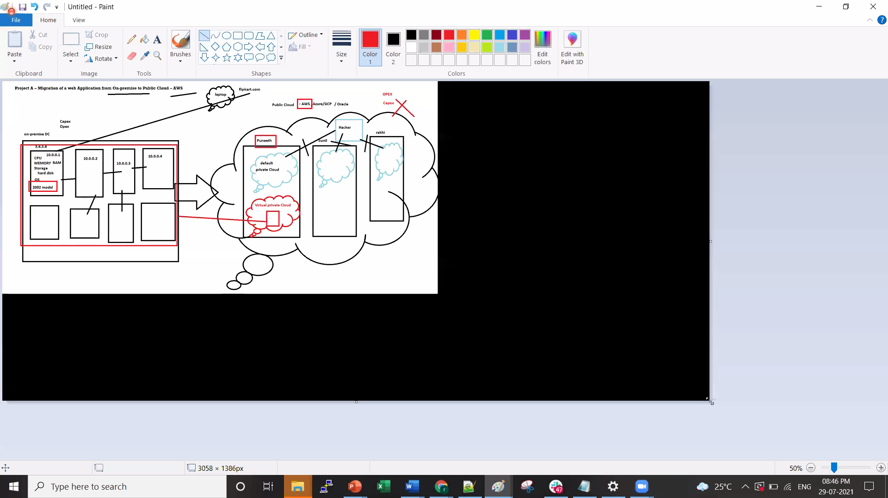

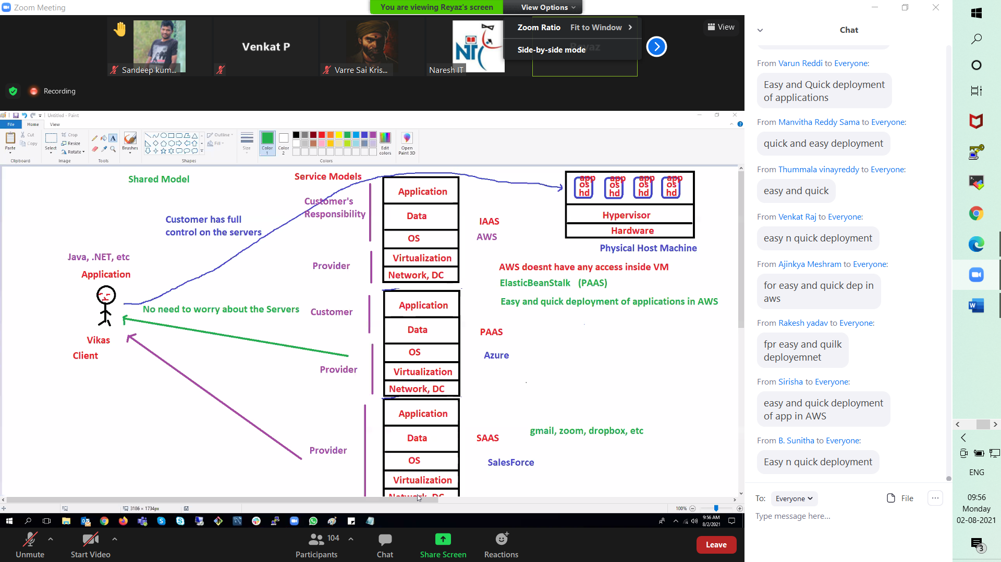

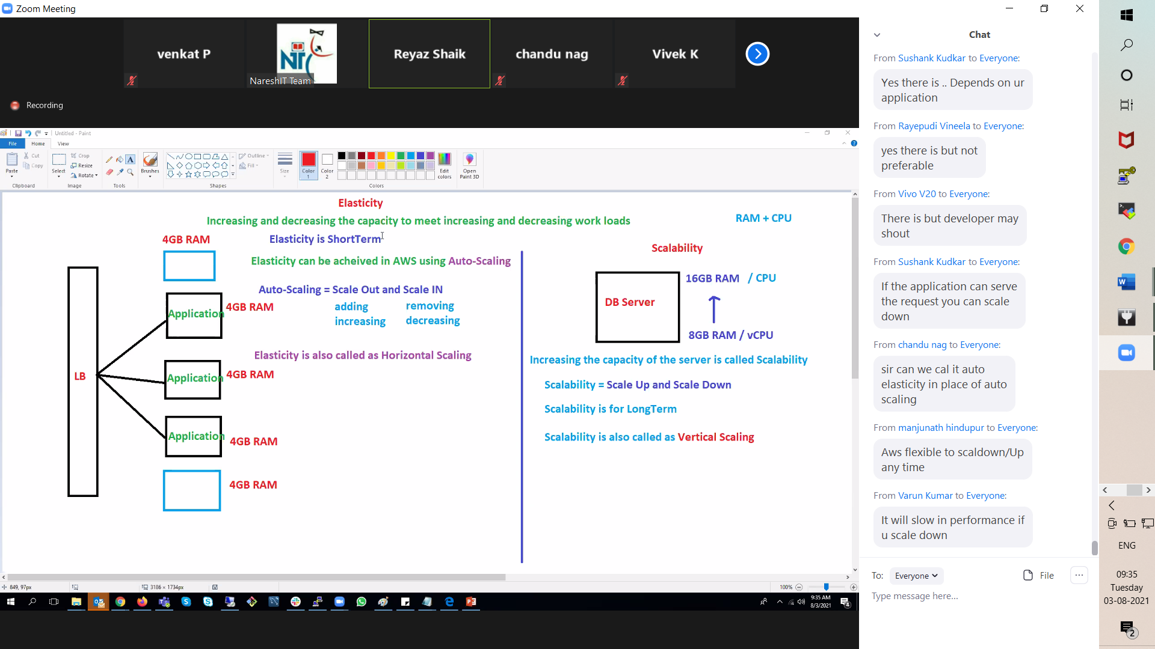

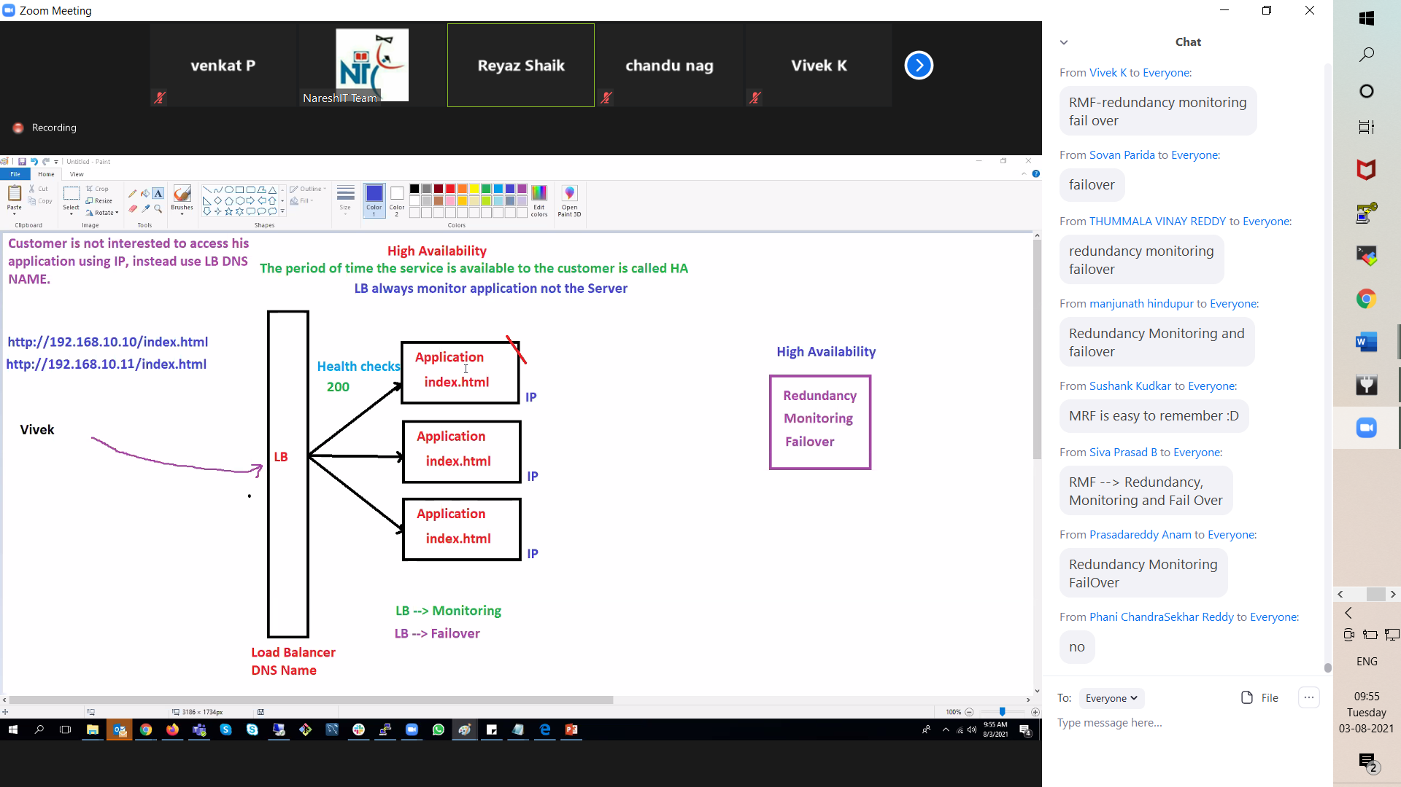

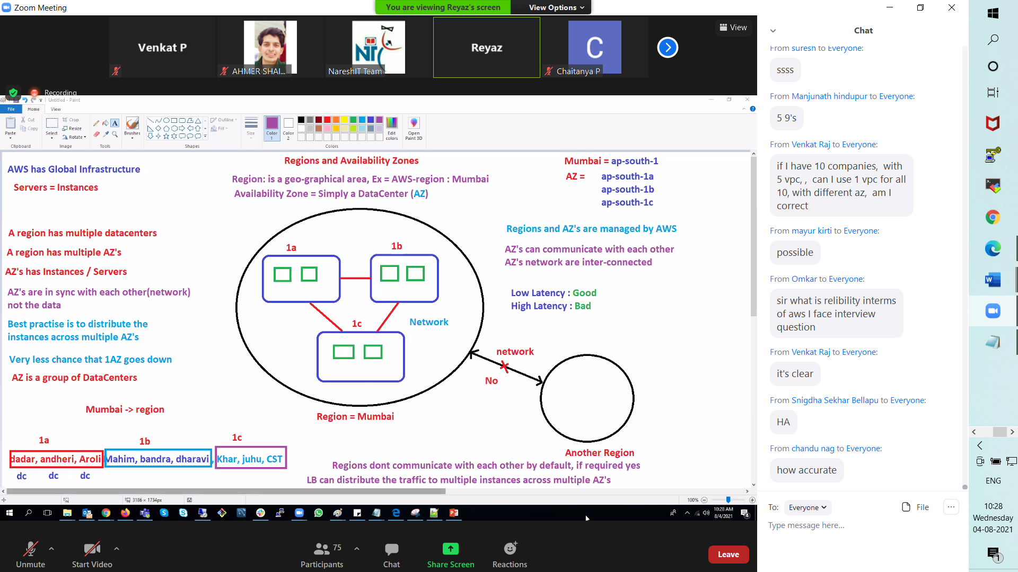

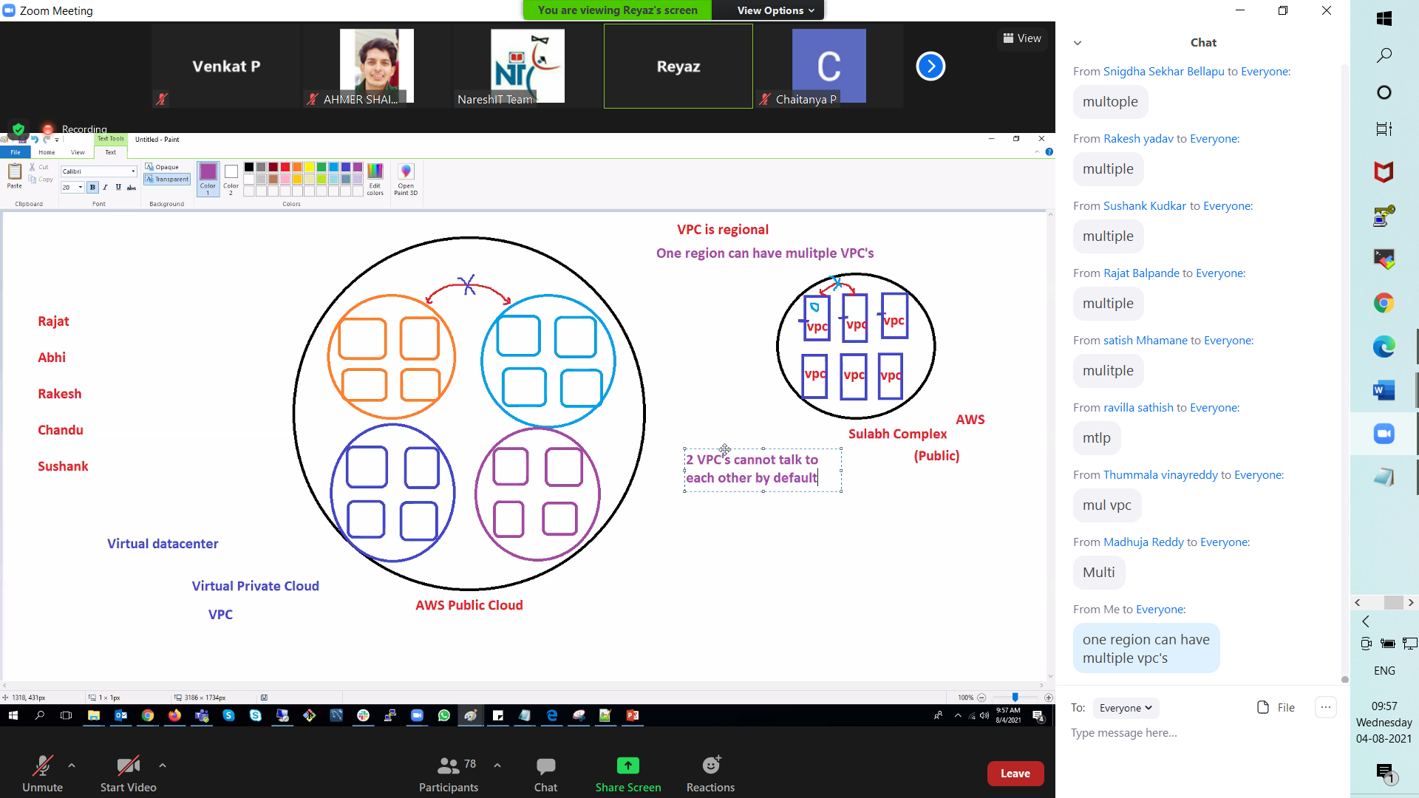

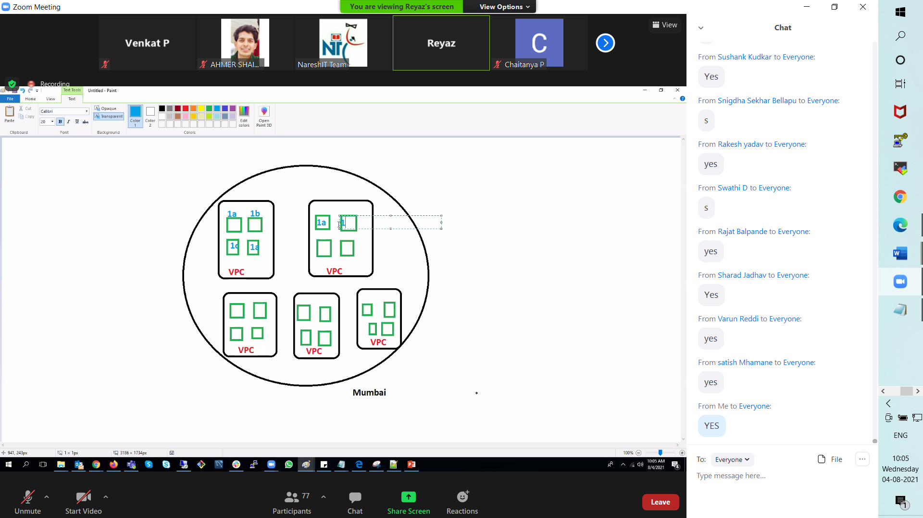

05-08-2021

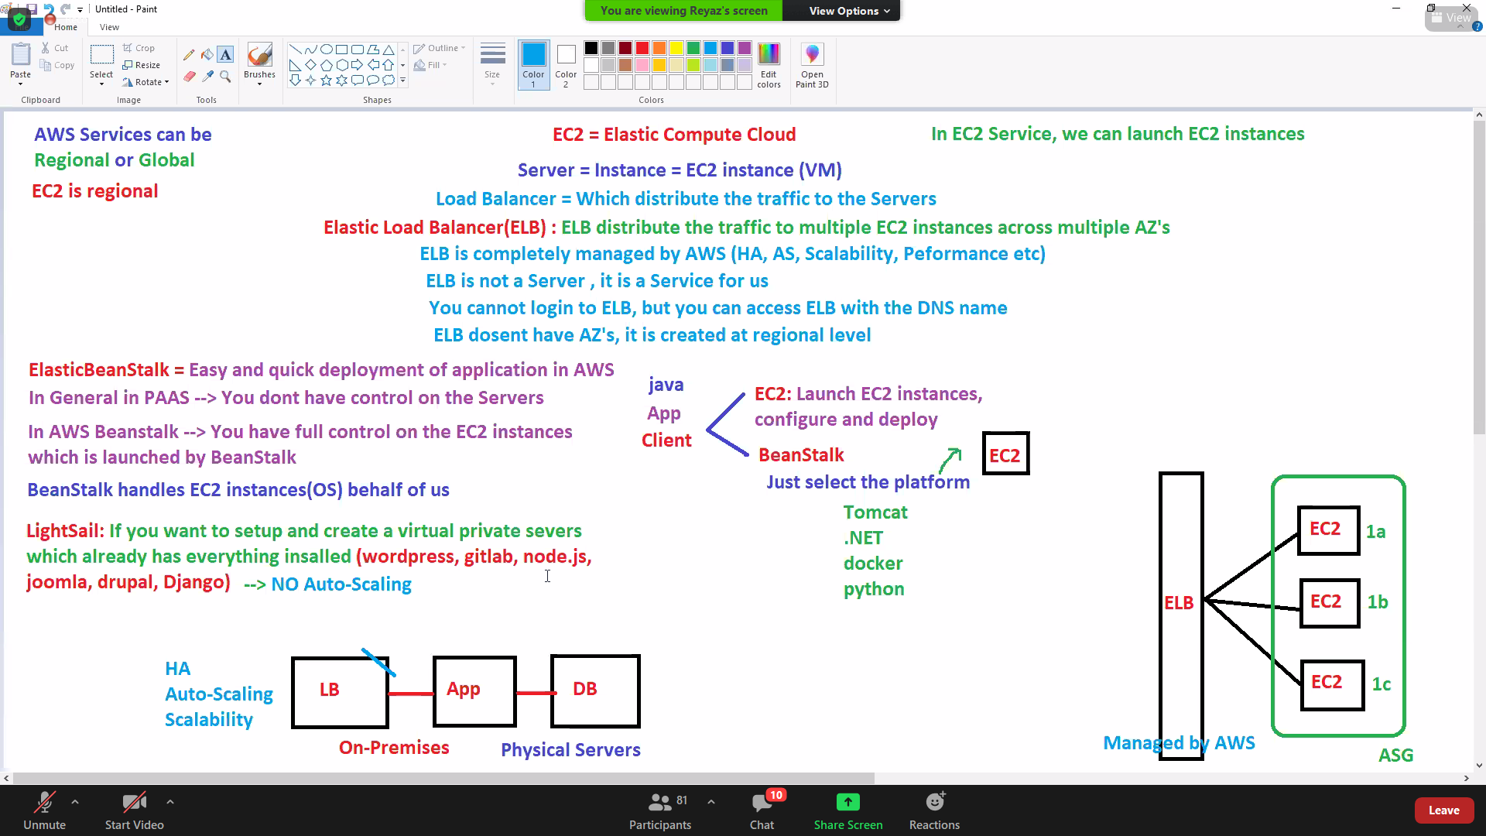

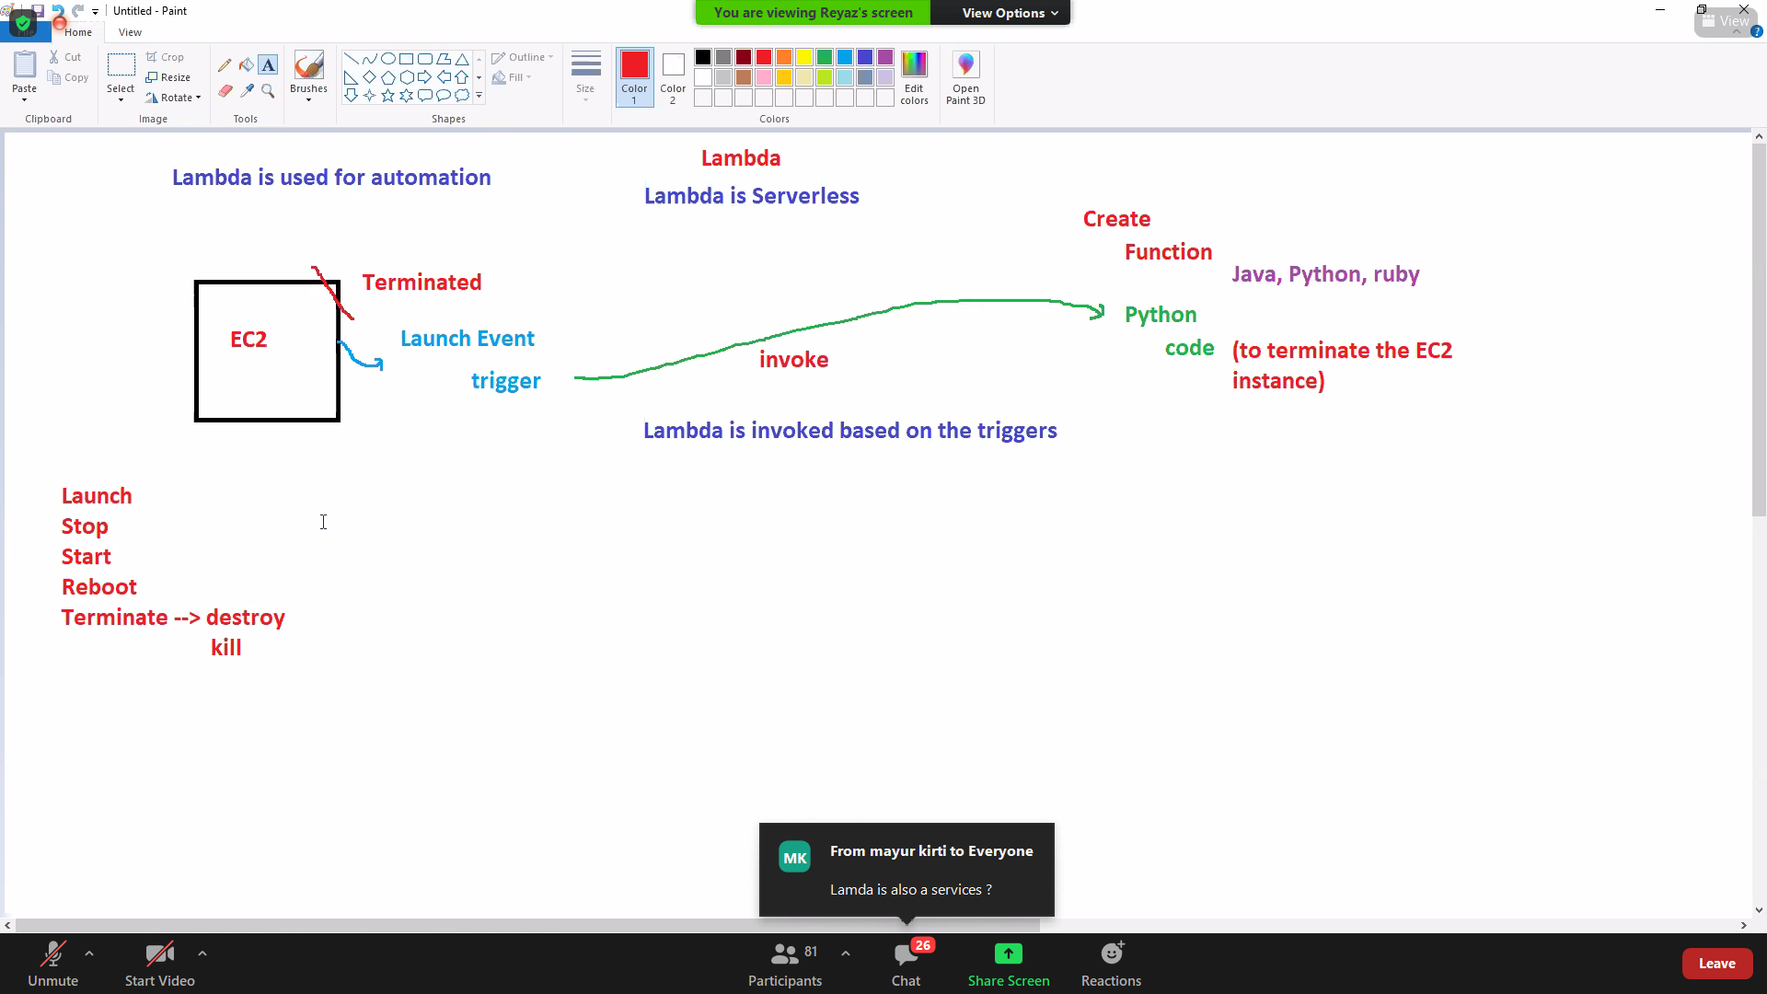

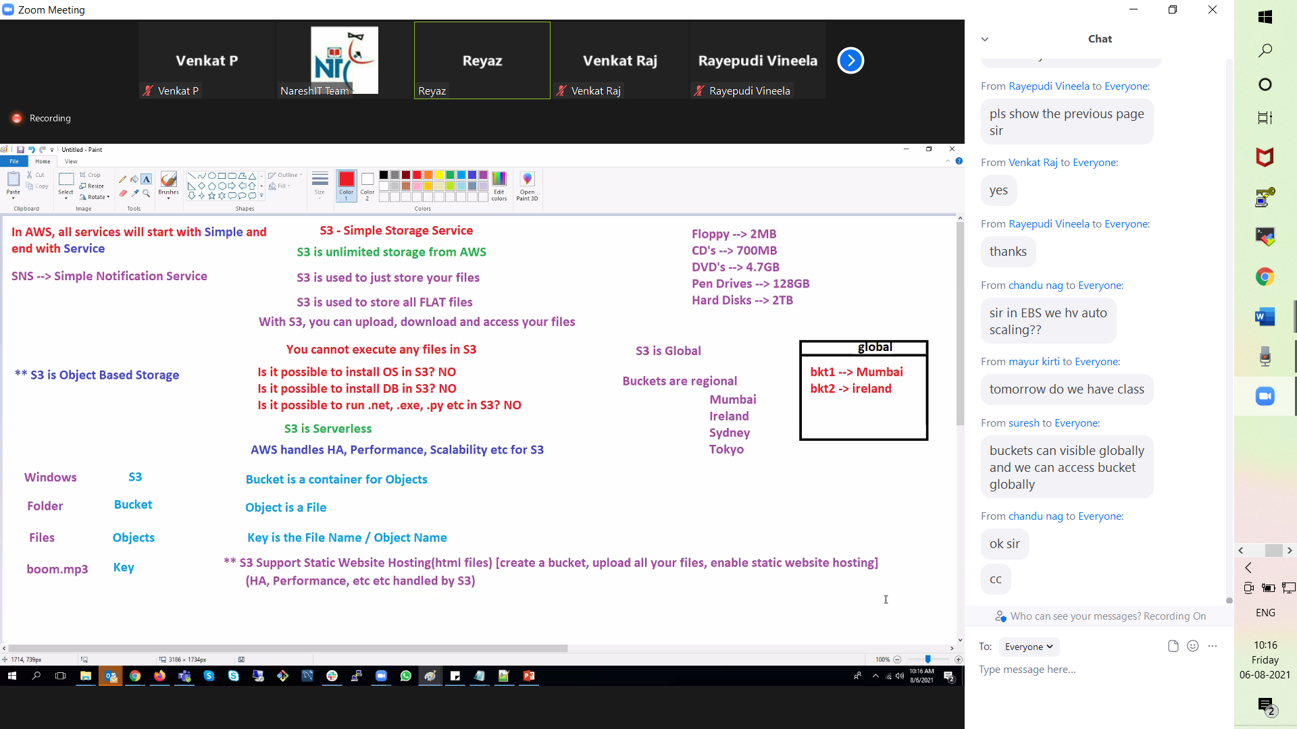

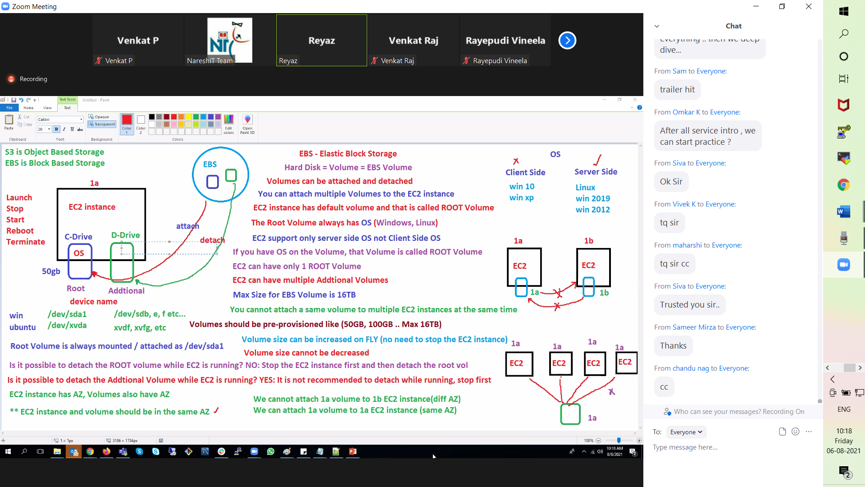

07-08-2021

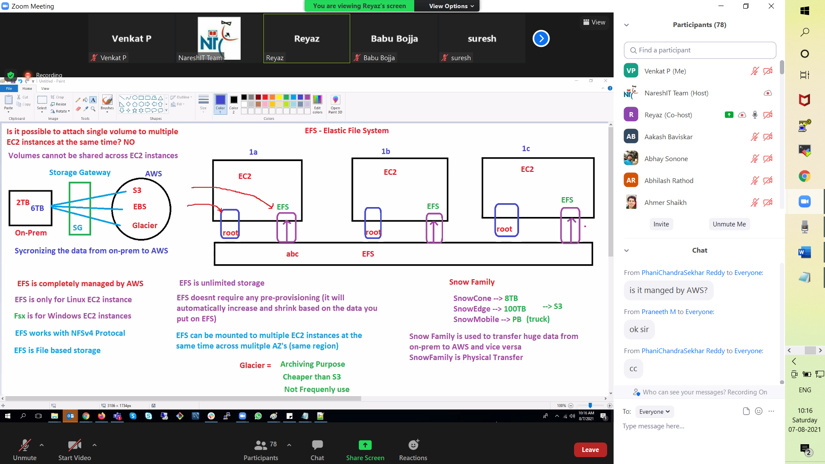

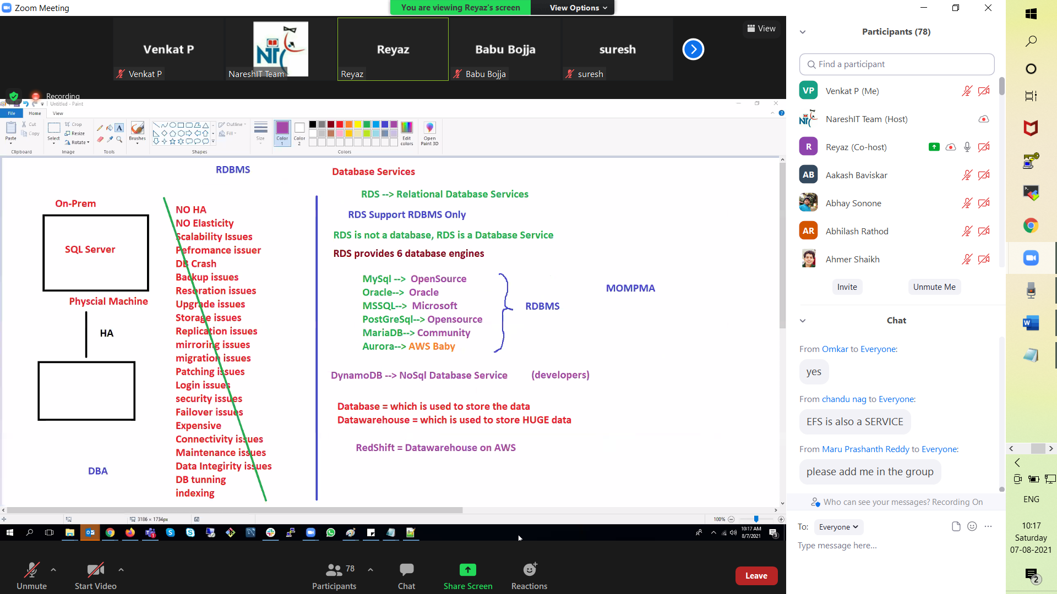

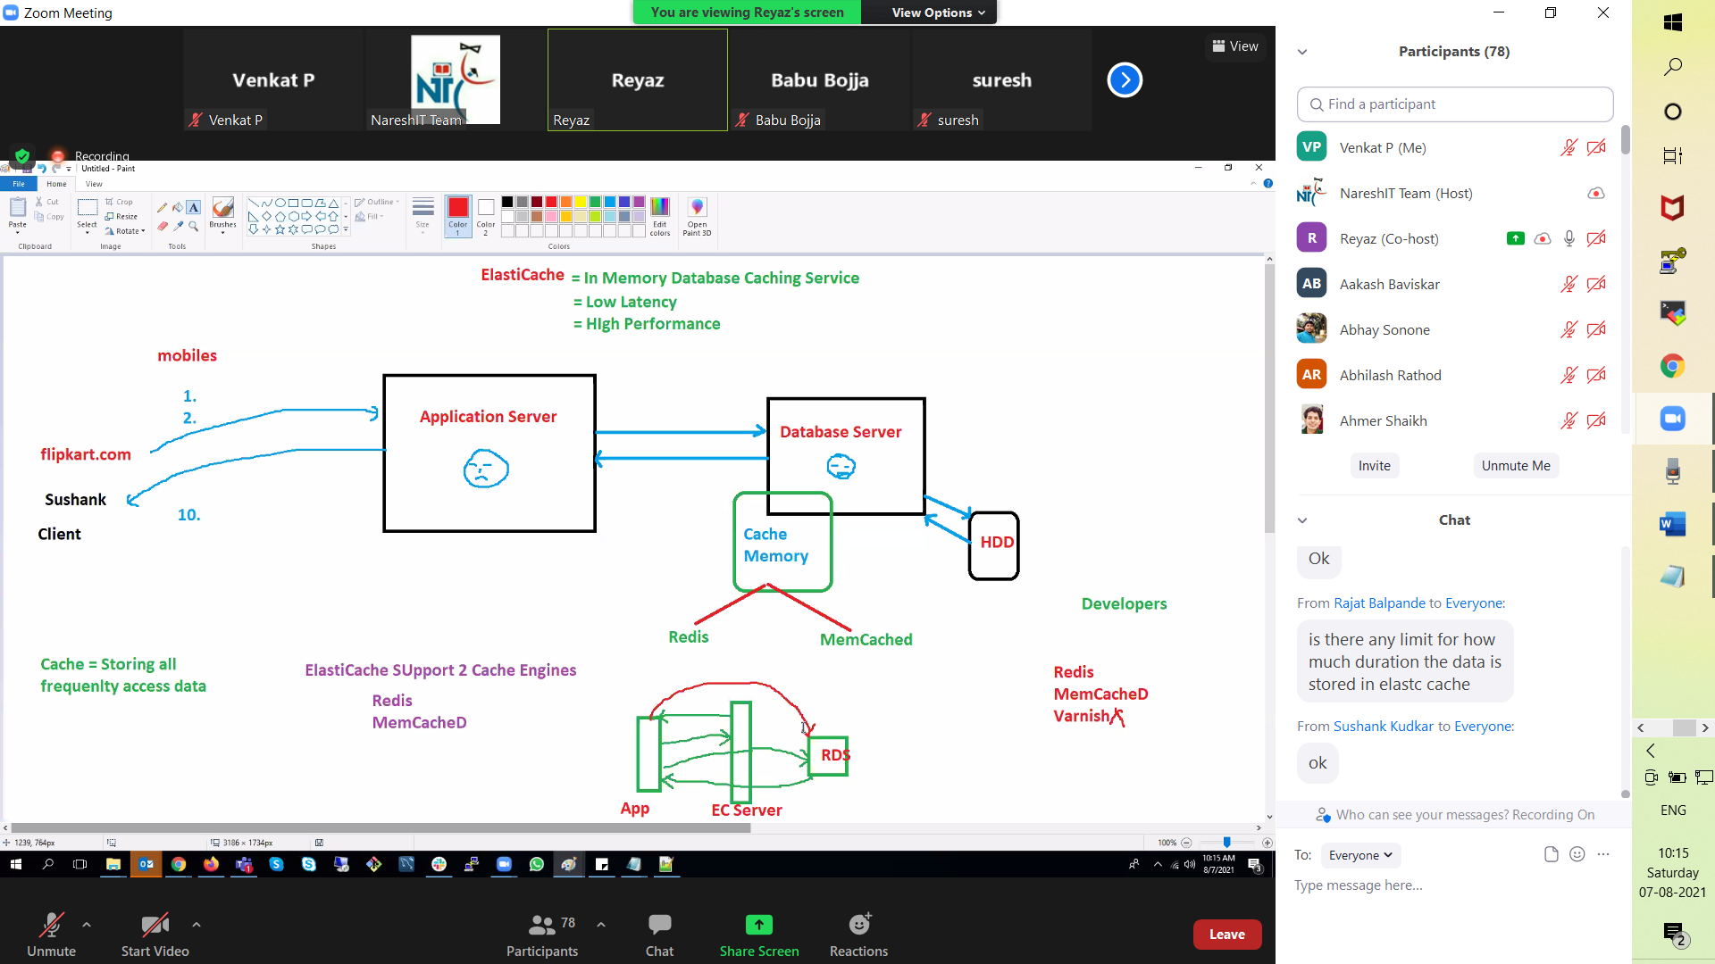

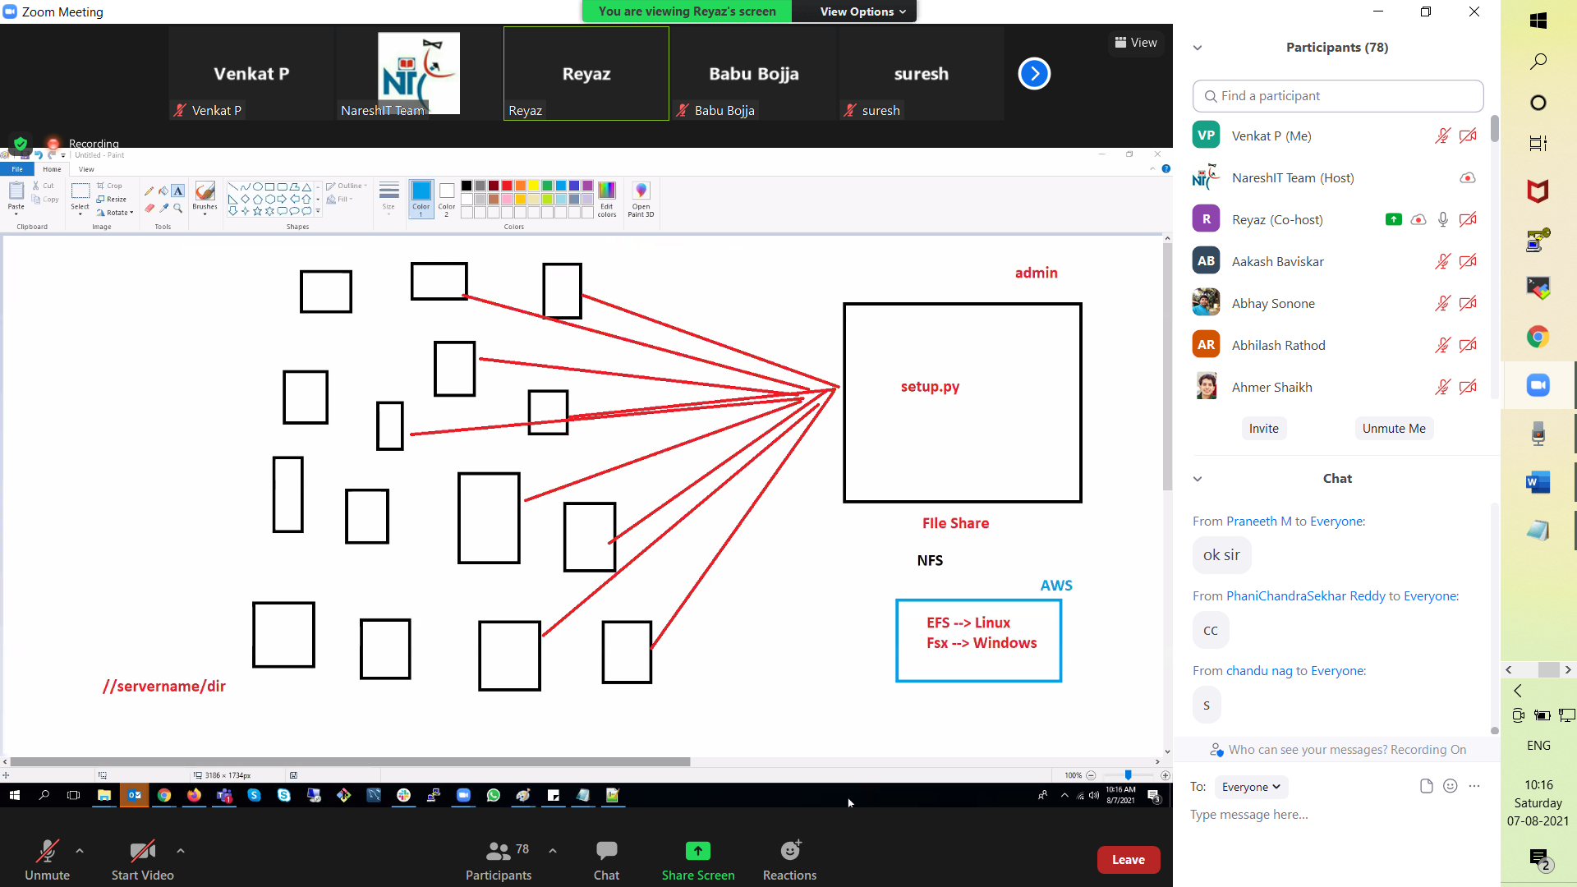

Storage Services Covered till now. Is this correct

S3---> Like GoogleDrive cannot be connected to EC2. Just for data storage,acess and write.Not for OS,app. execution

EBS--> Should be used with Ec2

EFS--->To share data acorss Ec2 across multiple AZ's

SnowFall-->Physical Tansfer

With the Help of SG we can upload 2TB from ON PREM to S3

using SG, can we use both on-prem and EFS parallelly as redundant storage?

cache is like a server? YES

It is managed by AWS ? Yes

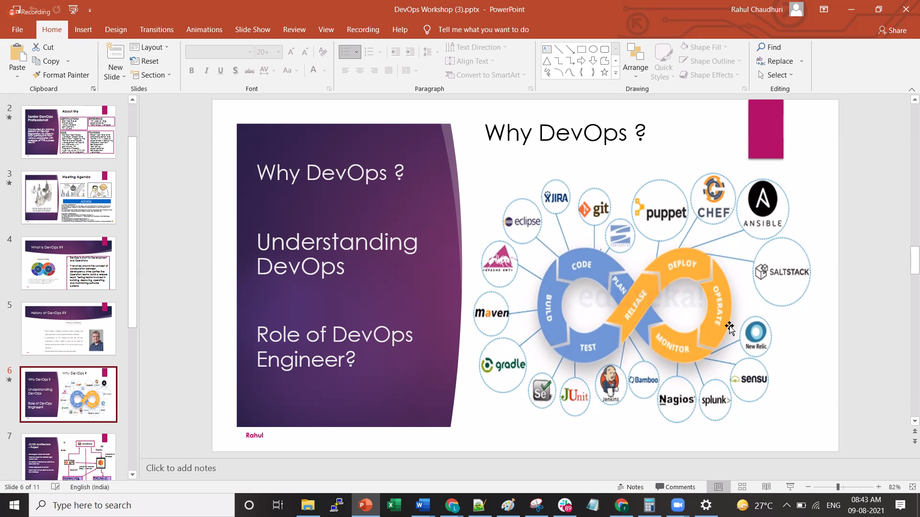

09-08-2021

CDN internal network for AWS

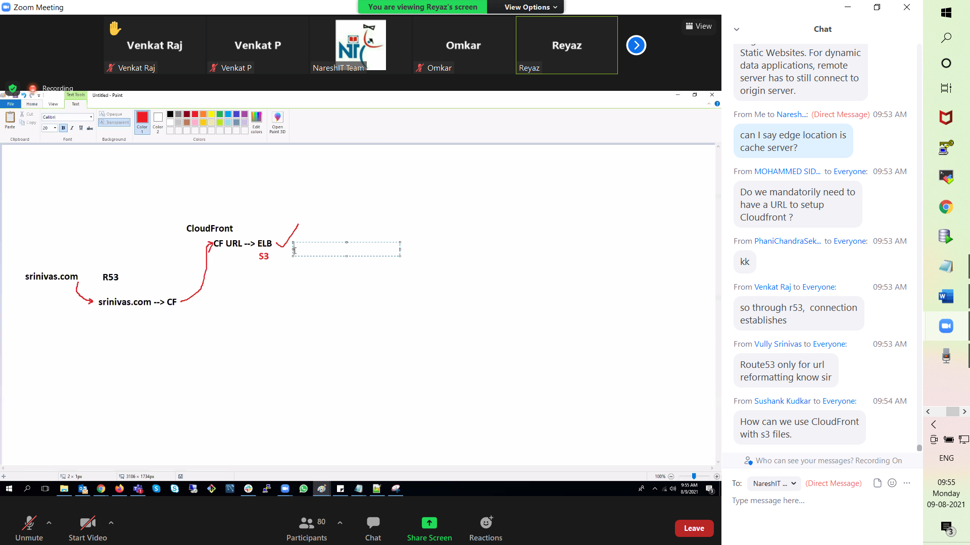

On premises to AWS connect.. AWS providing Leased line connection called Direct connect

Only Root user creates IAM user ?

Or IAM user with admin or IAM full access also can create IAM user ?

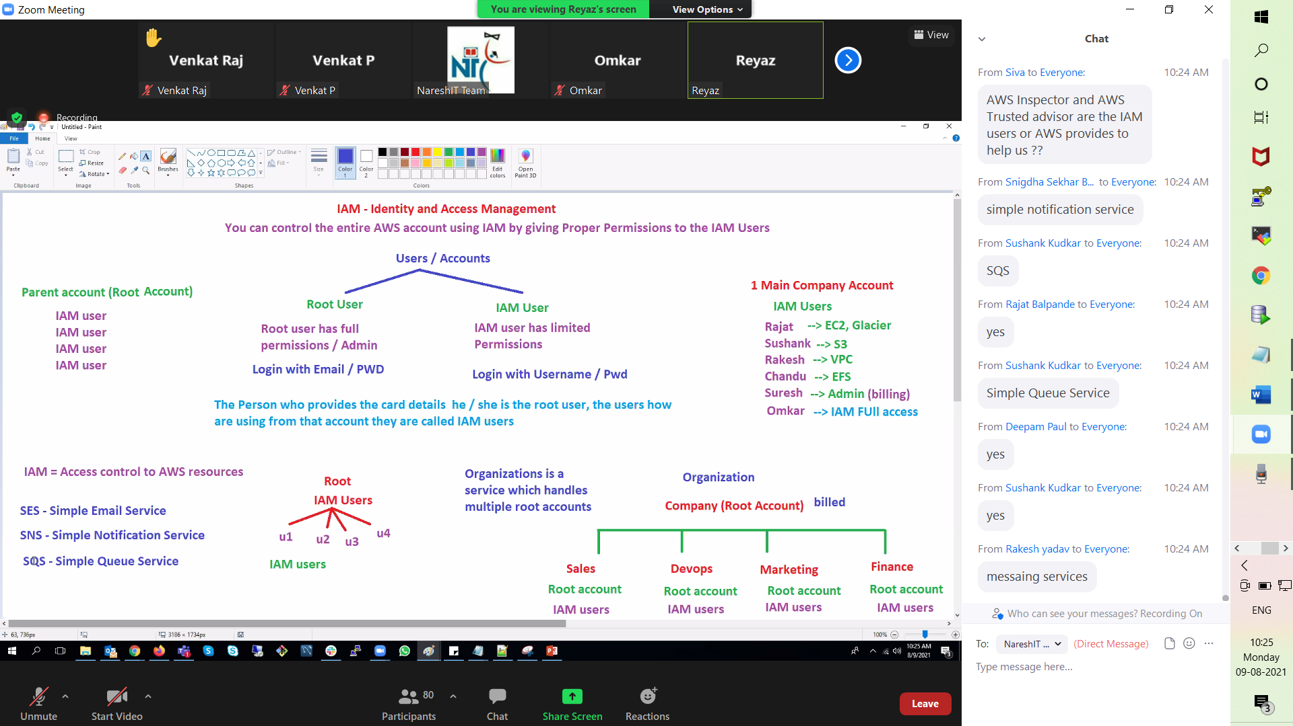

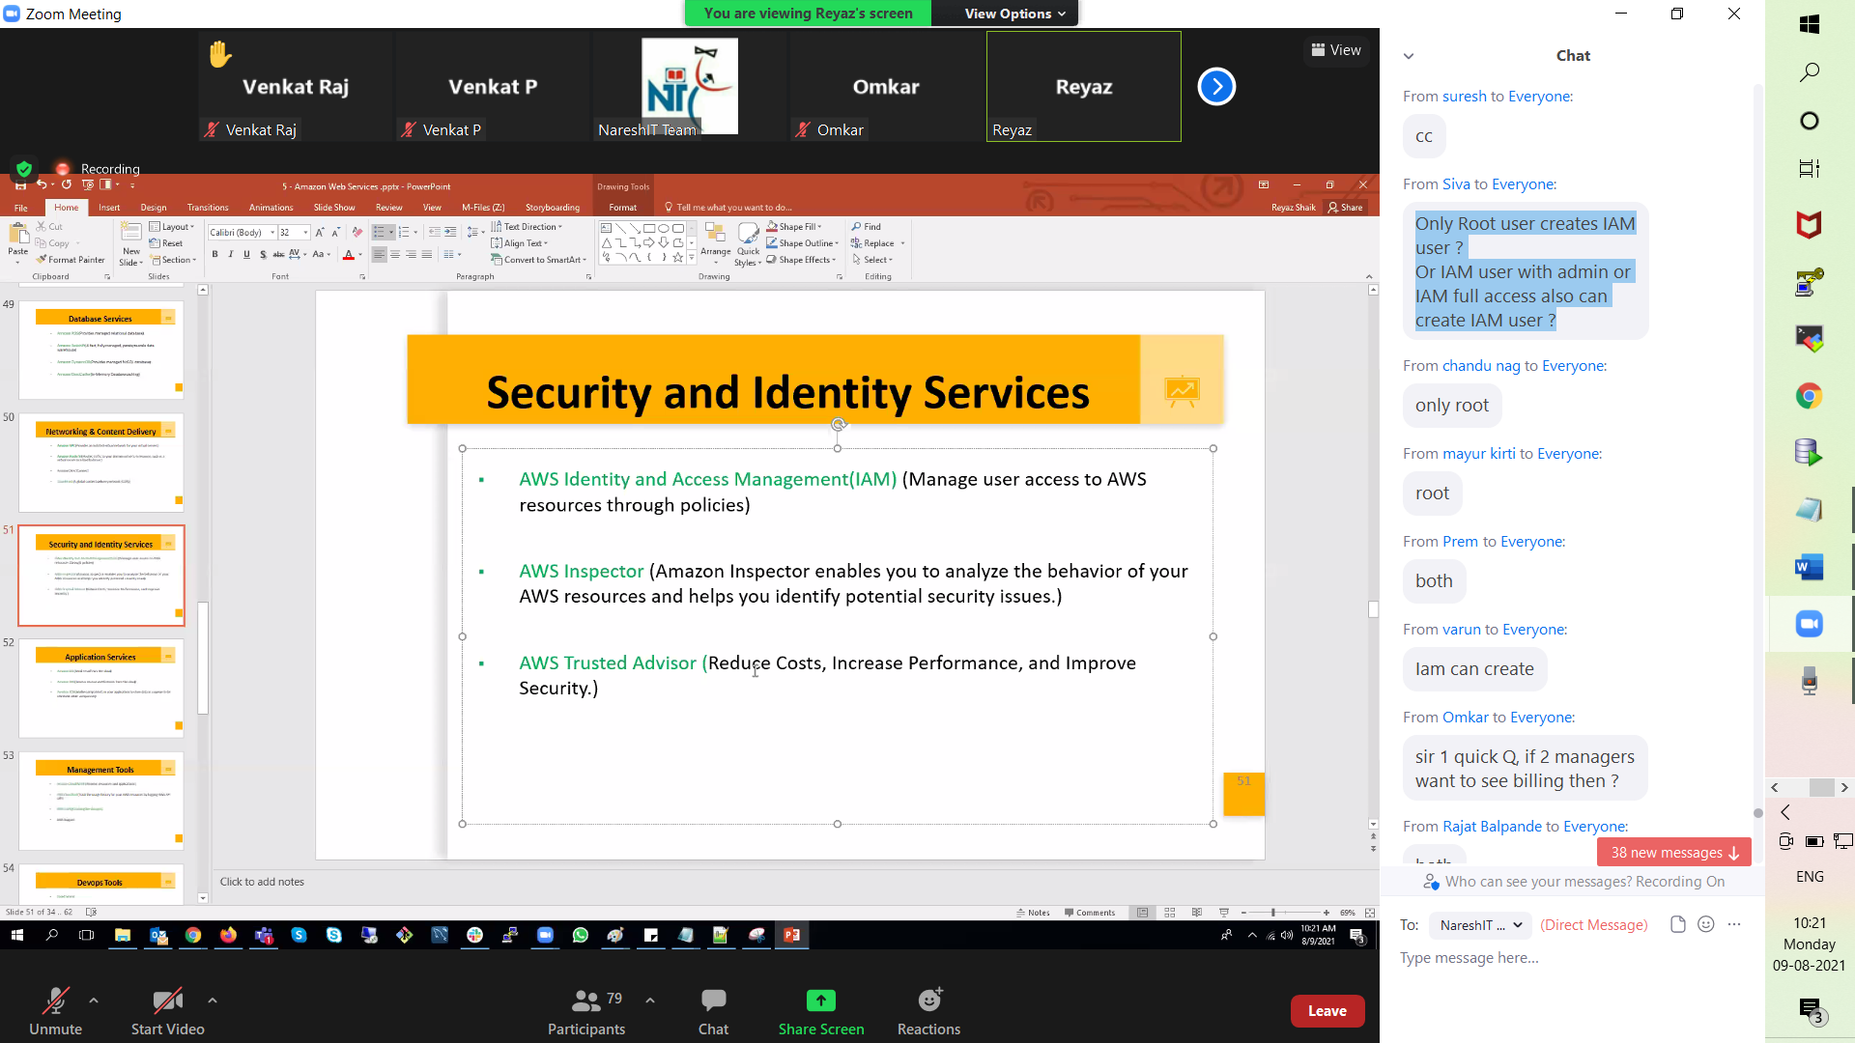

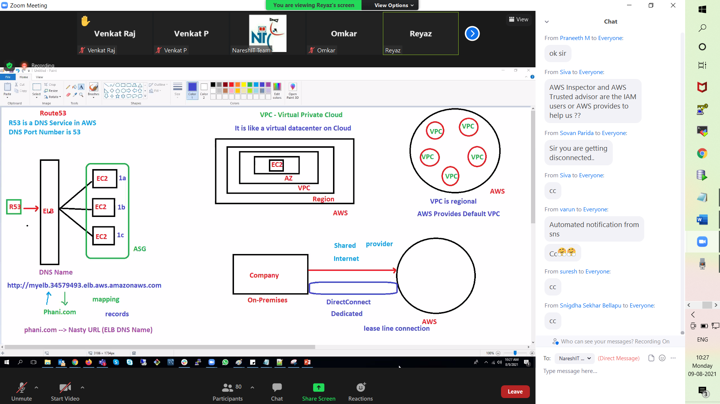

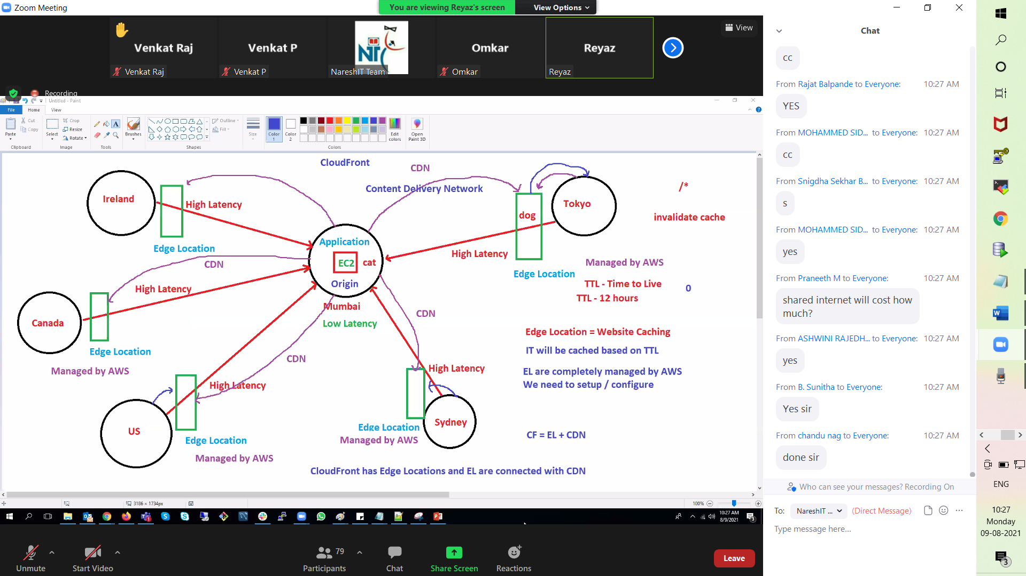

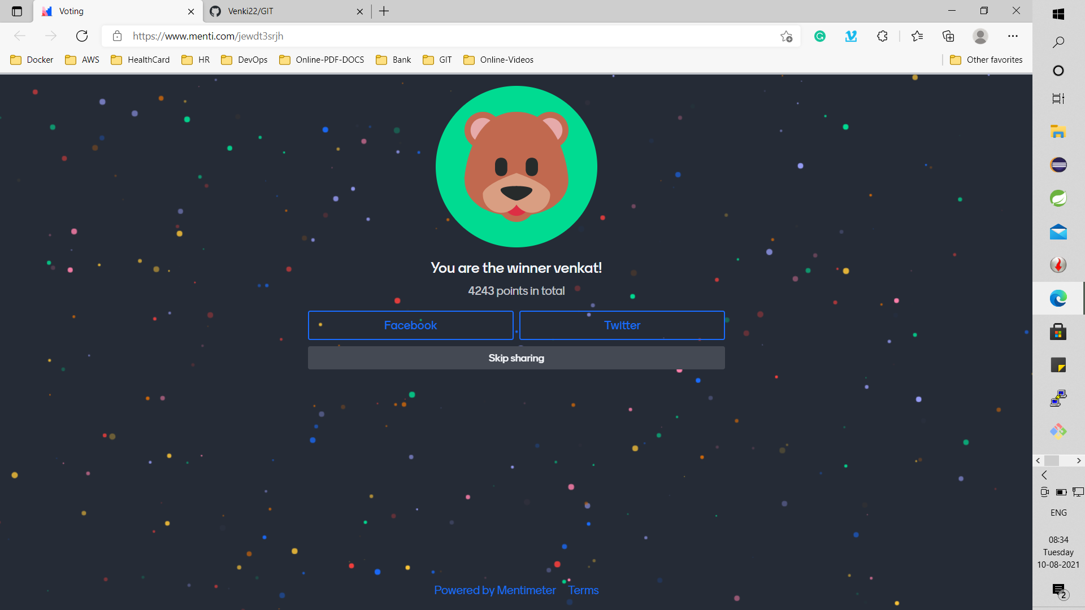

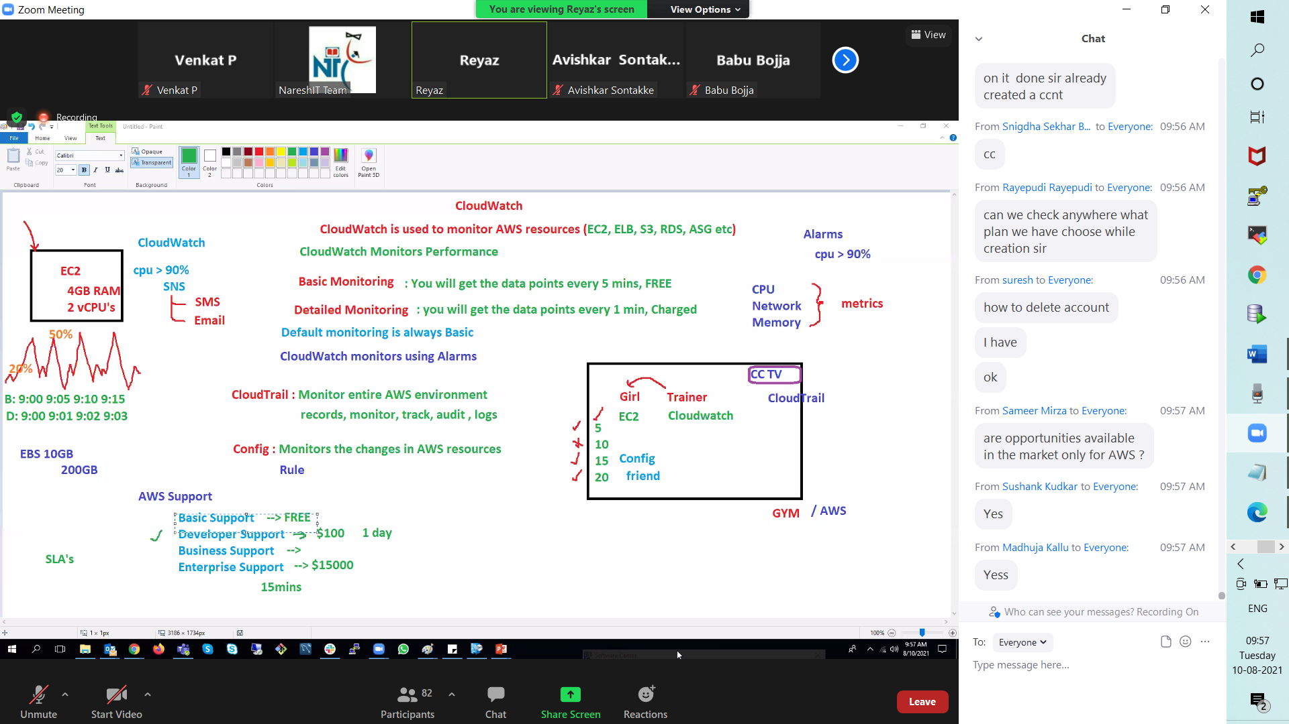

**12-08-2021**

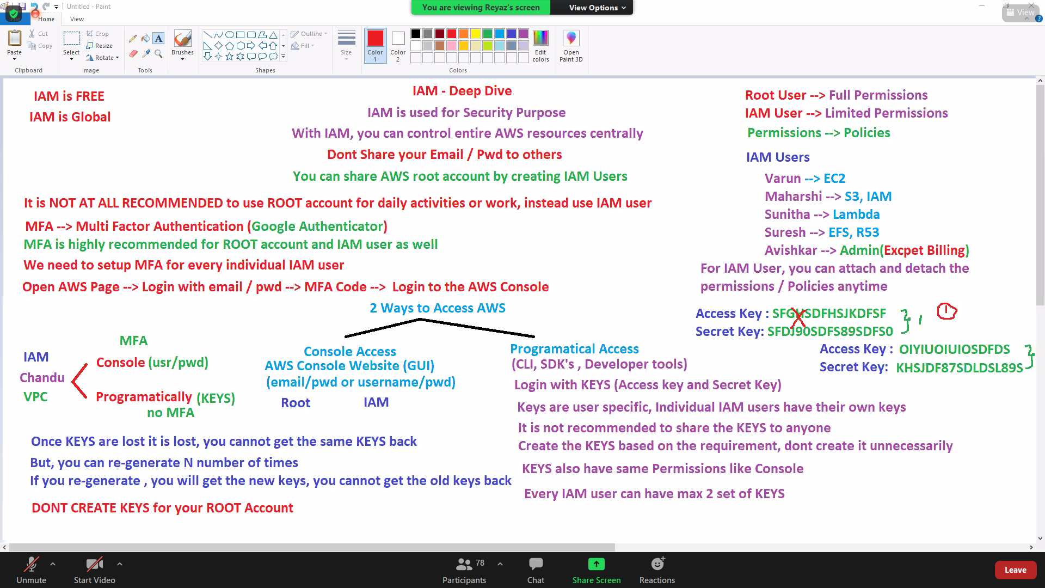

after creating group it is possible to give individual permissions right?yes

10 policies are max for a single group know sir? Yes

precedence over individual while setting policies for same user when policies are to be set more than 10 ?yes

Sir, groups for IAM users and roles for aws services sir? Yes

If I create a role name called Role1 and add s3,EBS,Cloudwatch under it and attach it to EC2 instance then I will be able to access these services without keys , is this correct? Yes

Access resource inside other resource need ROLES ?Yes

so can we say

We restrict access to EC2

Whoever has access to EC2 willcan access S3 bcooz EC2 has ROLE defined—YES

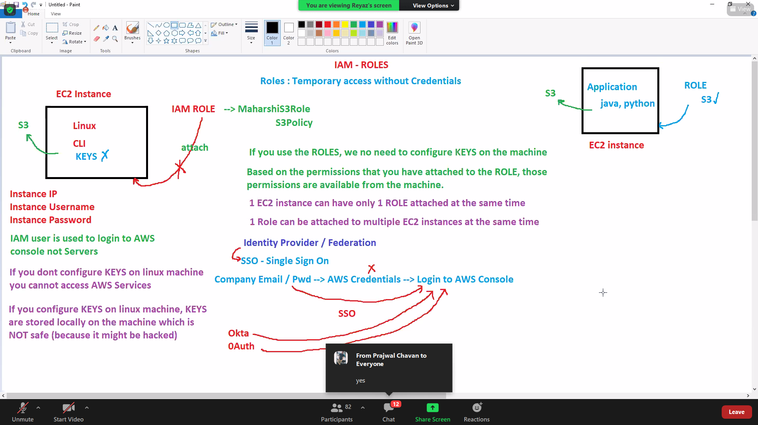

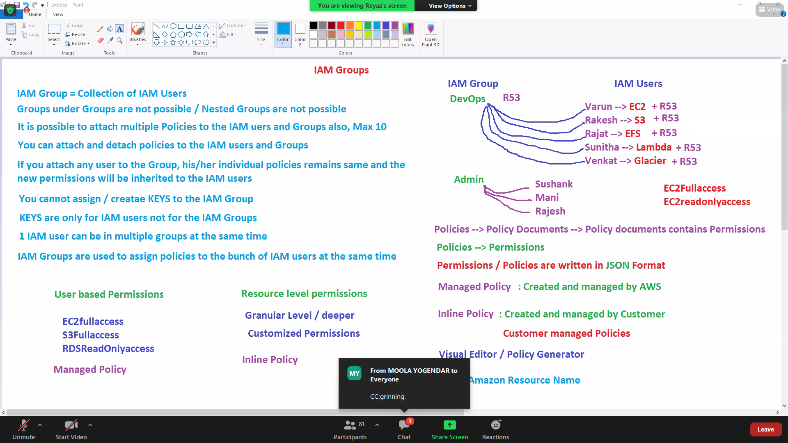

iam user signin in link

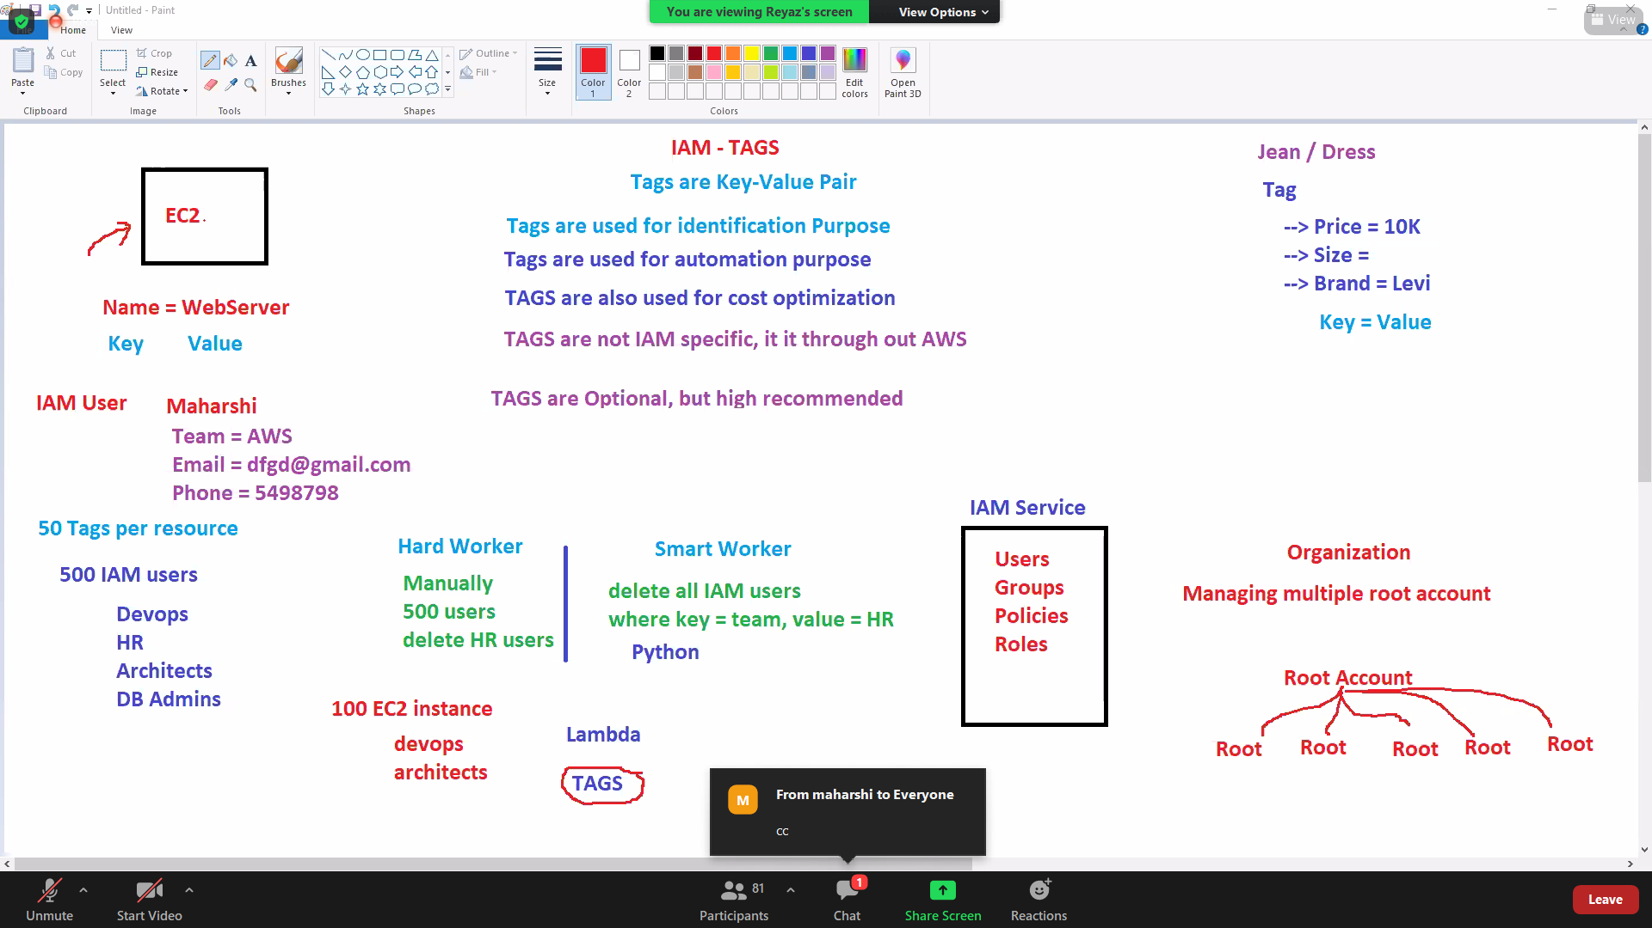

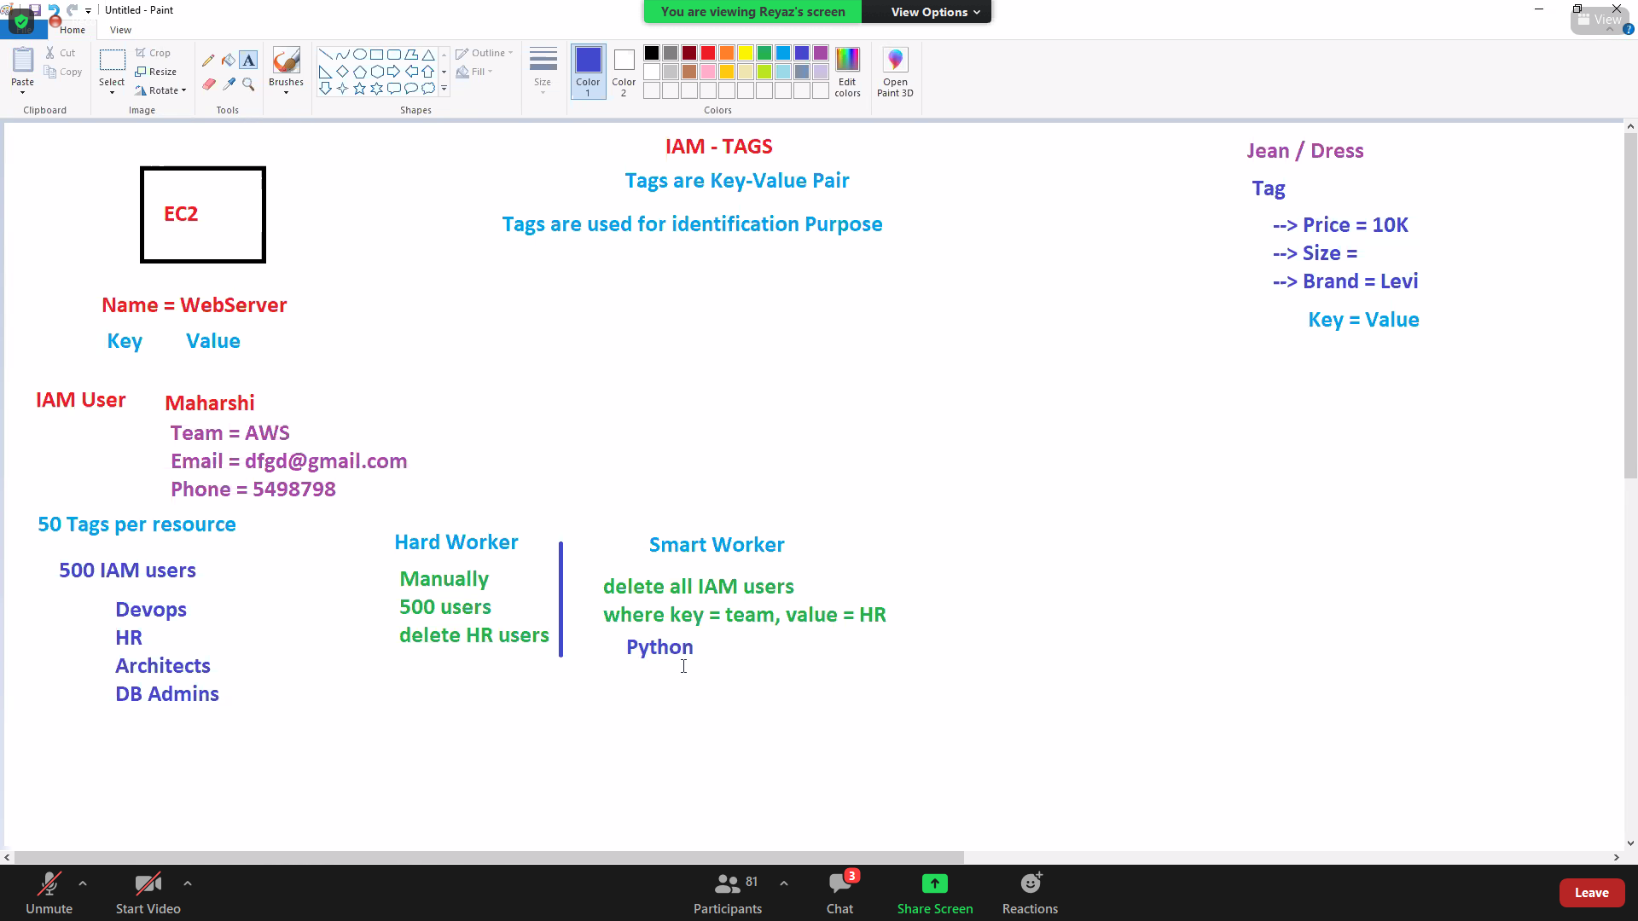

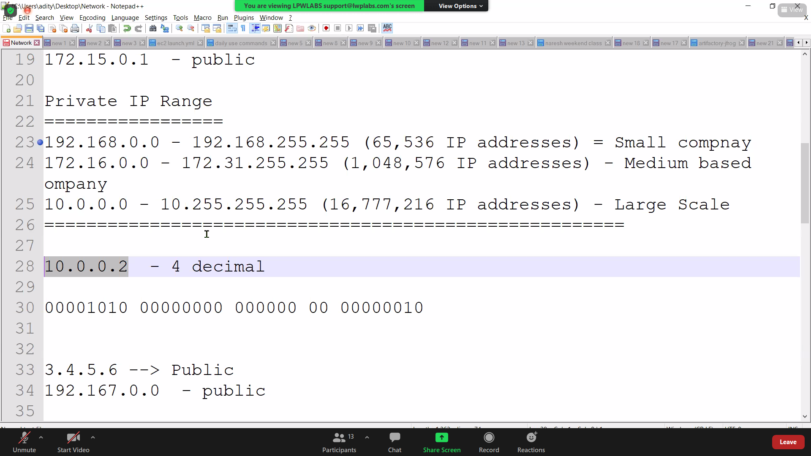

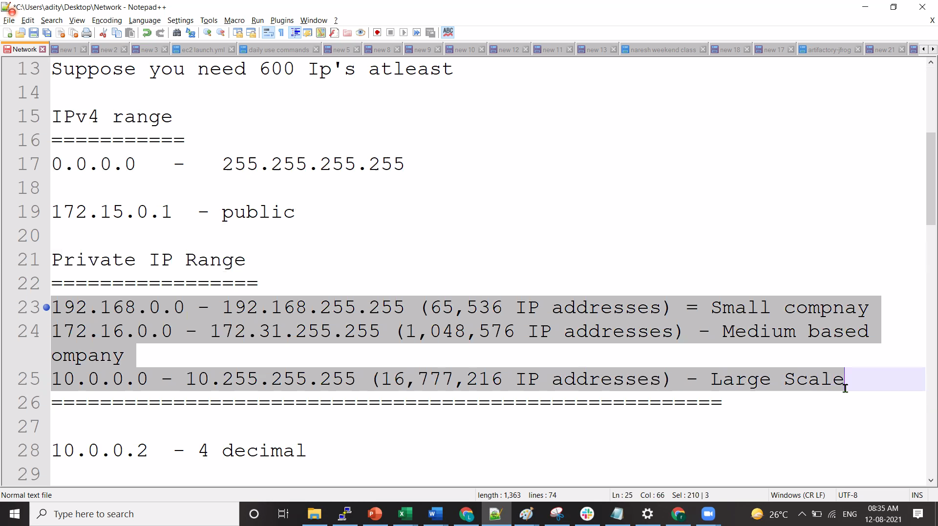





**13-08-2021**

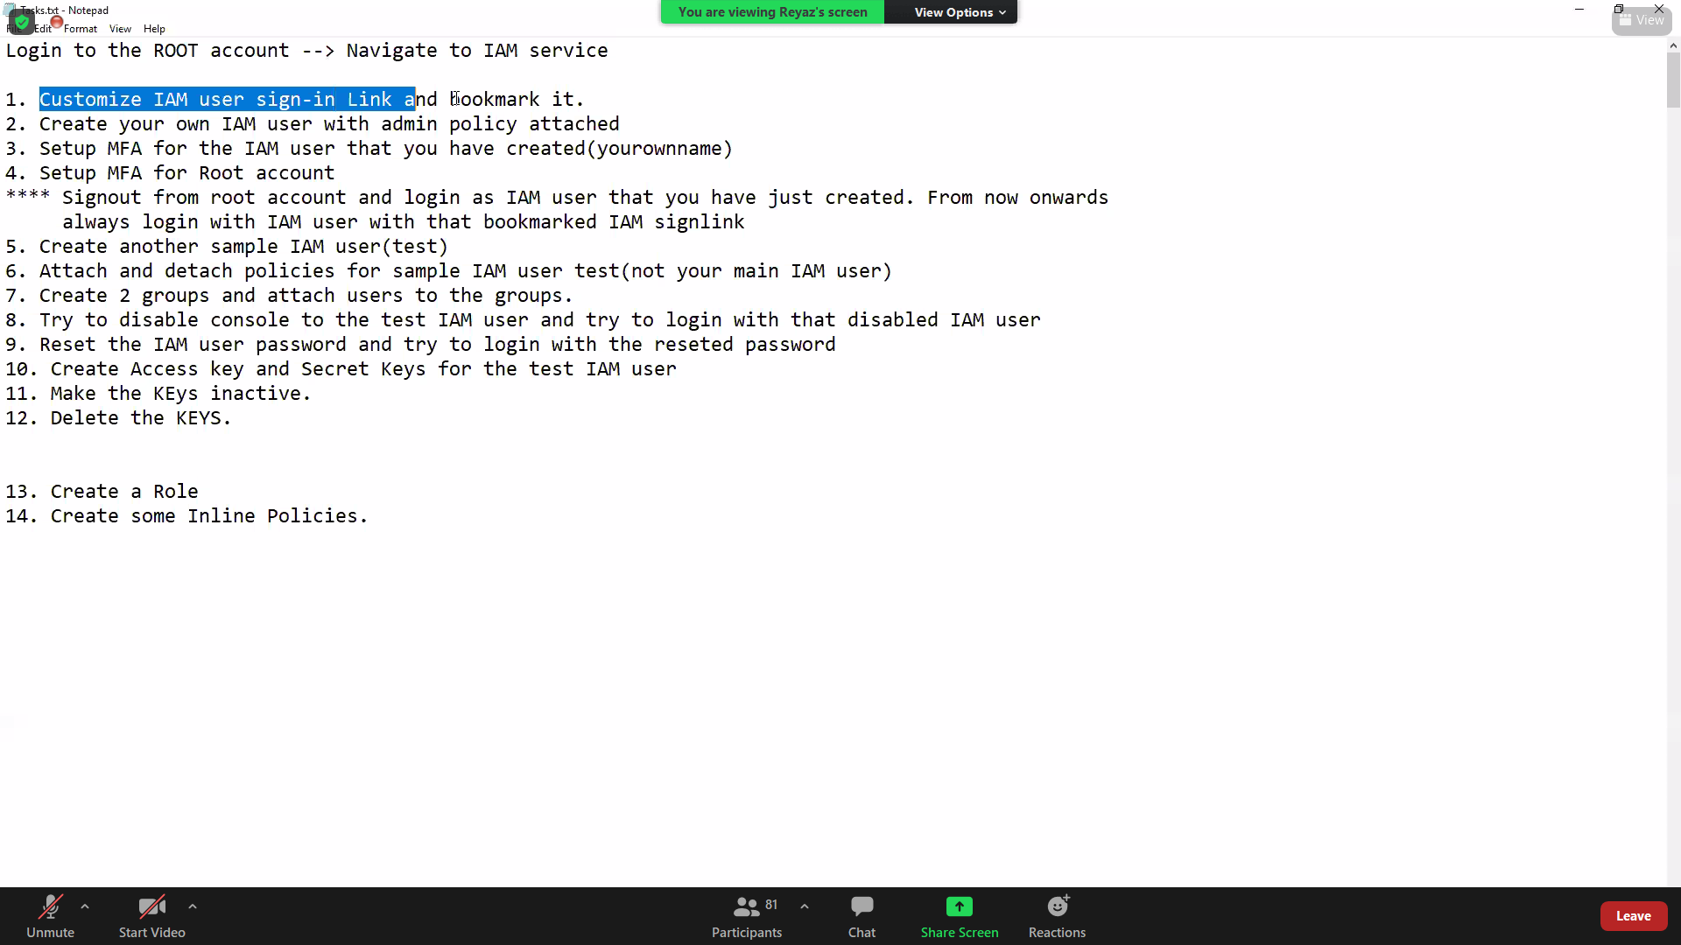

policy will attach to user & Role is attach to service ? YES

Giving access to Another AWS account Accountid should be within same organisation ? NO just account id is enough

14: Create a role and assign permissions15. Create a policy16. Create 2 IAM Users(test1 and test2) --> Test1 assign IAMFULLPERMISSIONS --> TEST2 assing IAMREADONLYLogout and login with test1 and verify permissionsLogout and login with test2 and verify permissionsThis user should able to only create users,list users,Get users, list policies17. Create IAM Users(test3 ) --> Test3 custom policy(the one which you just created)Logout and login with test3 and verify permissionsSwitch Roles (account id)

**16-08-2021**

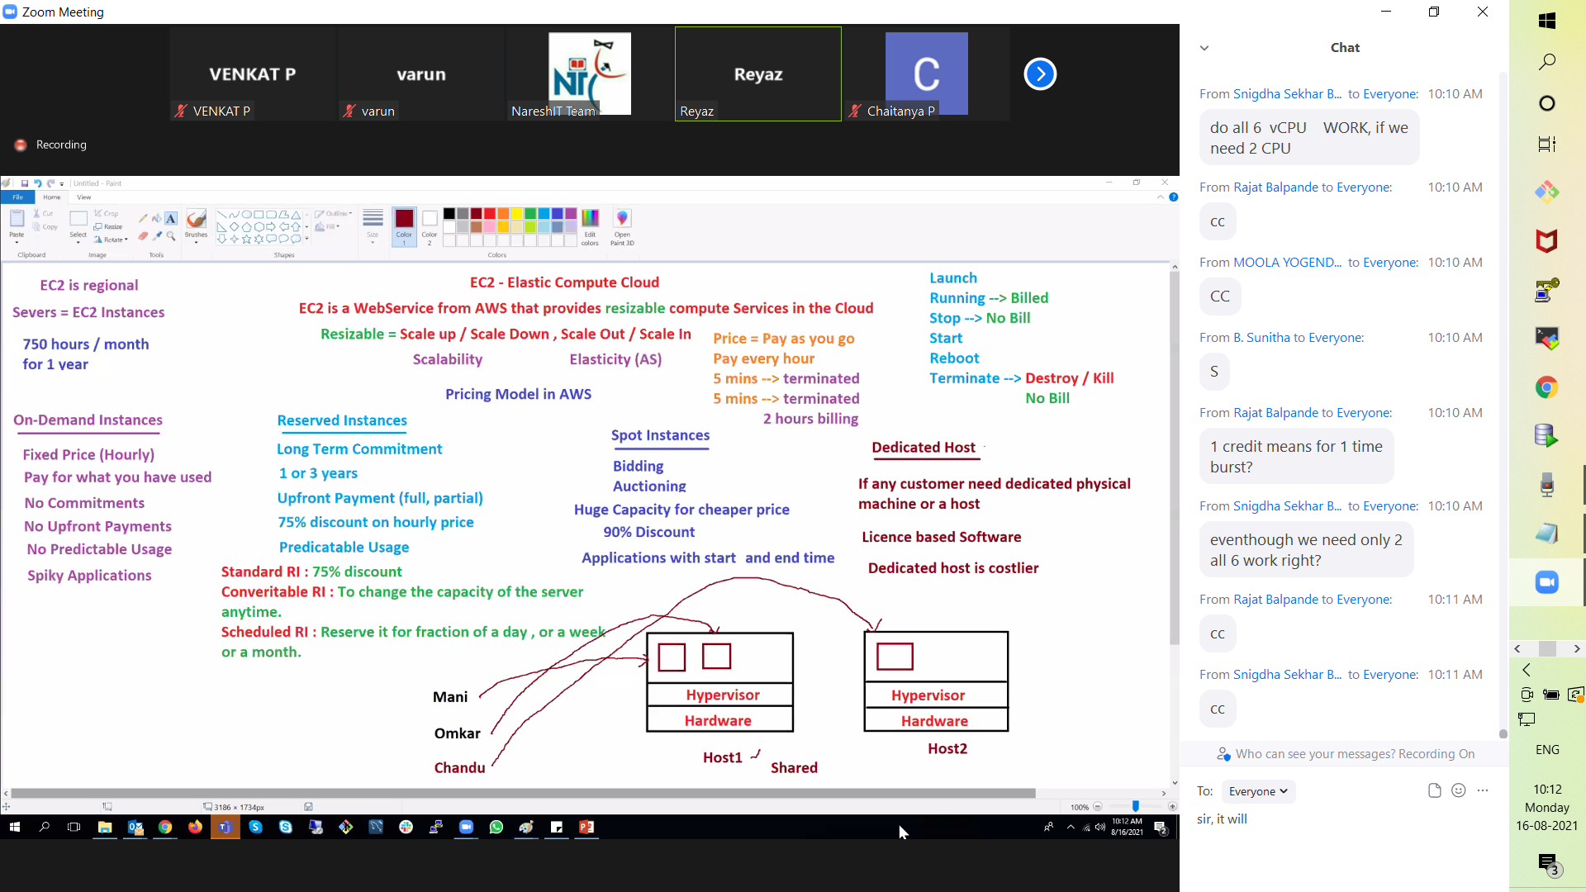

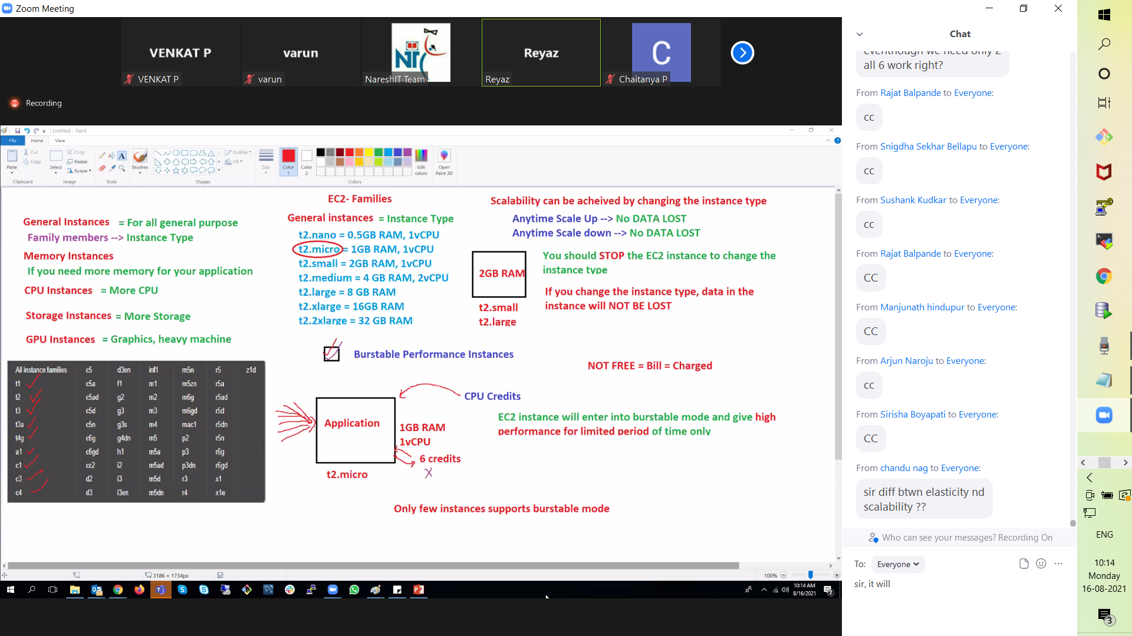

one question ..in office i will be creating AD account on o365 and i will be adding all required licenses and groups

next user requirement will be AWS desktop ...i will be sahring AD account credentials to AWS team..

will they use same credentials to create iAM user or will they create new IAM user or will they add roles to same AD account can i know how this works if possible

dedicated host means, we need to purchase the whole hardware machine ? and can we convert it to multiple small EC2 since we own an entire Host? YES

sir can we convert on-demand instance to reserve instance YES

If we reserved some instances and in future the need arises to upscale ? will the commitment break? and EC2 converted to on-demand in this case?

**18-08-2021**

from snapshot we can create images also

what to take only backup of the volume is called SS

What to take backup of entire mechine is called AMI it includes volumes also

AMI-in which only root vol will be there that AWS provide. Custome AMI-In which contain additional vol also. YES

Snapshots for volume; AMI for total EC2 :YES

**one question sir , one interviewr asked me how aws provide ip address to instance ?**

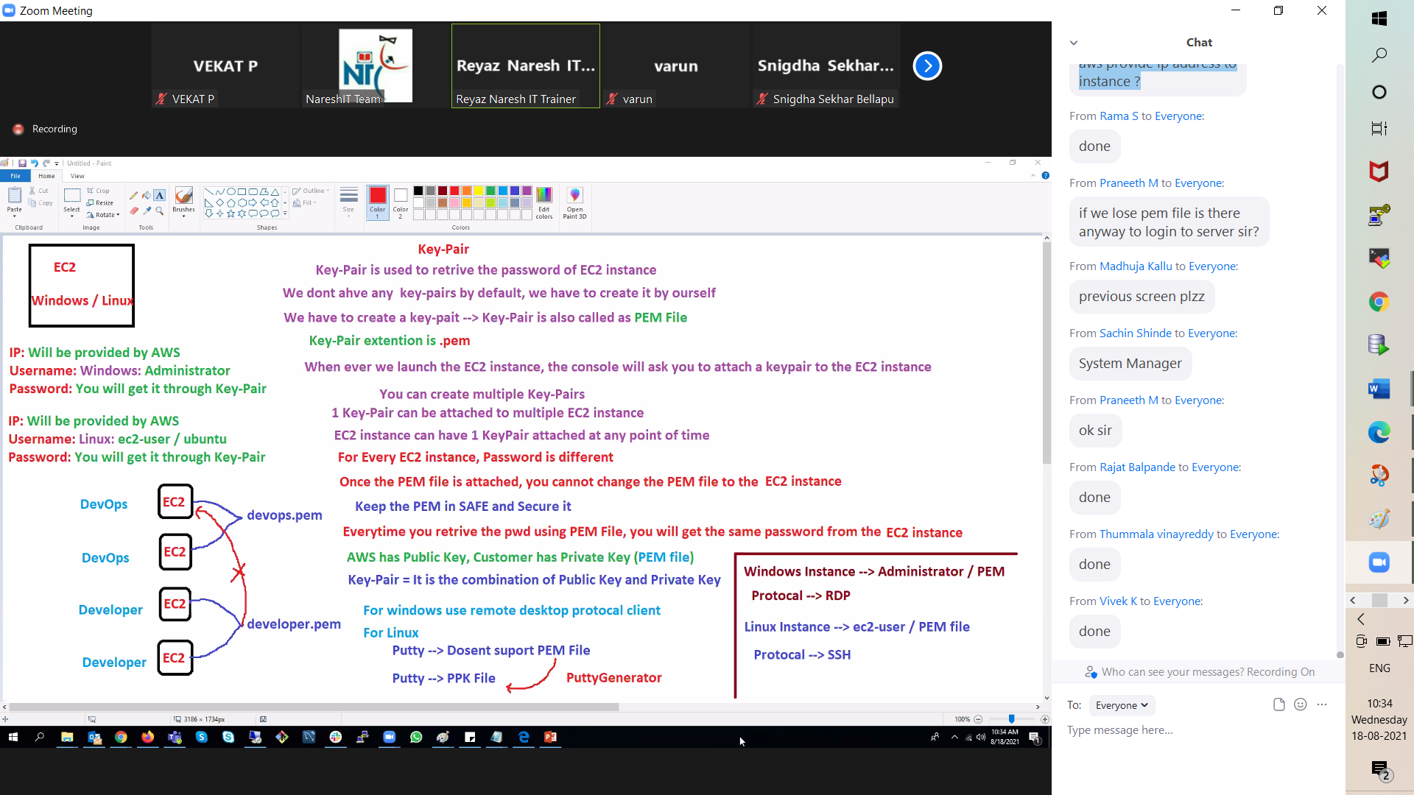

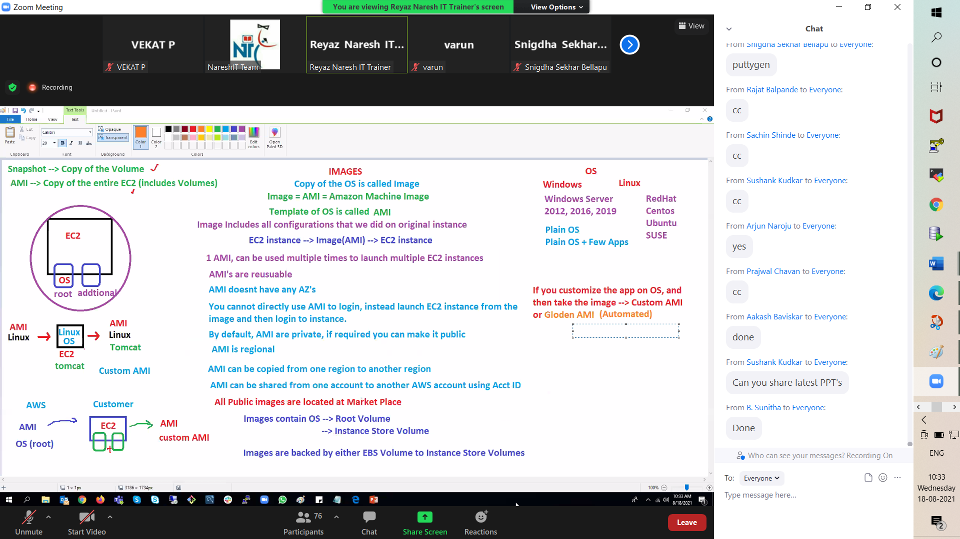

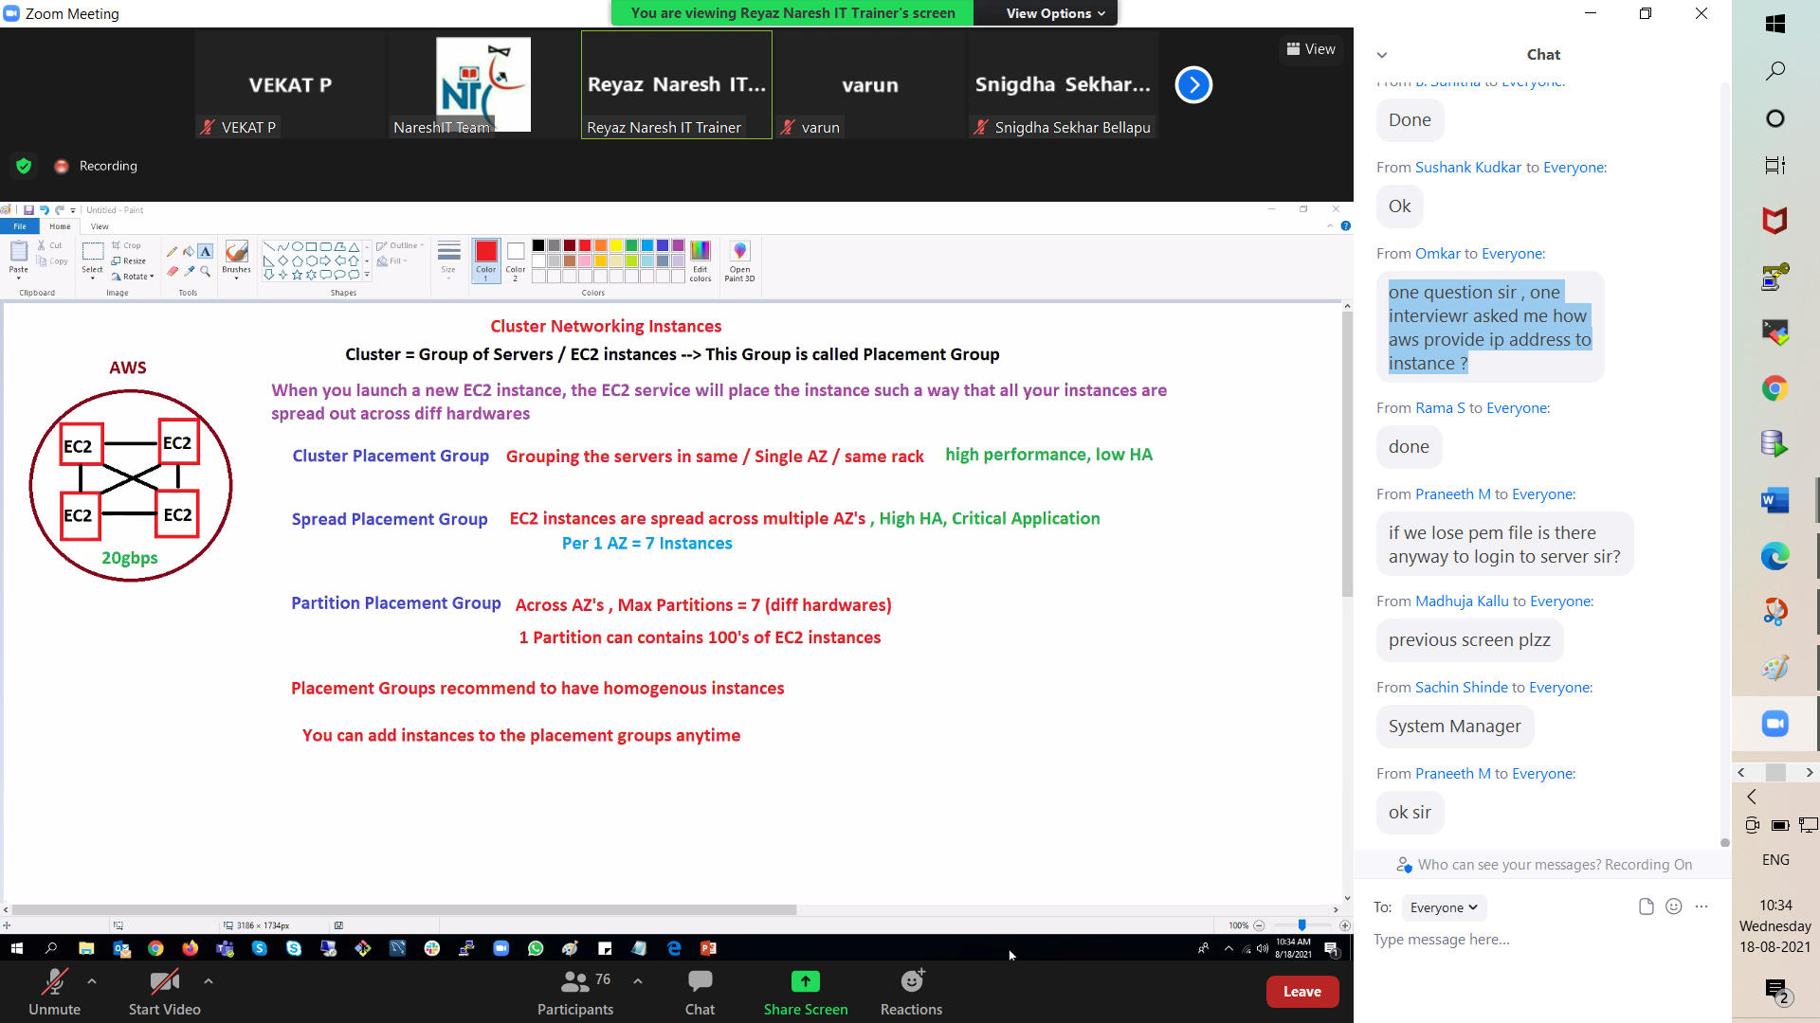

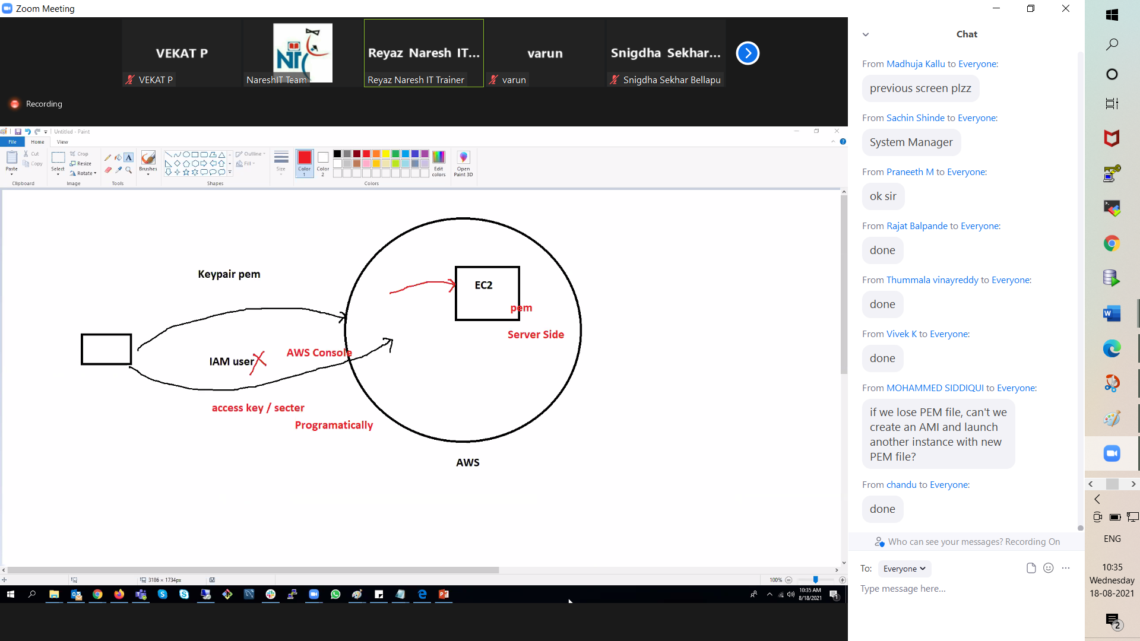

19-08-2021

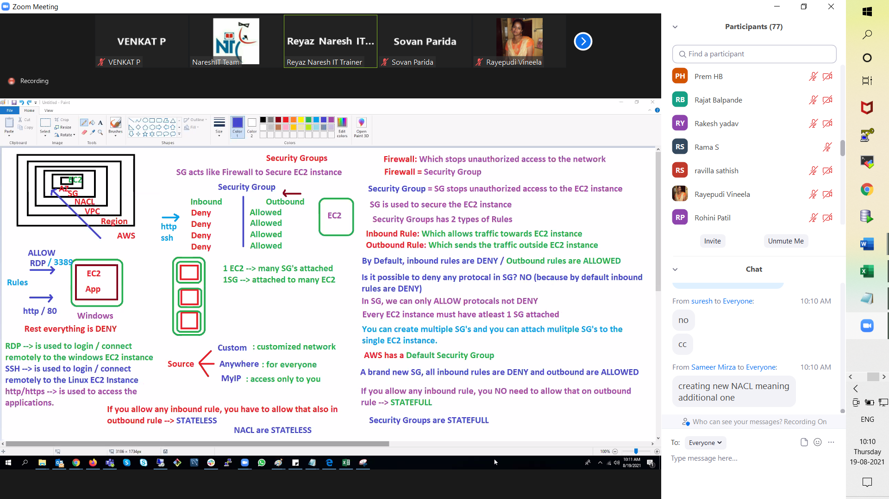

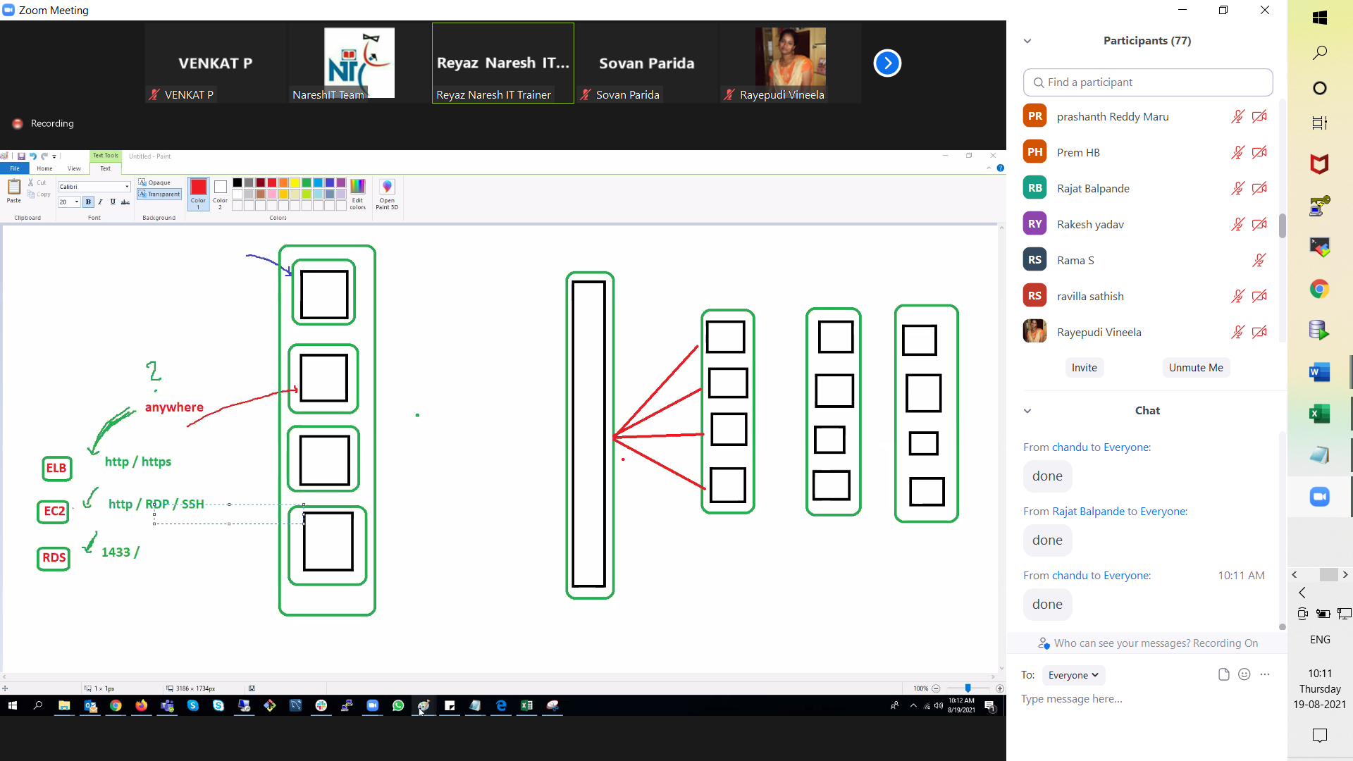

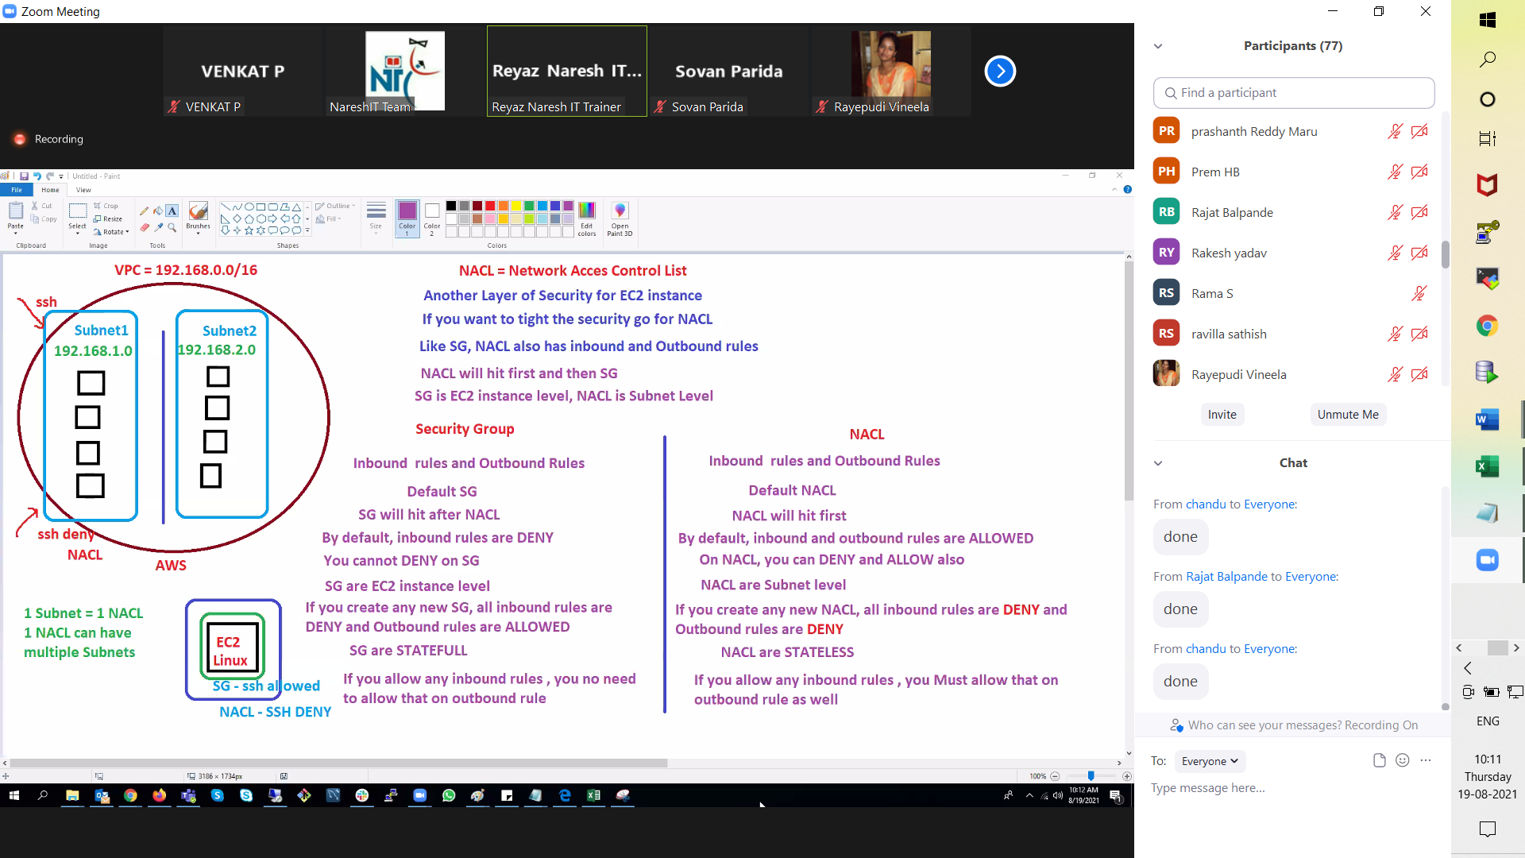

more security

Additional layer of security group (if rquired we can use it)

ISOLATED n/w is called subnet

All ec2 instance inside subnet

remote ssh from inbound rule

NACL entire subnet level

NACL we can denied inbound rule

we can denied it on NACL level

NACL inbound and outbound are allowed

20-08-2021

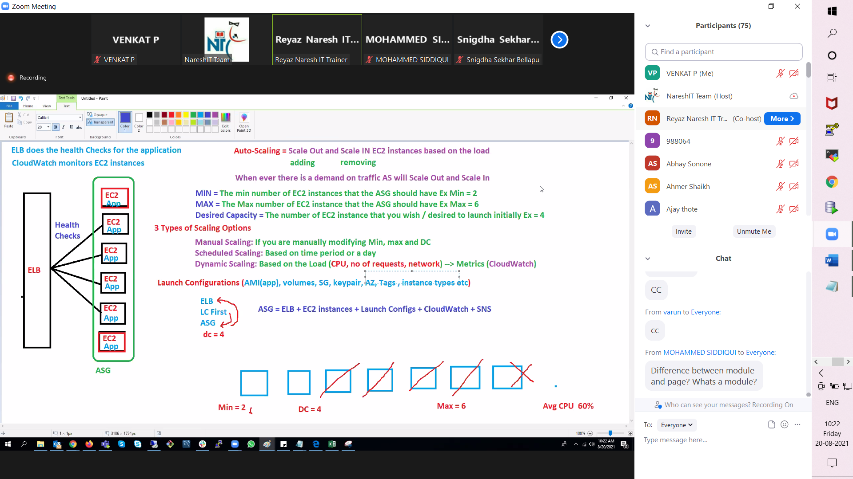

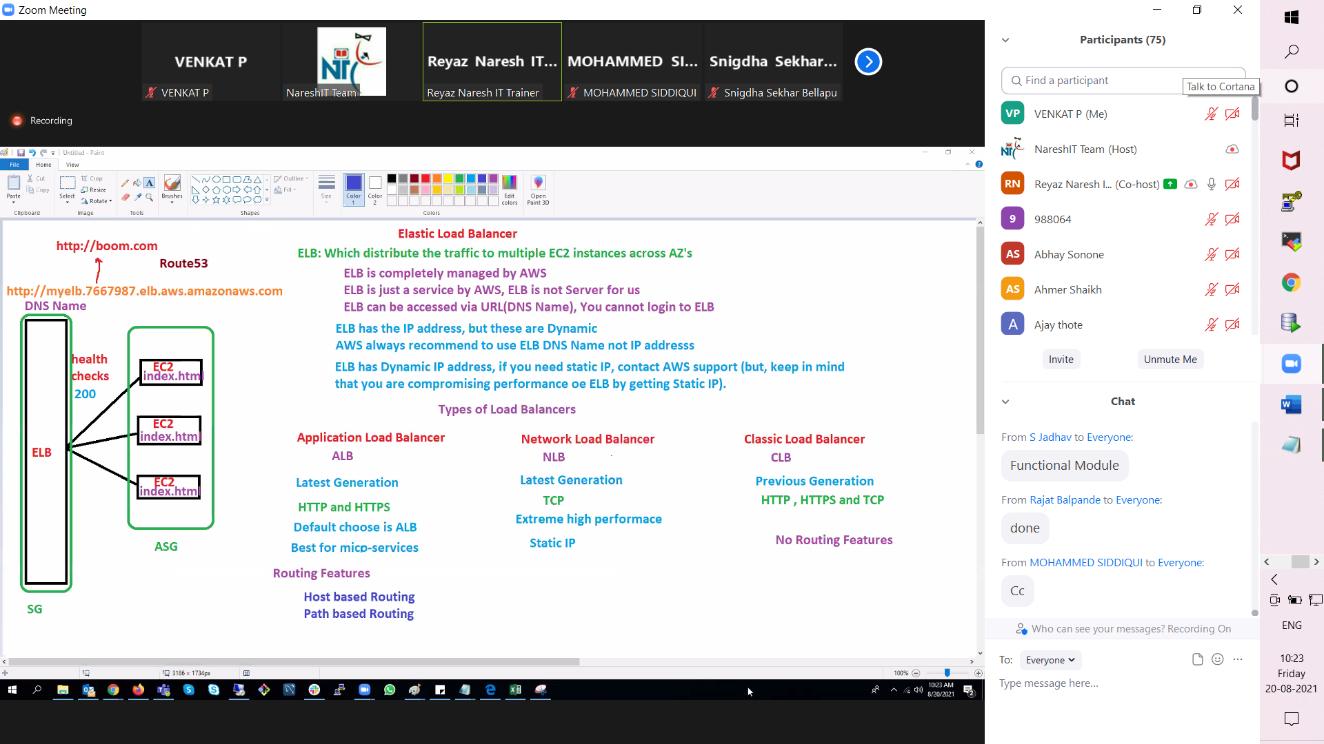

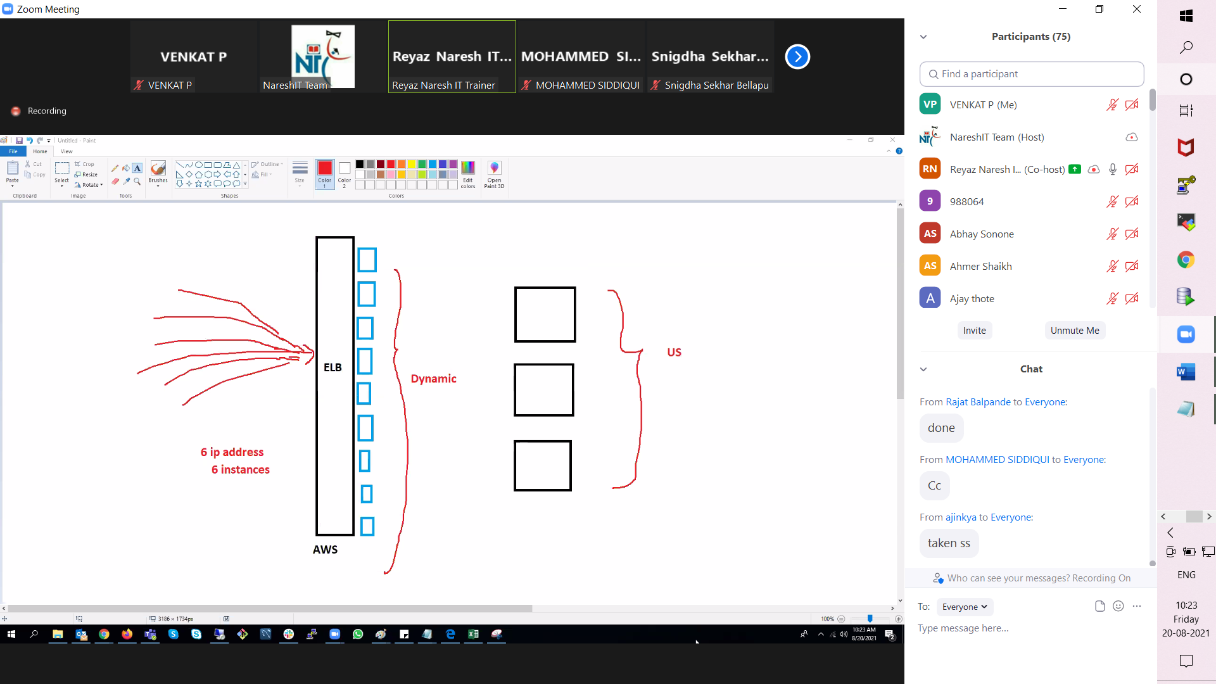

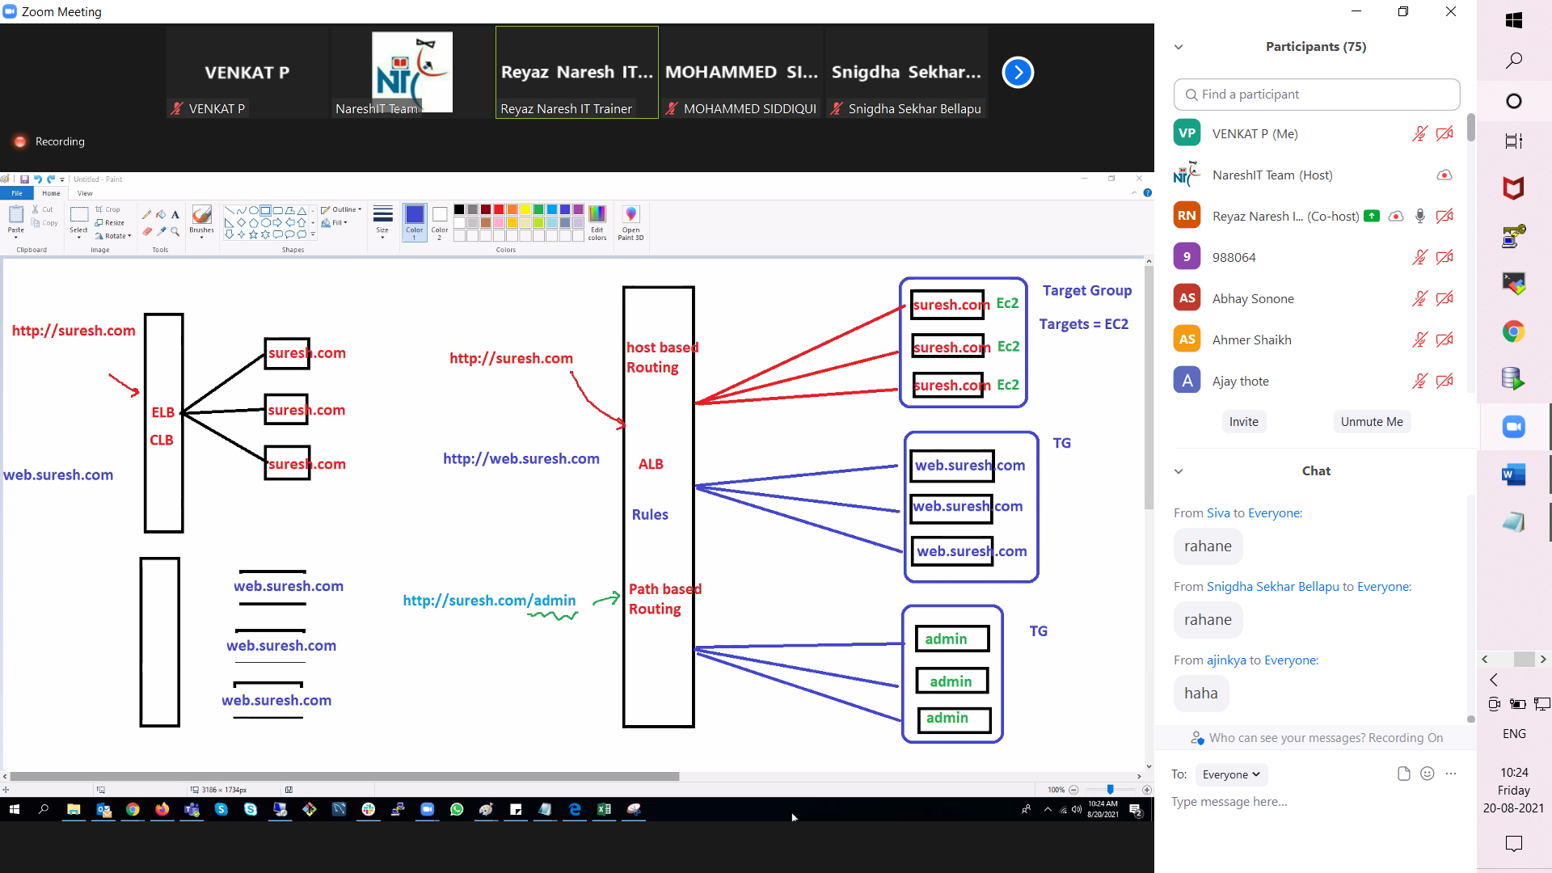

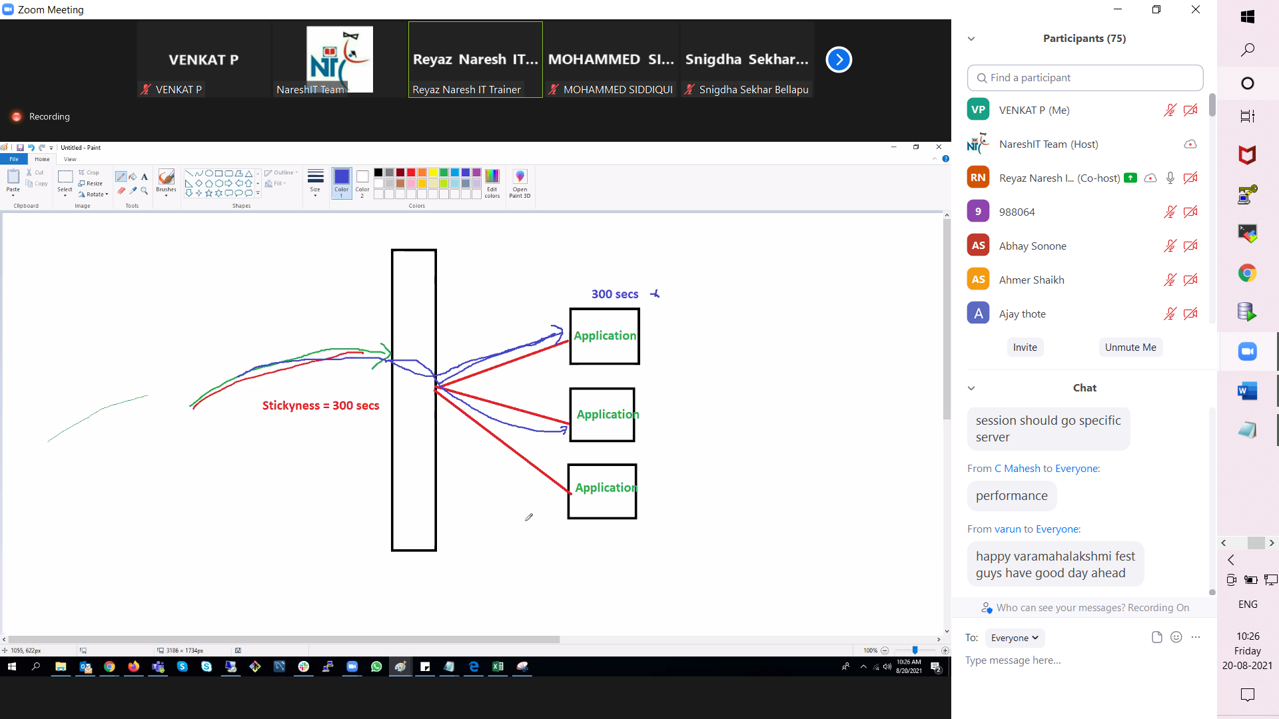

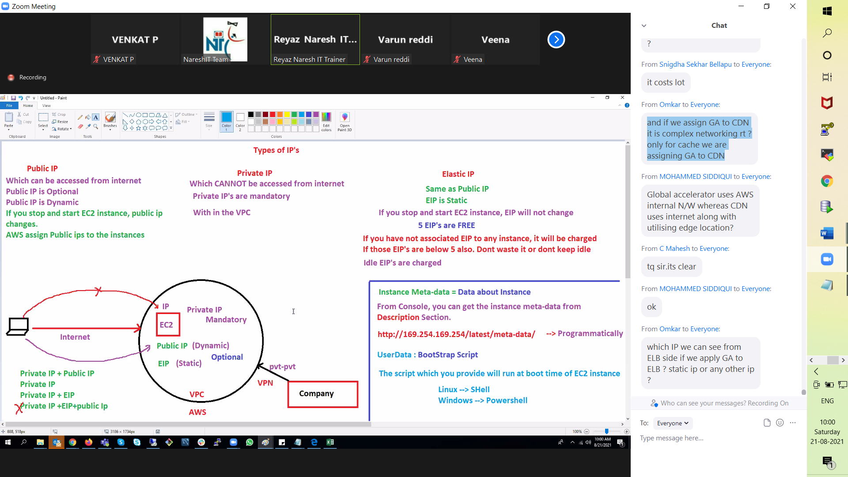

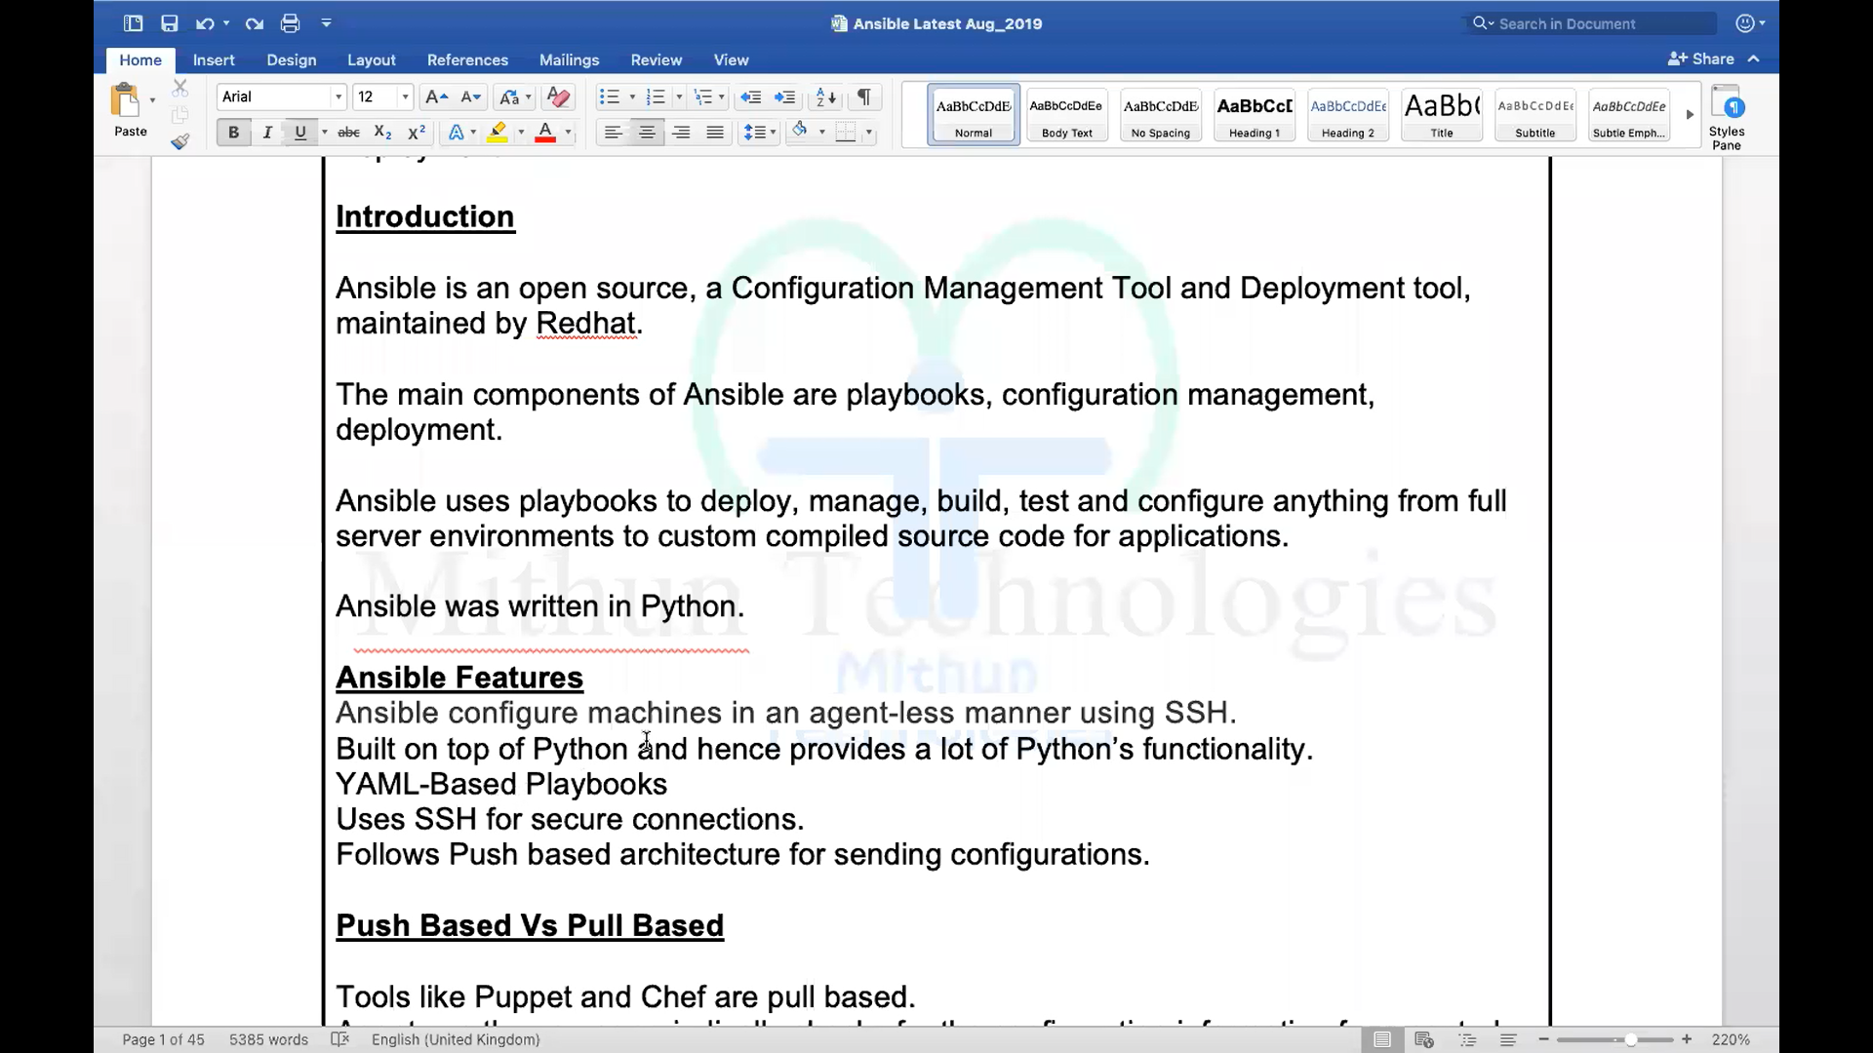

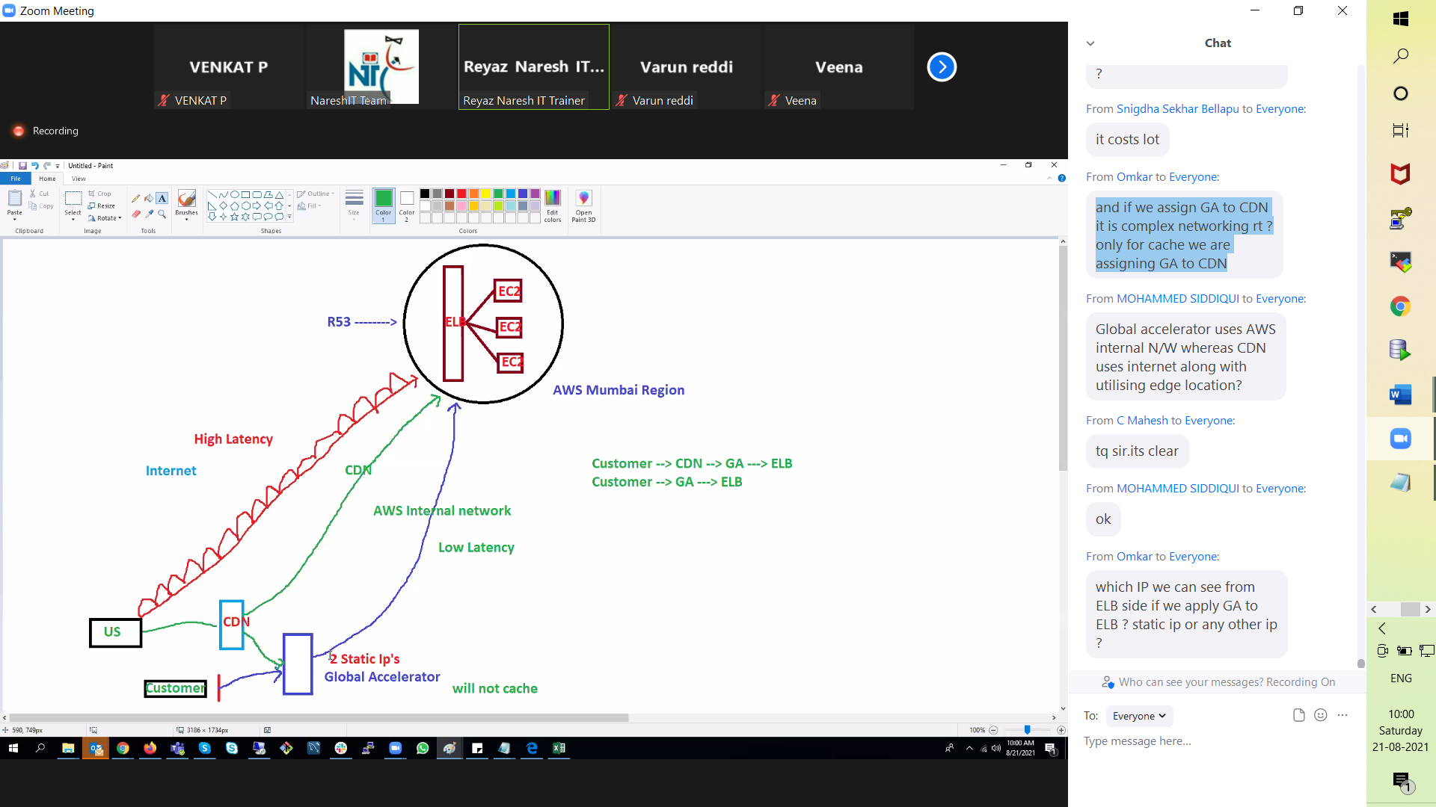

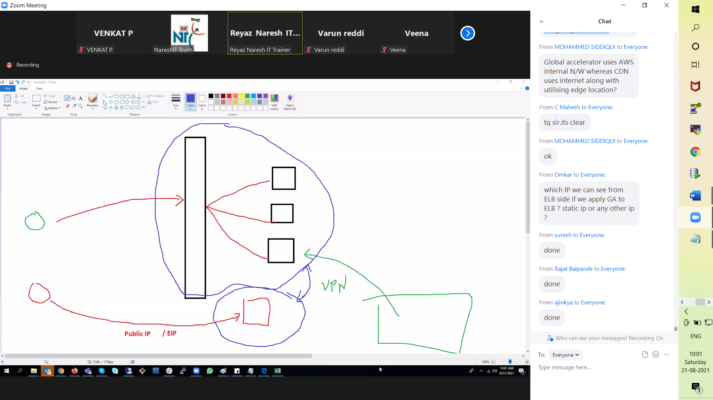

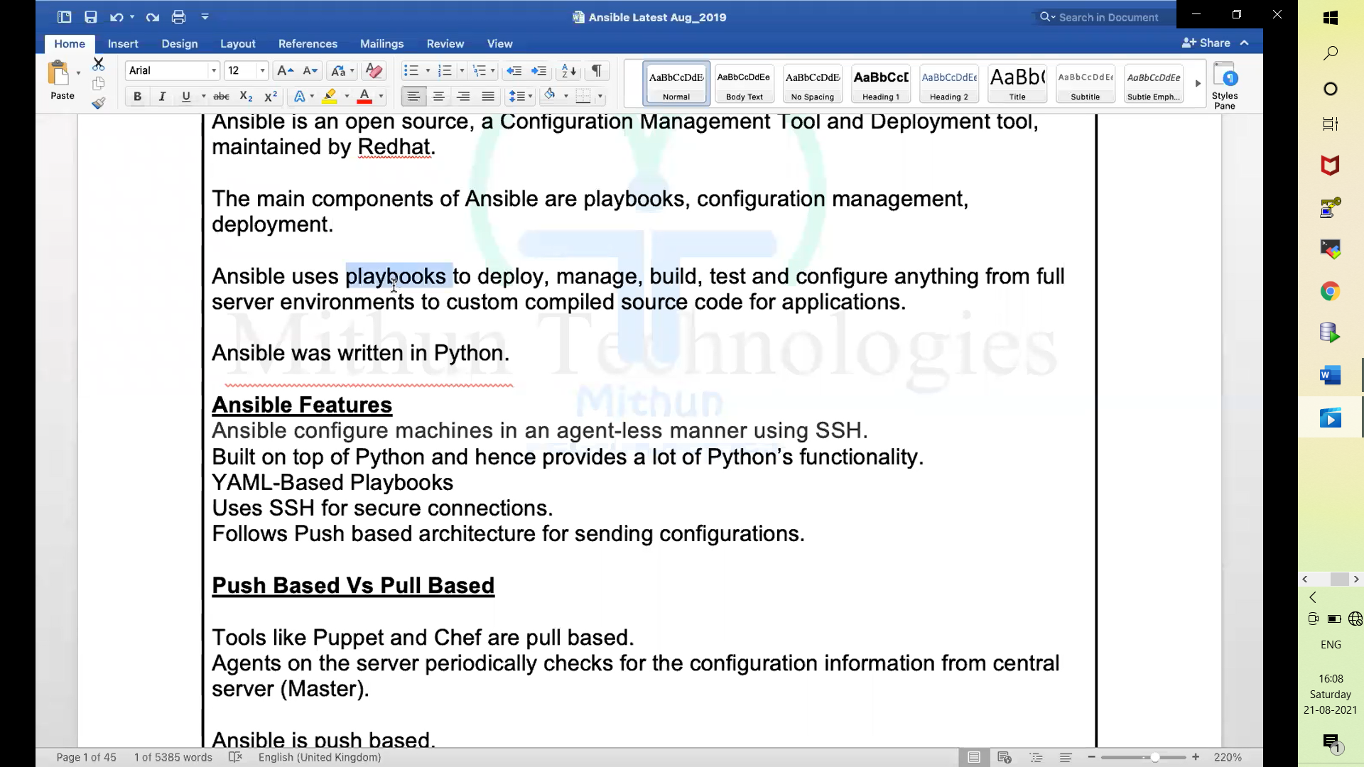

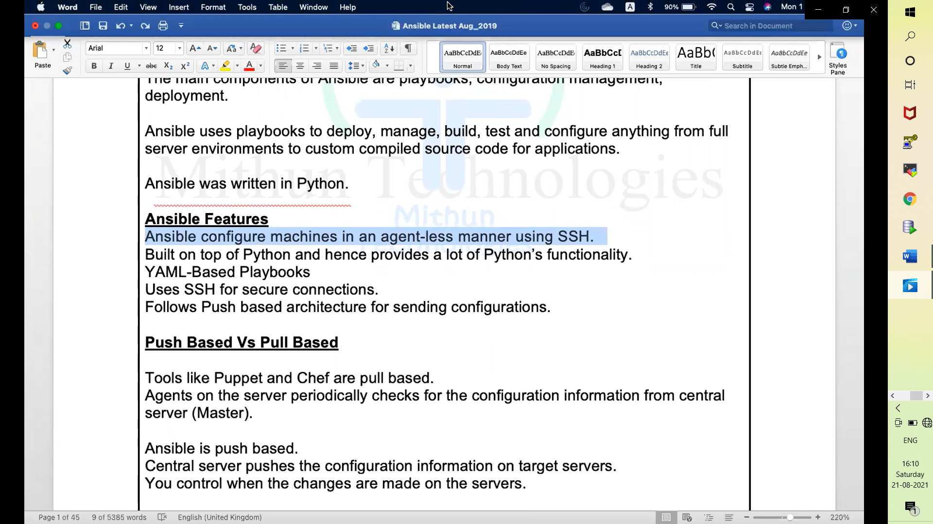

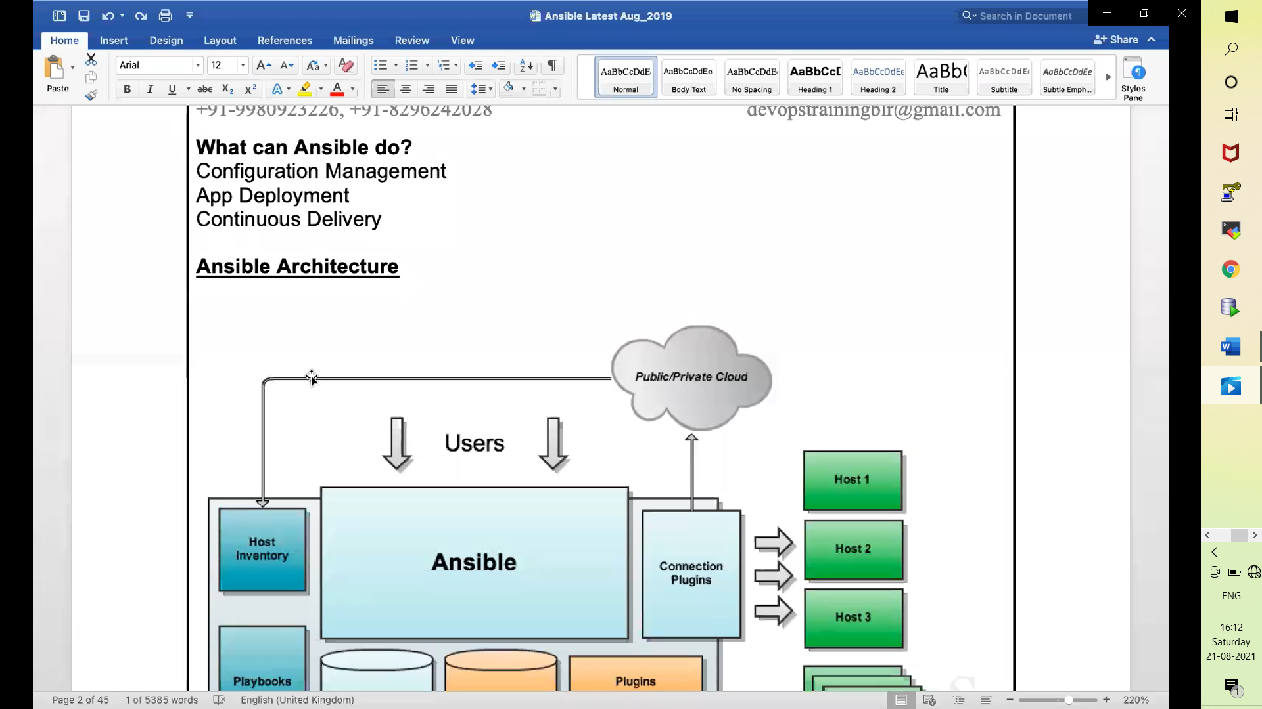

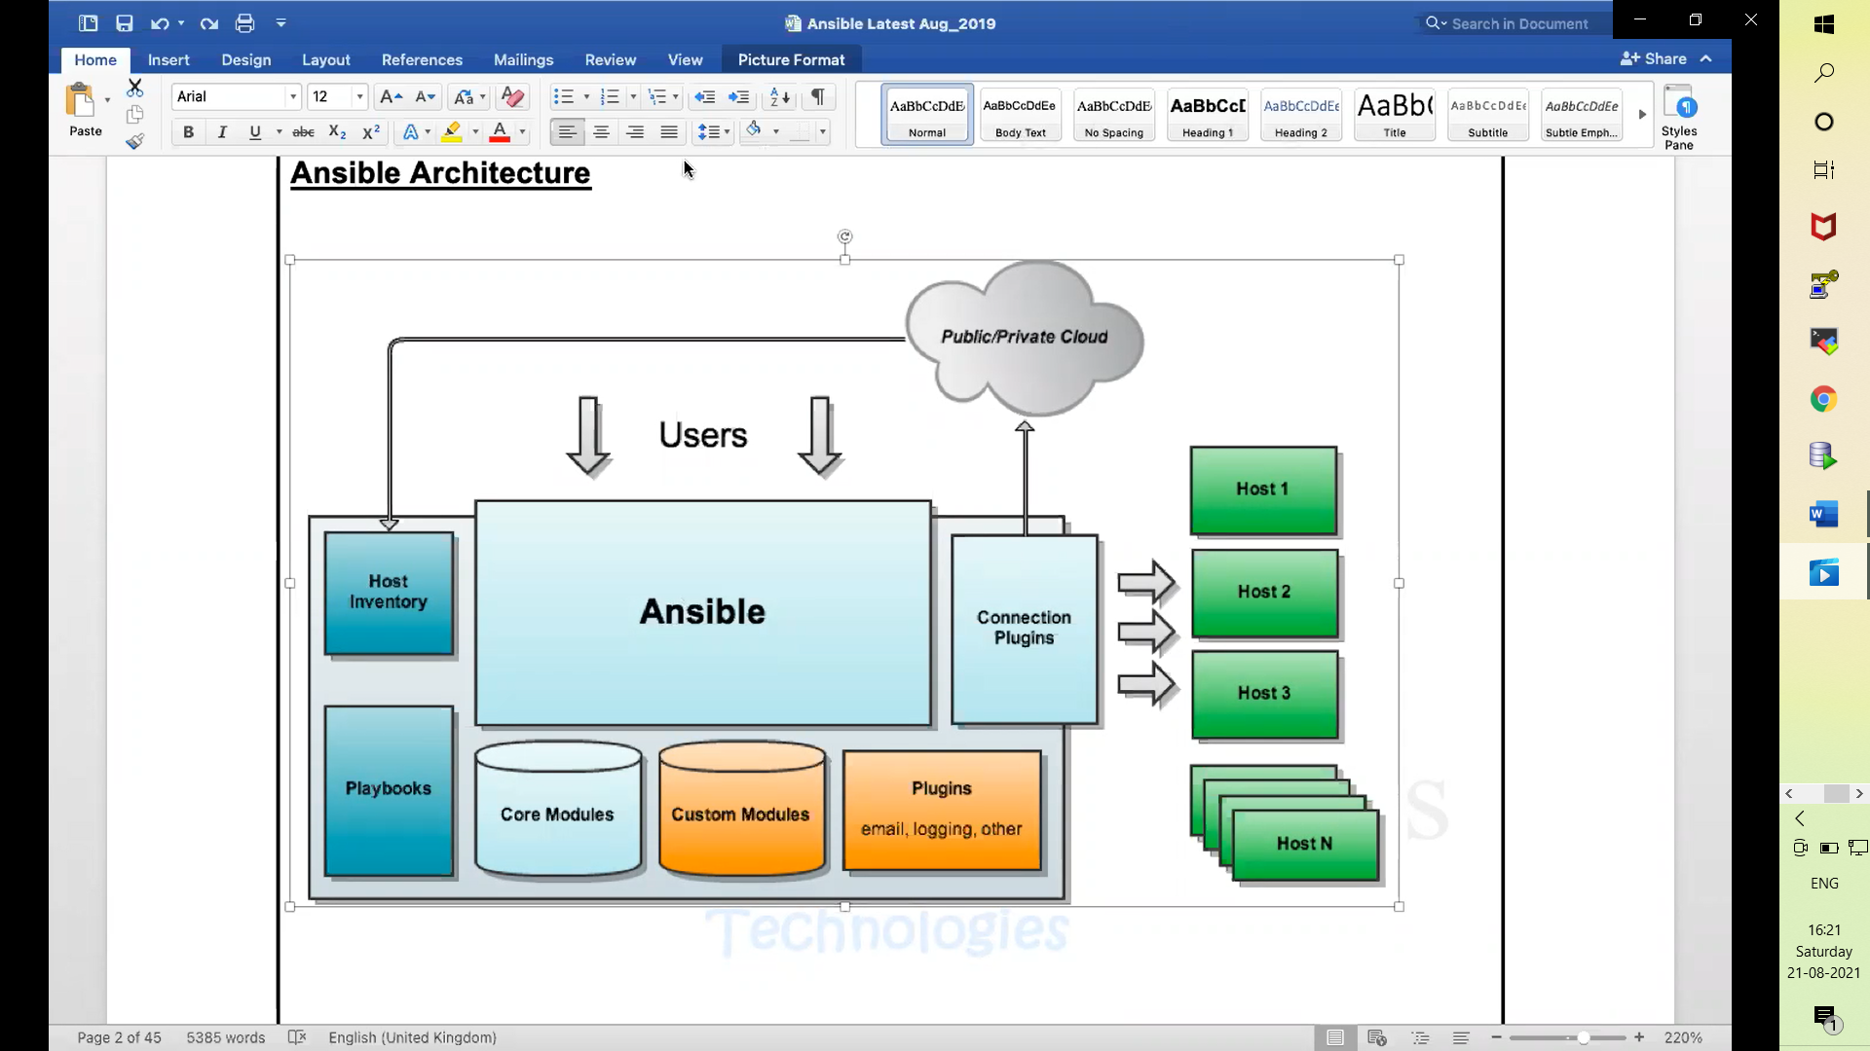

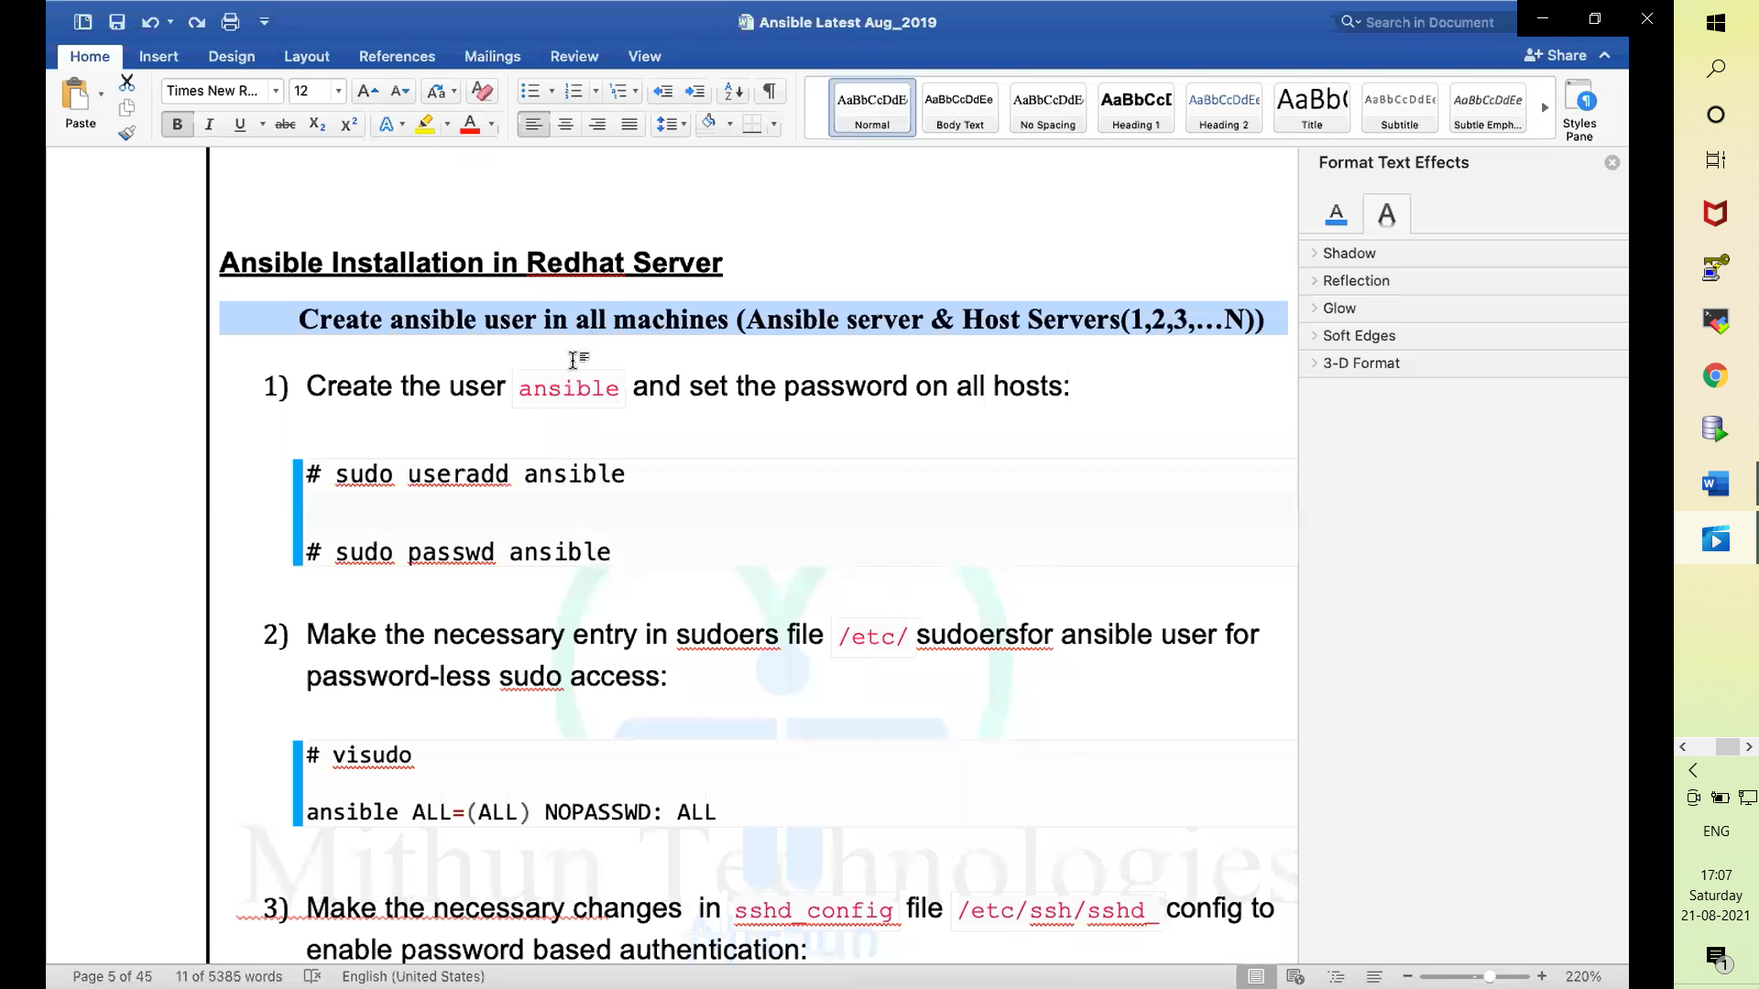

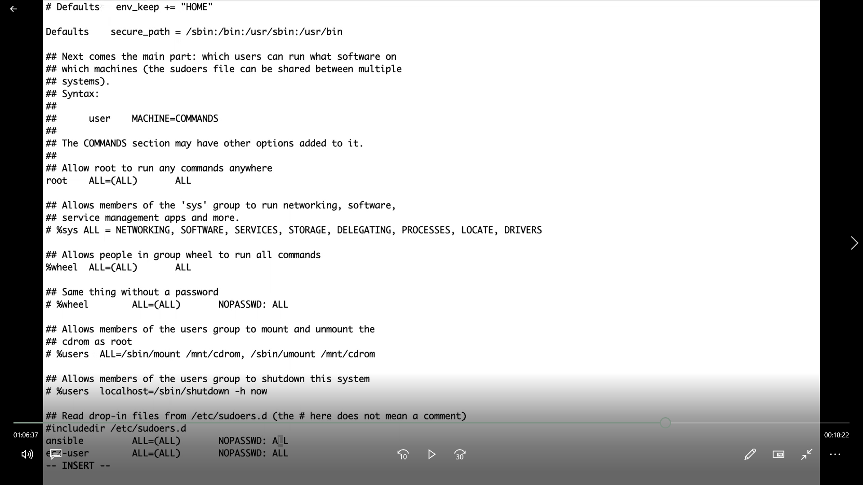

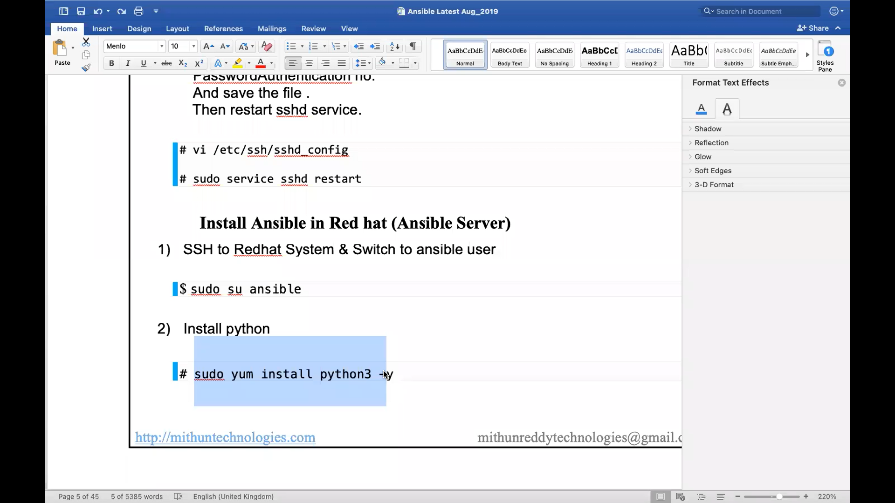

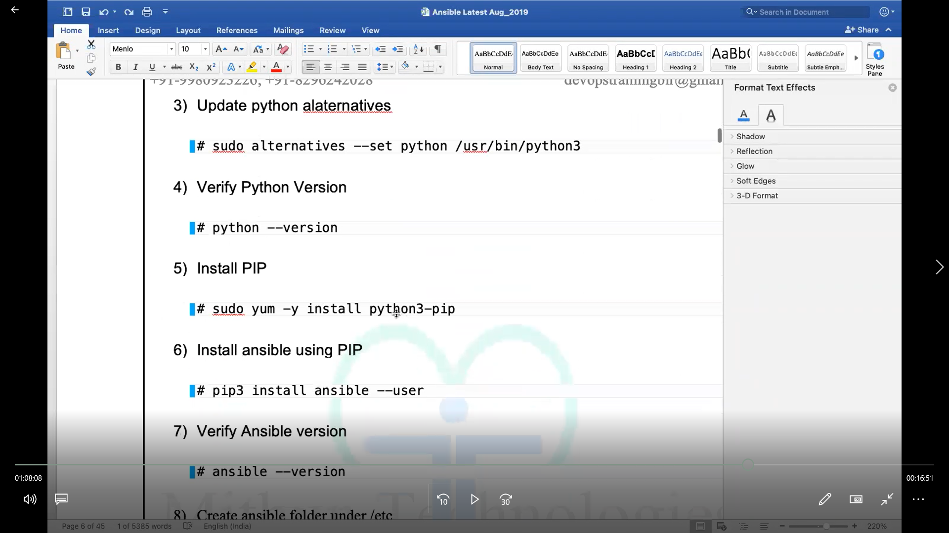

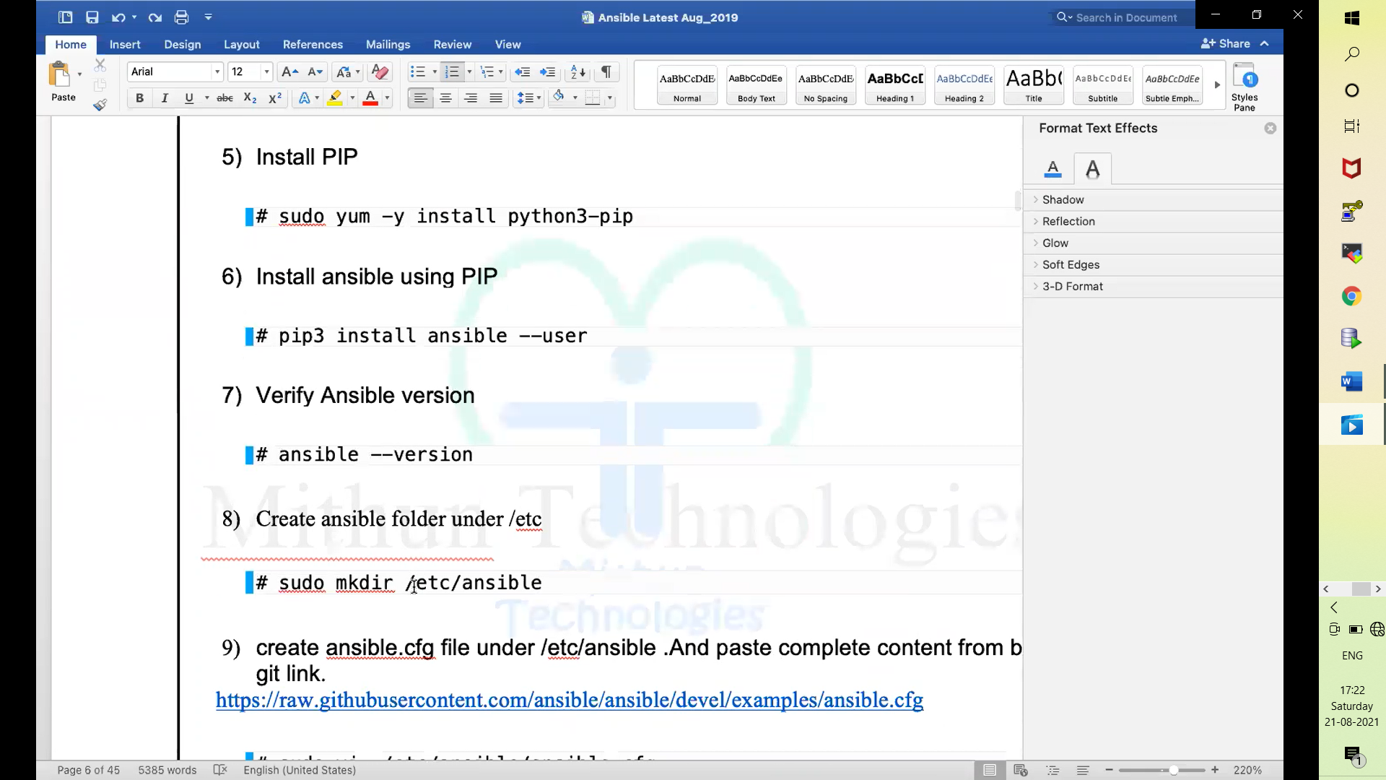

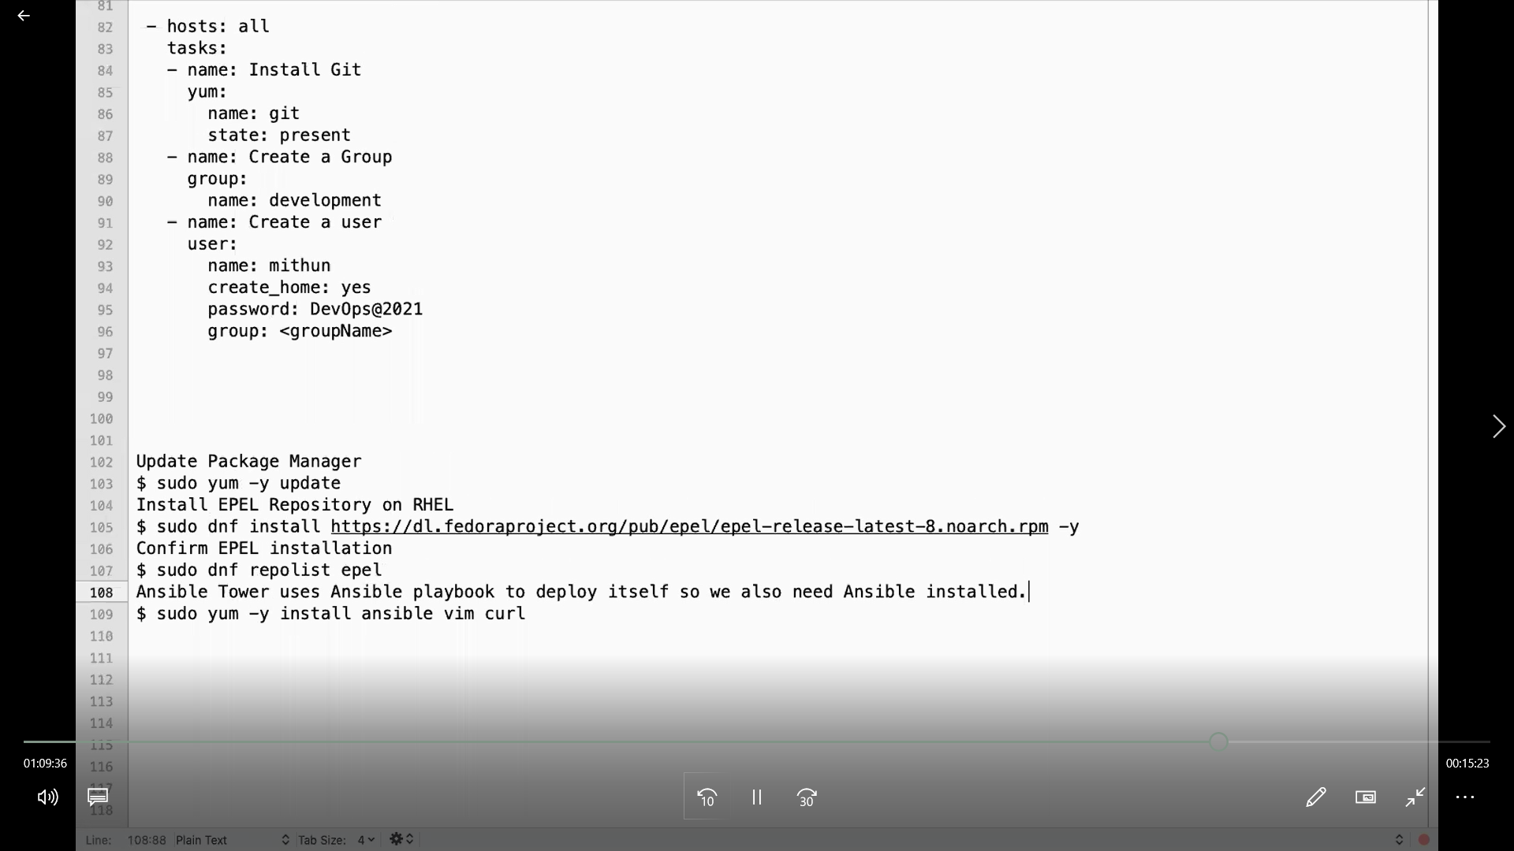

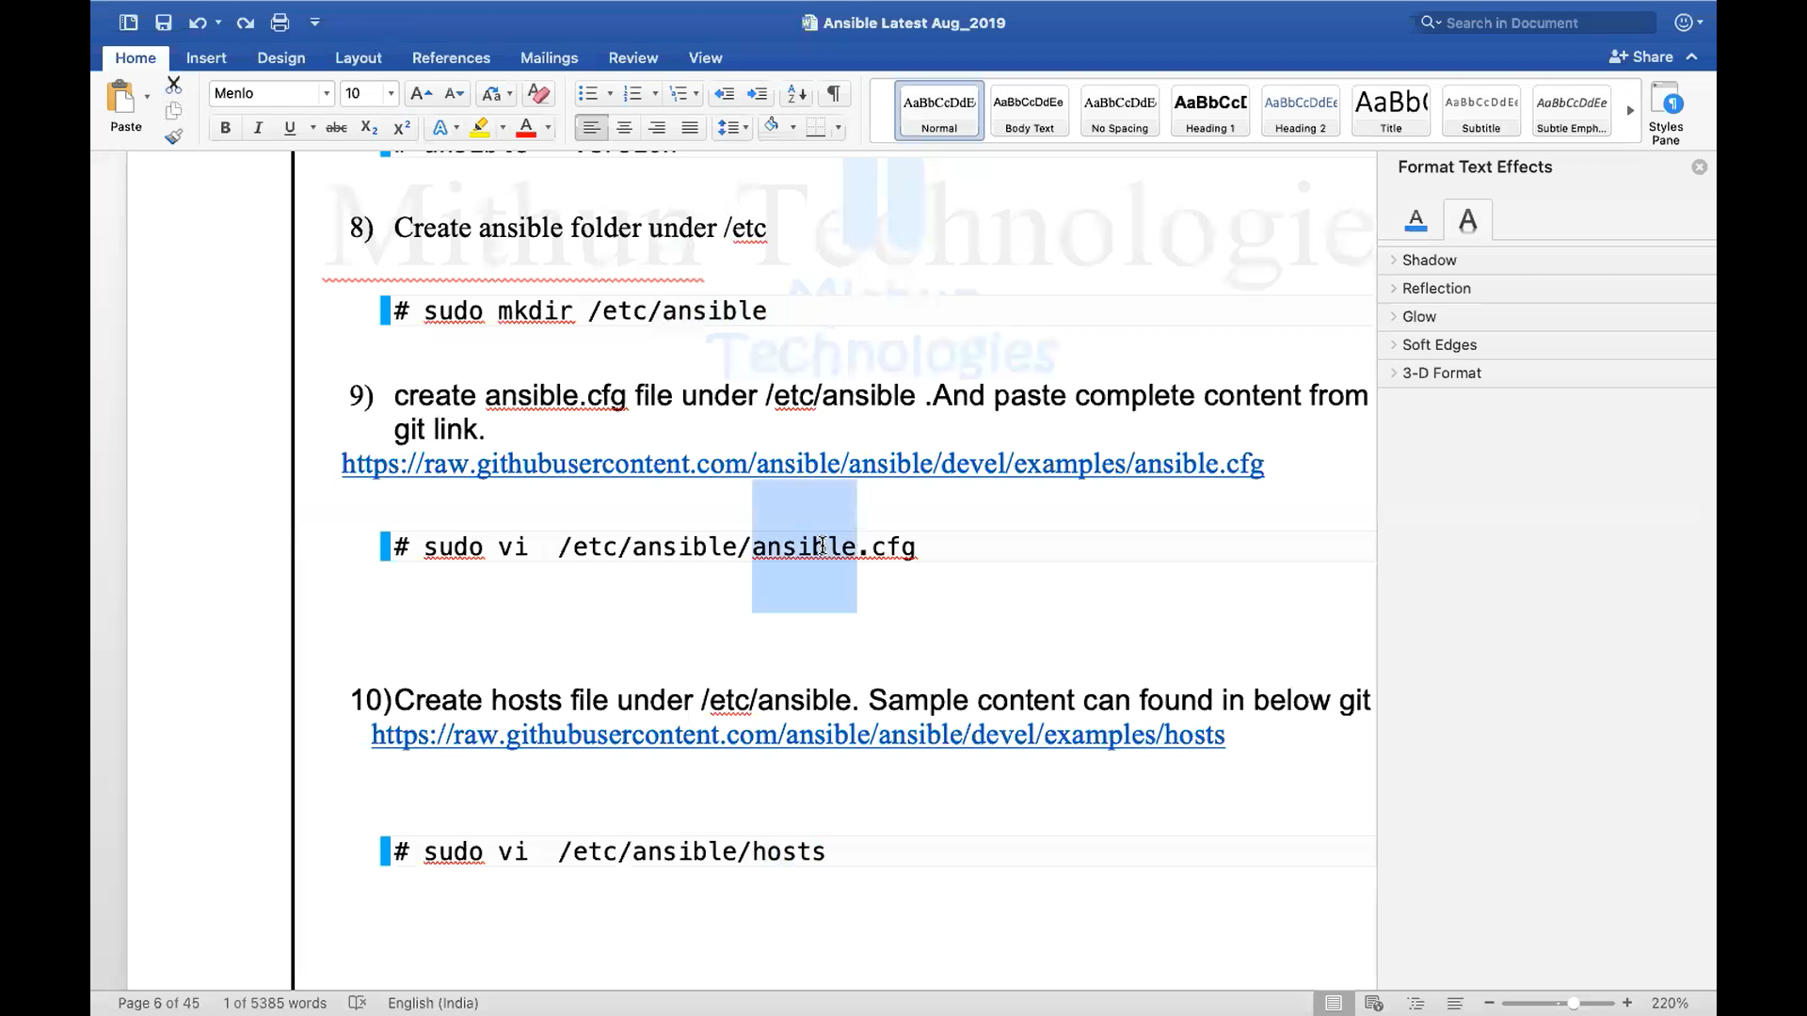ssh

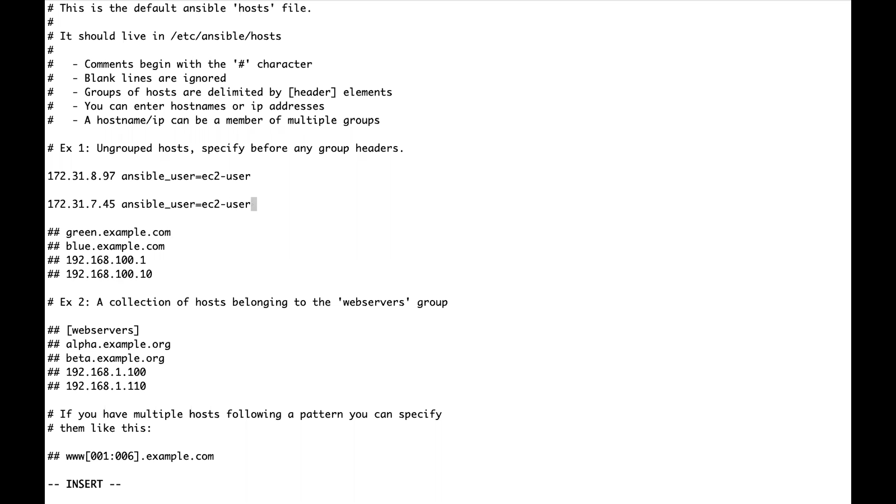

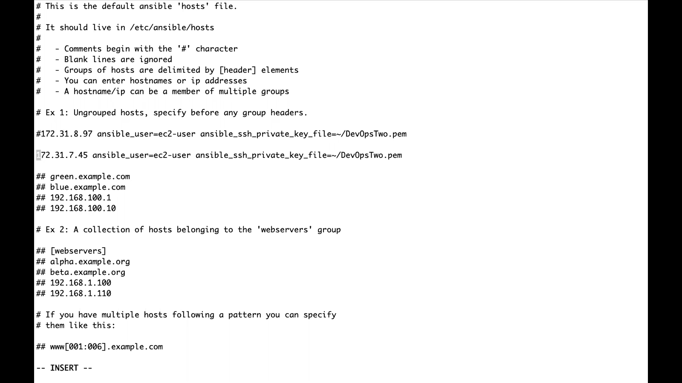

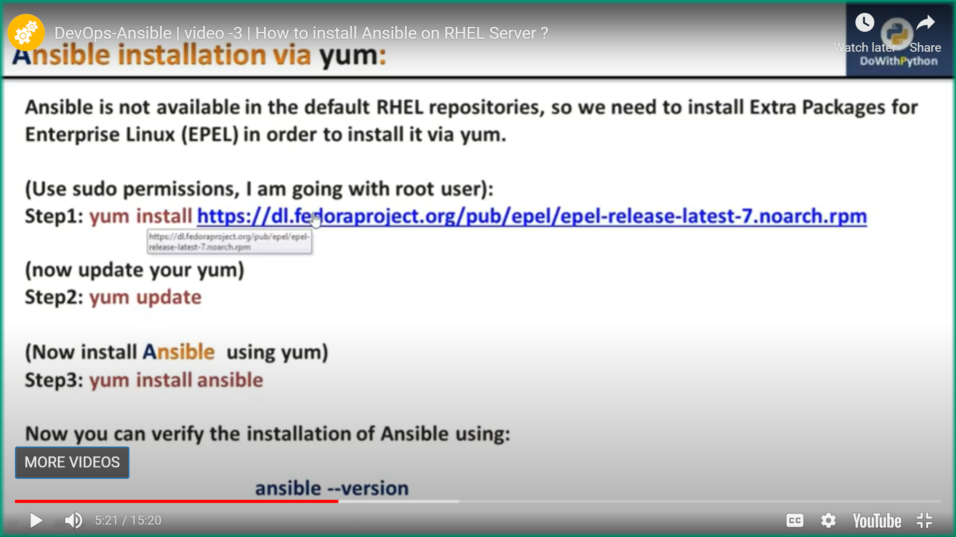

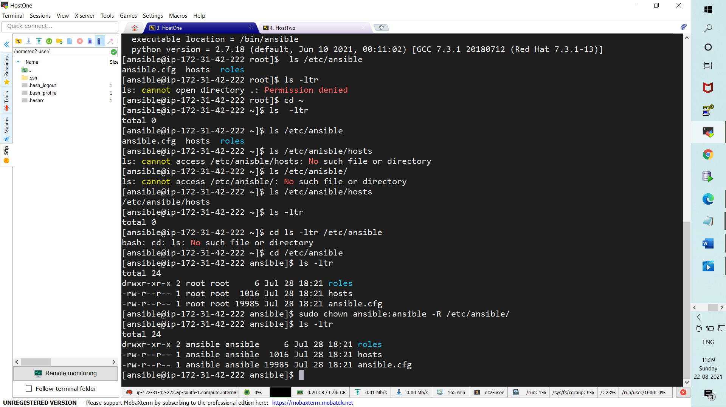

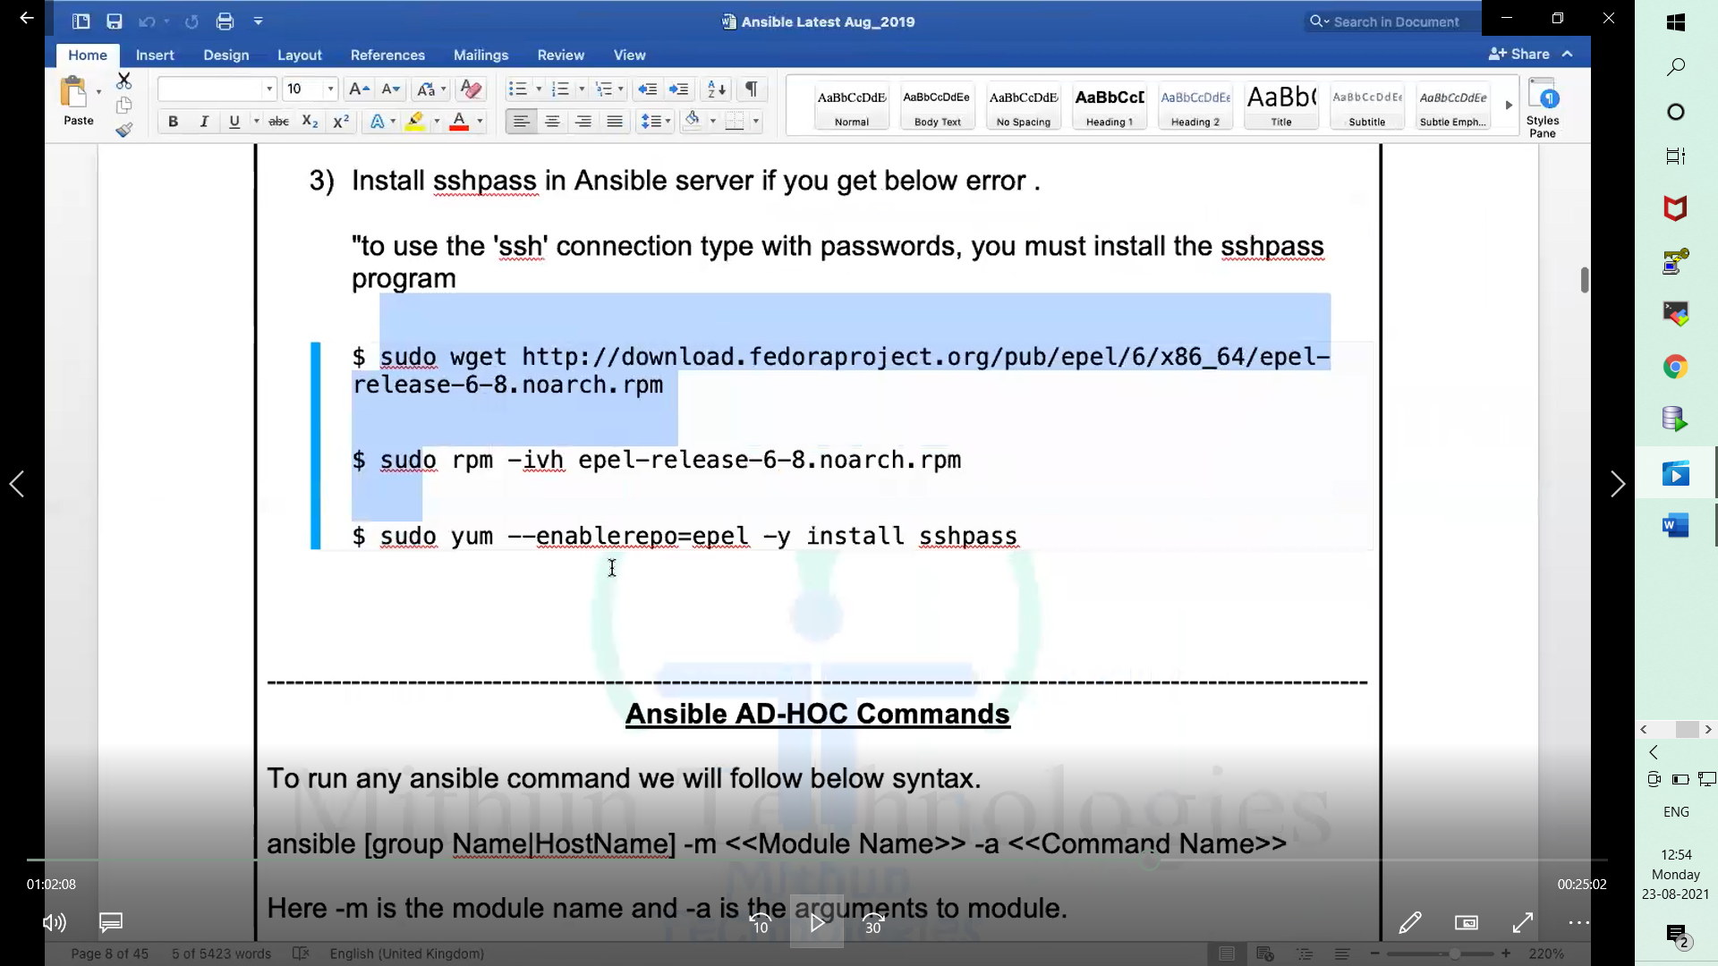

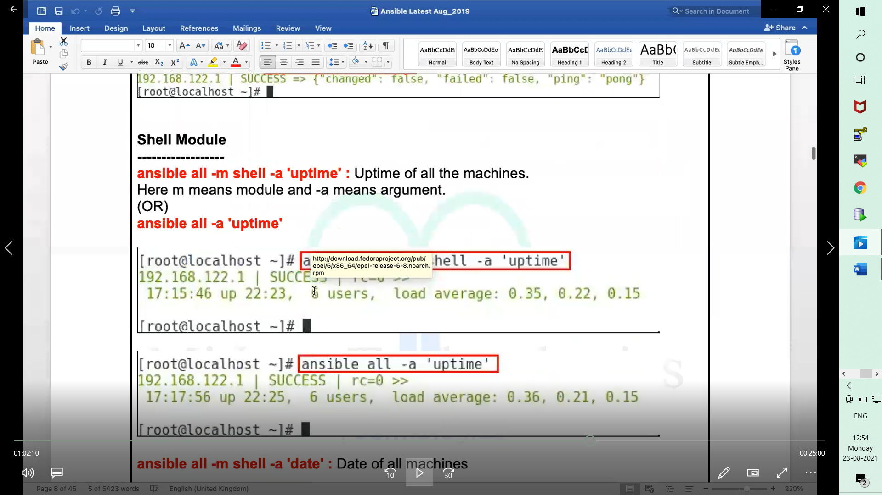

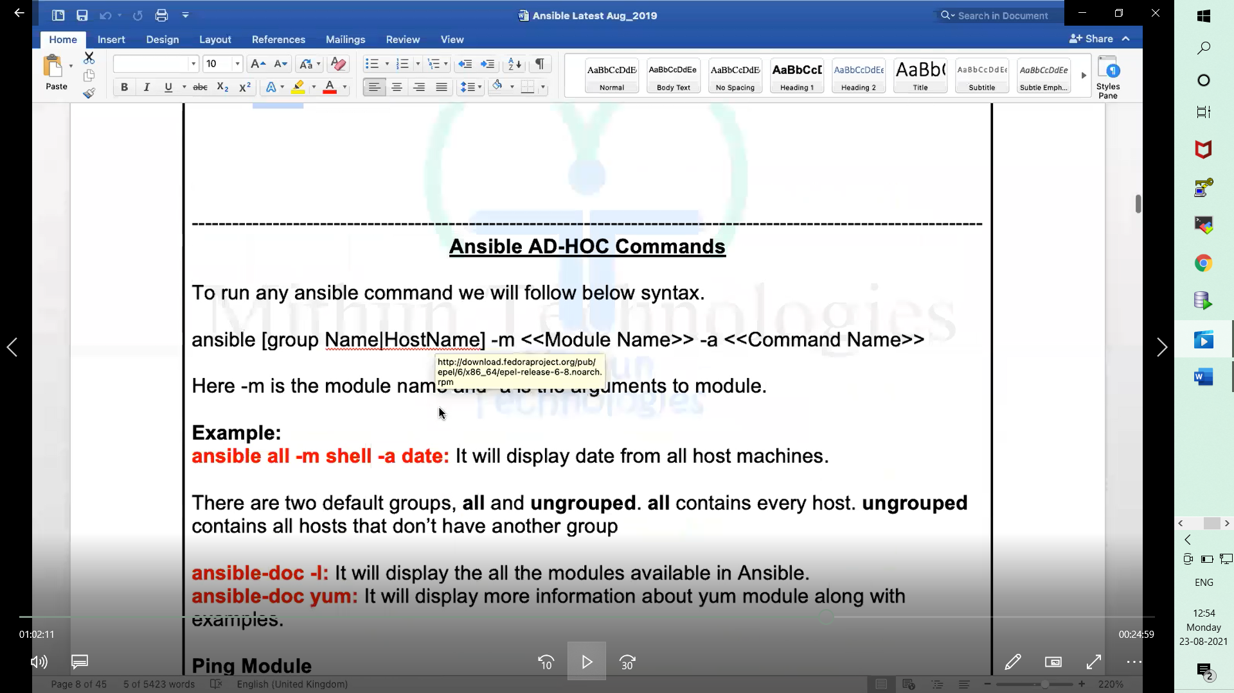

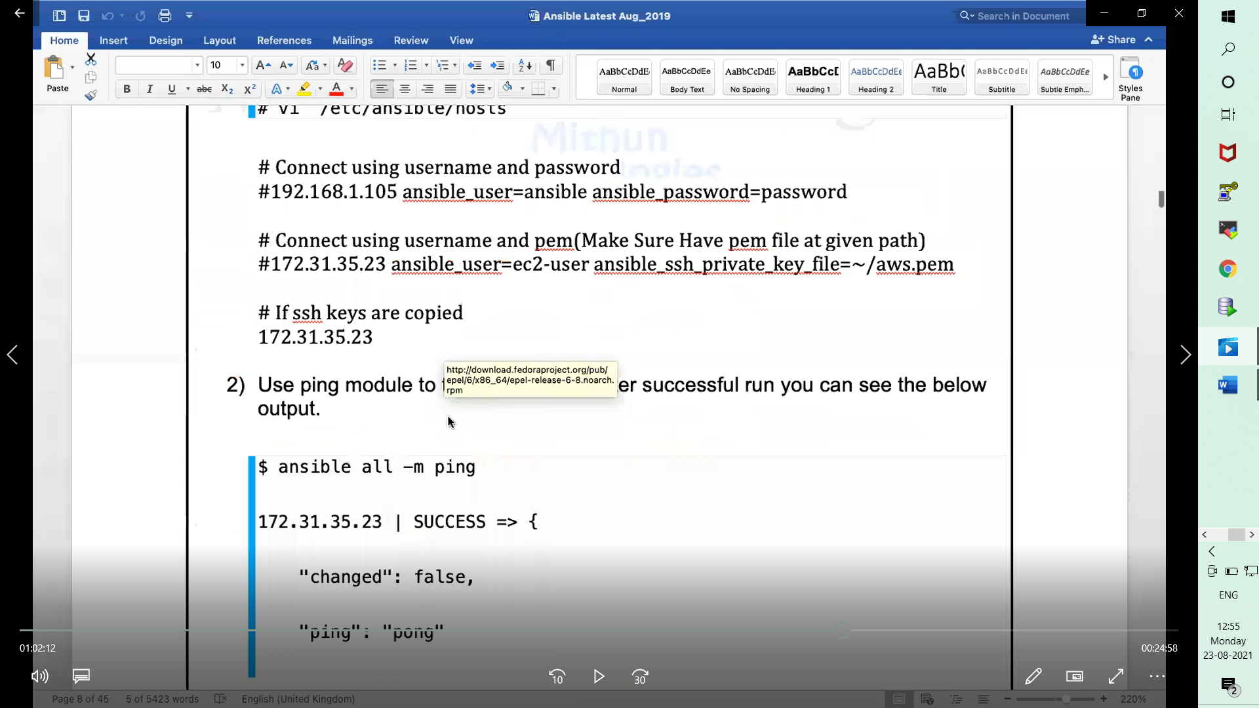

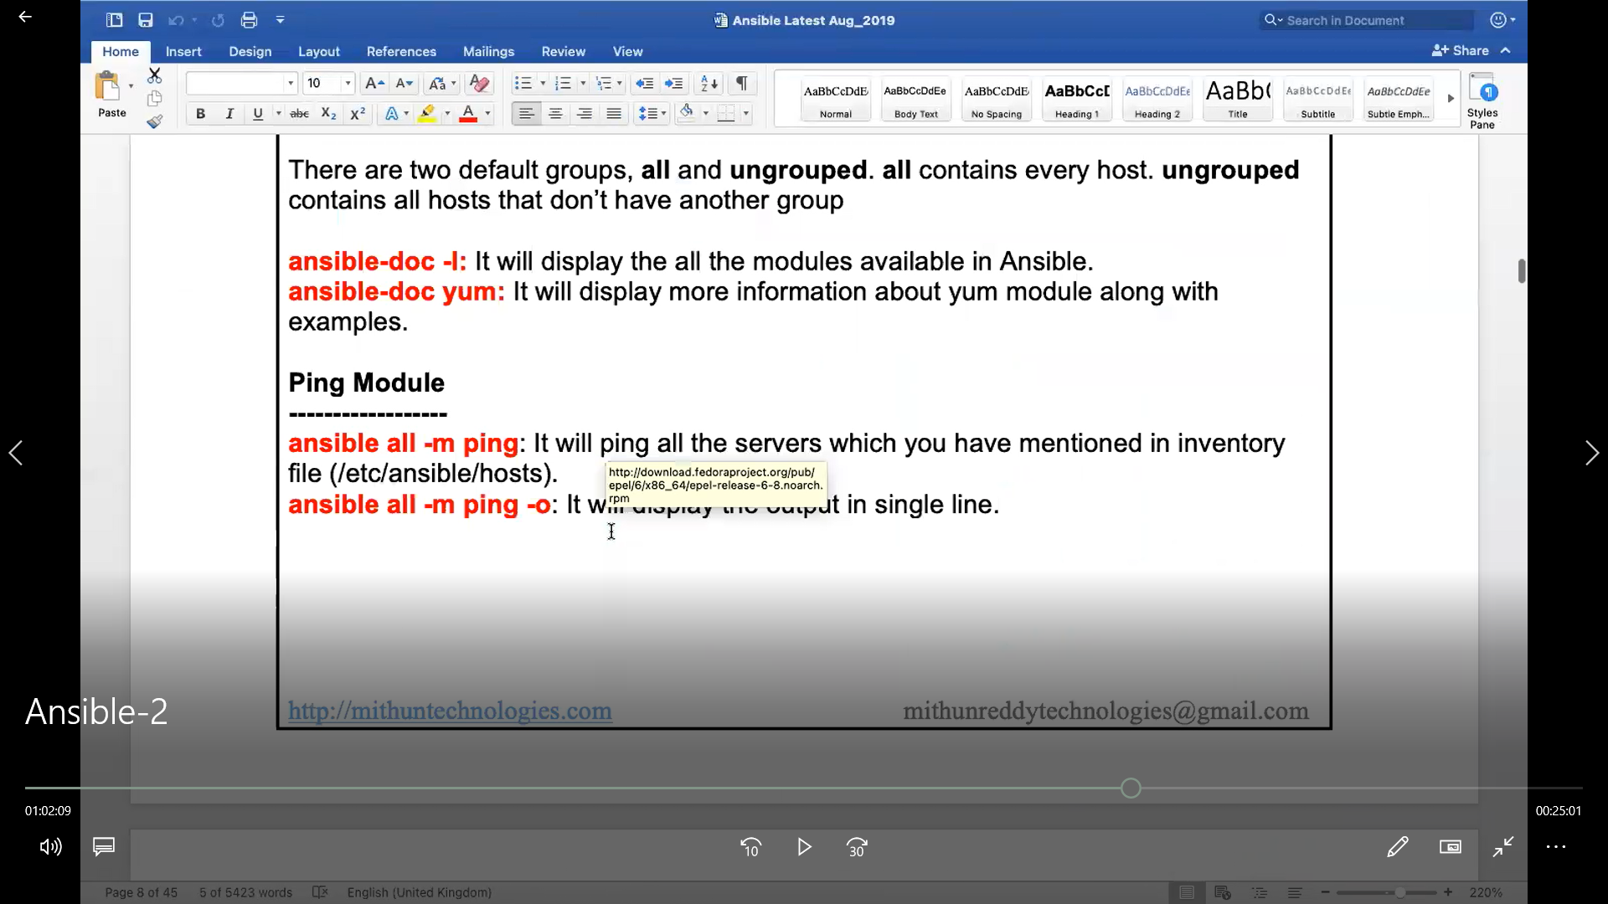

24-08-2021

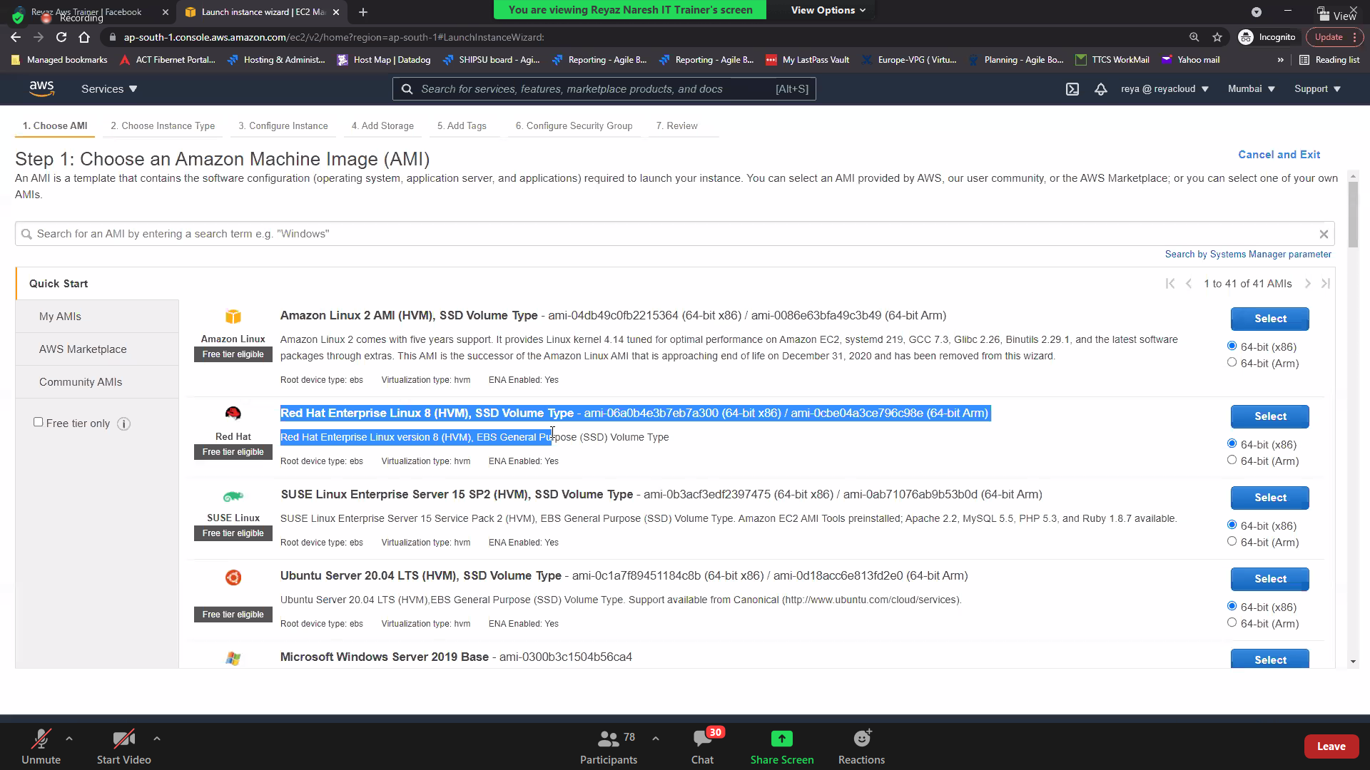

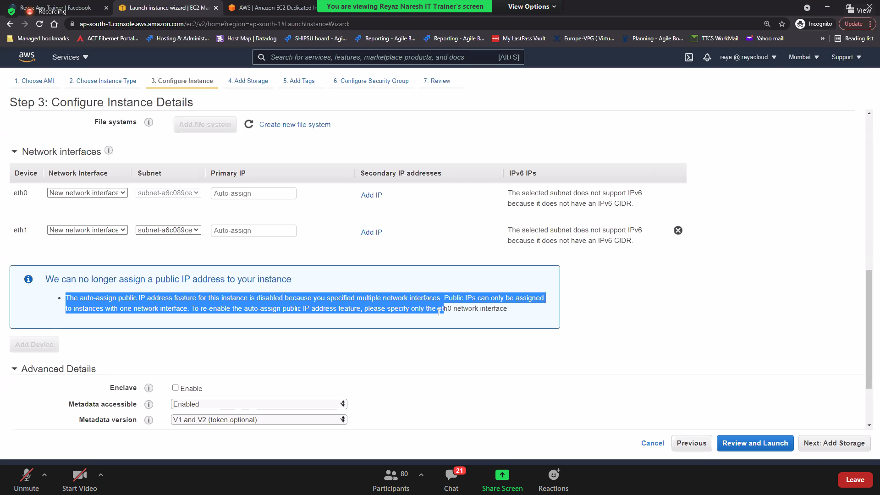

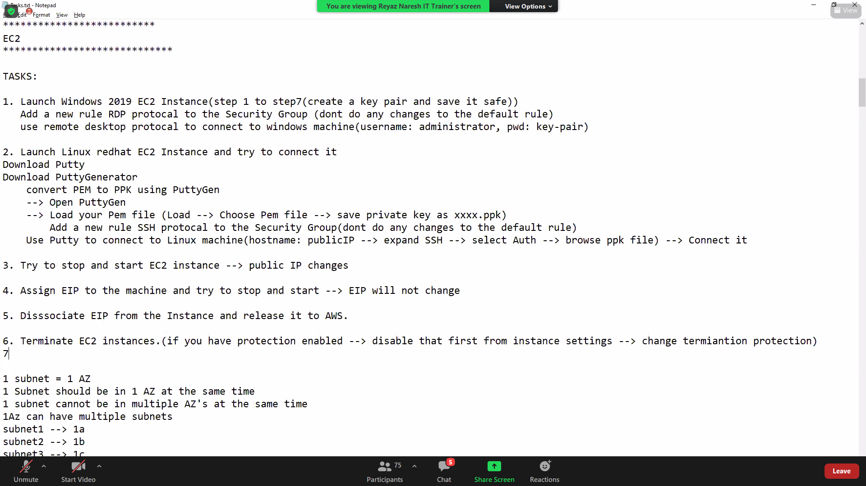

hi sir if you don't mine can I ask one unrelated question...its all about JOB role …..I heard there was a role called "AWS DEVSECOPS" do you have any idea sir .....sorry guys for this irrelevant question

28-08-2021

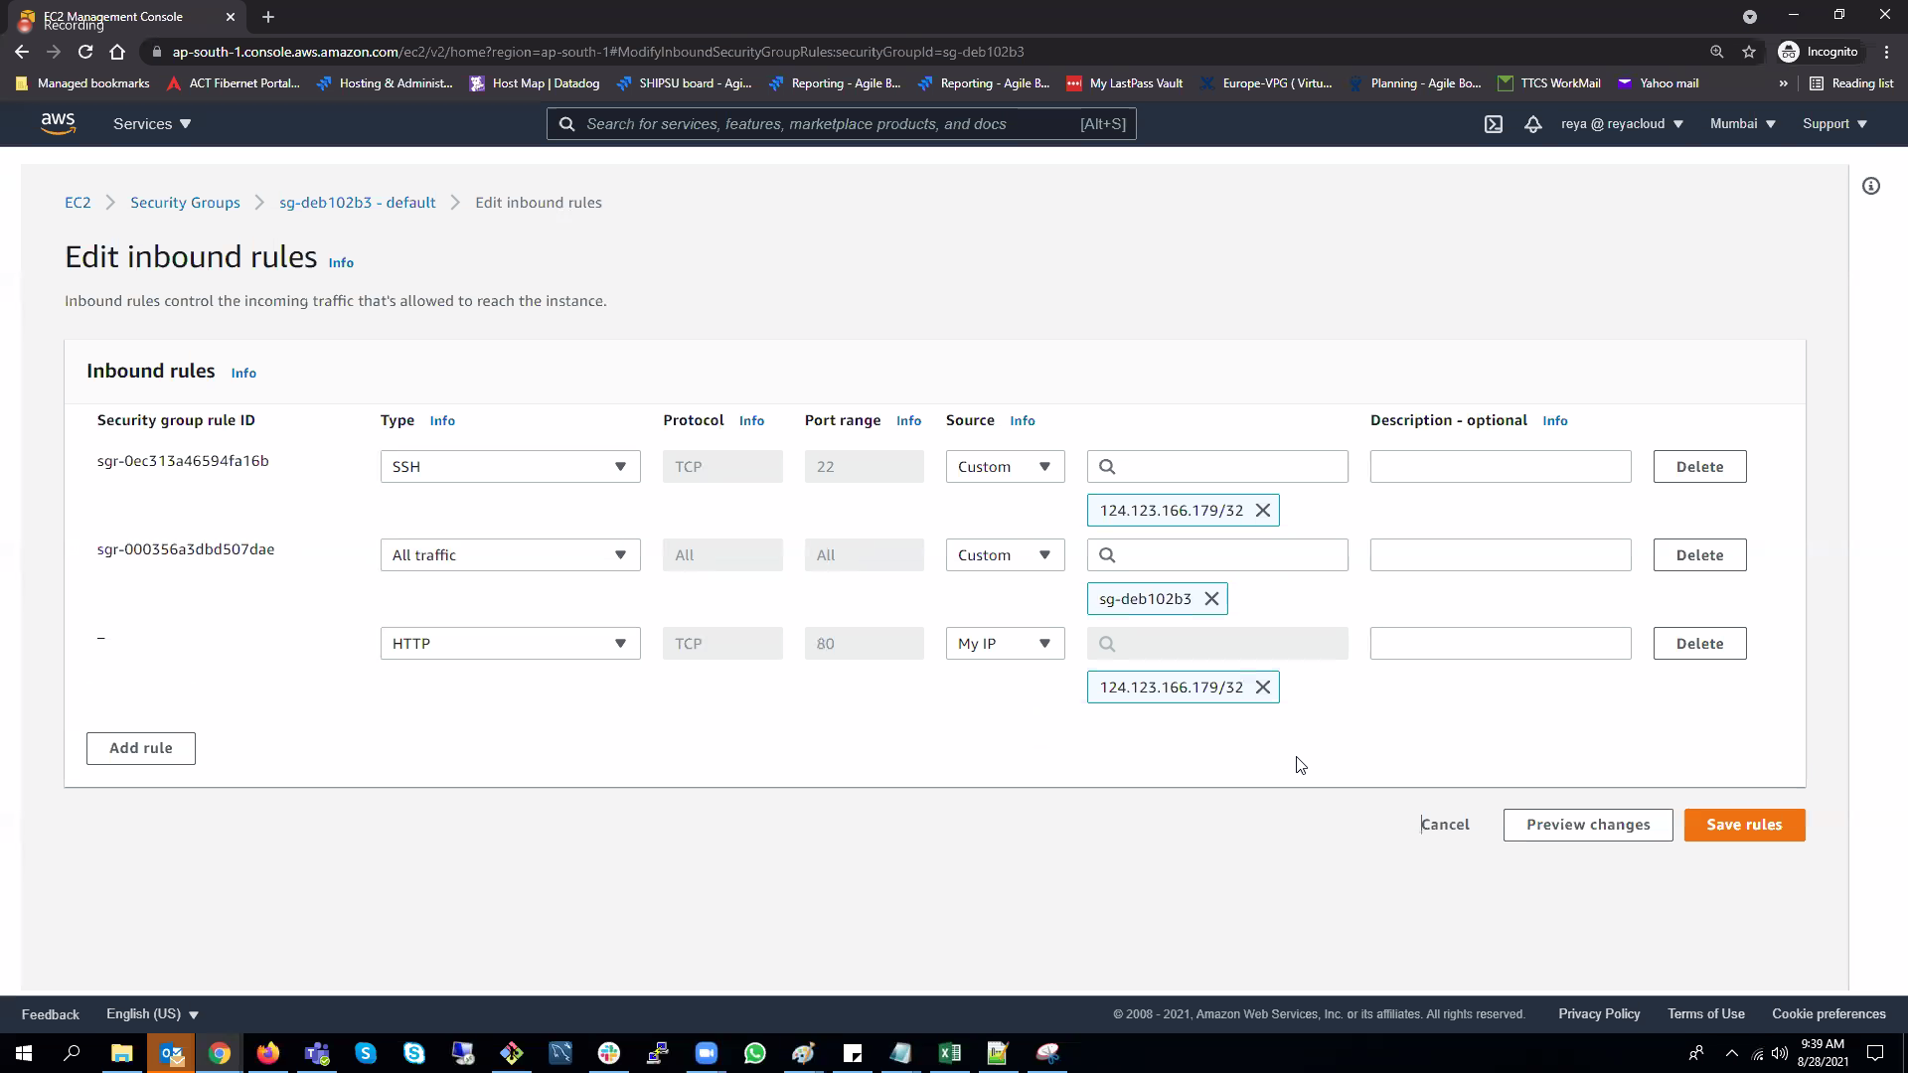

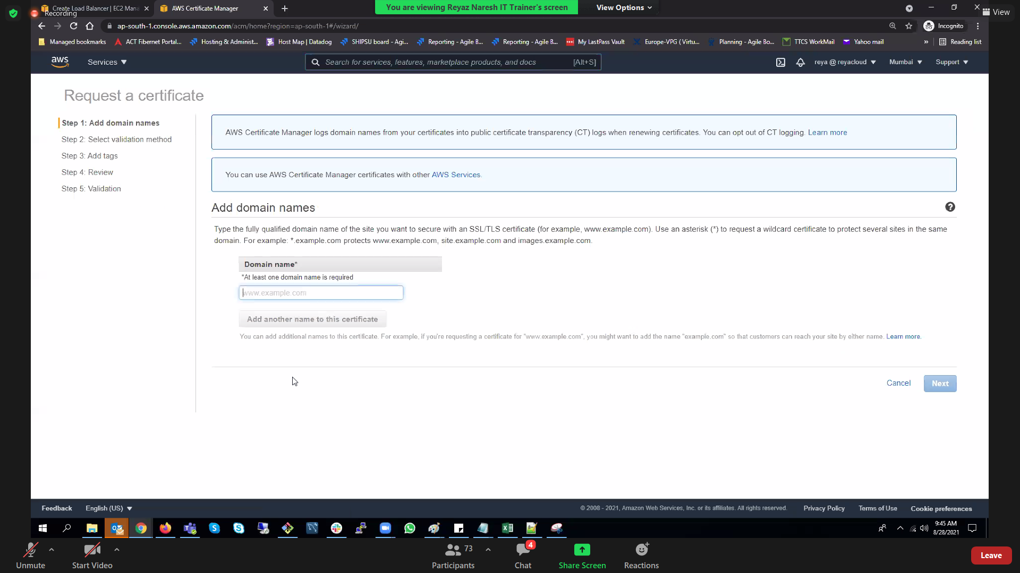

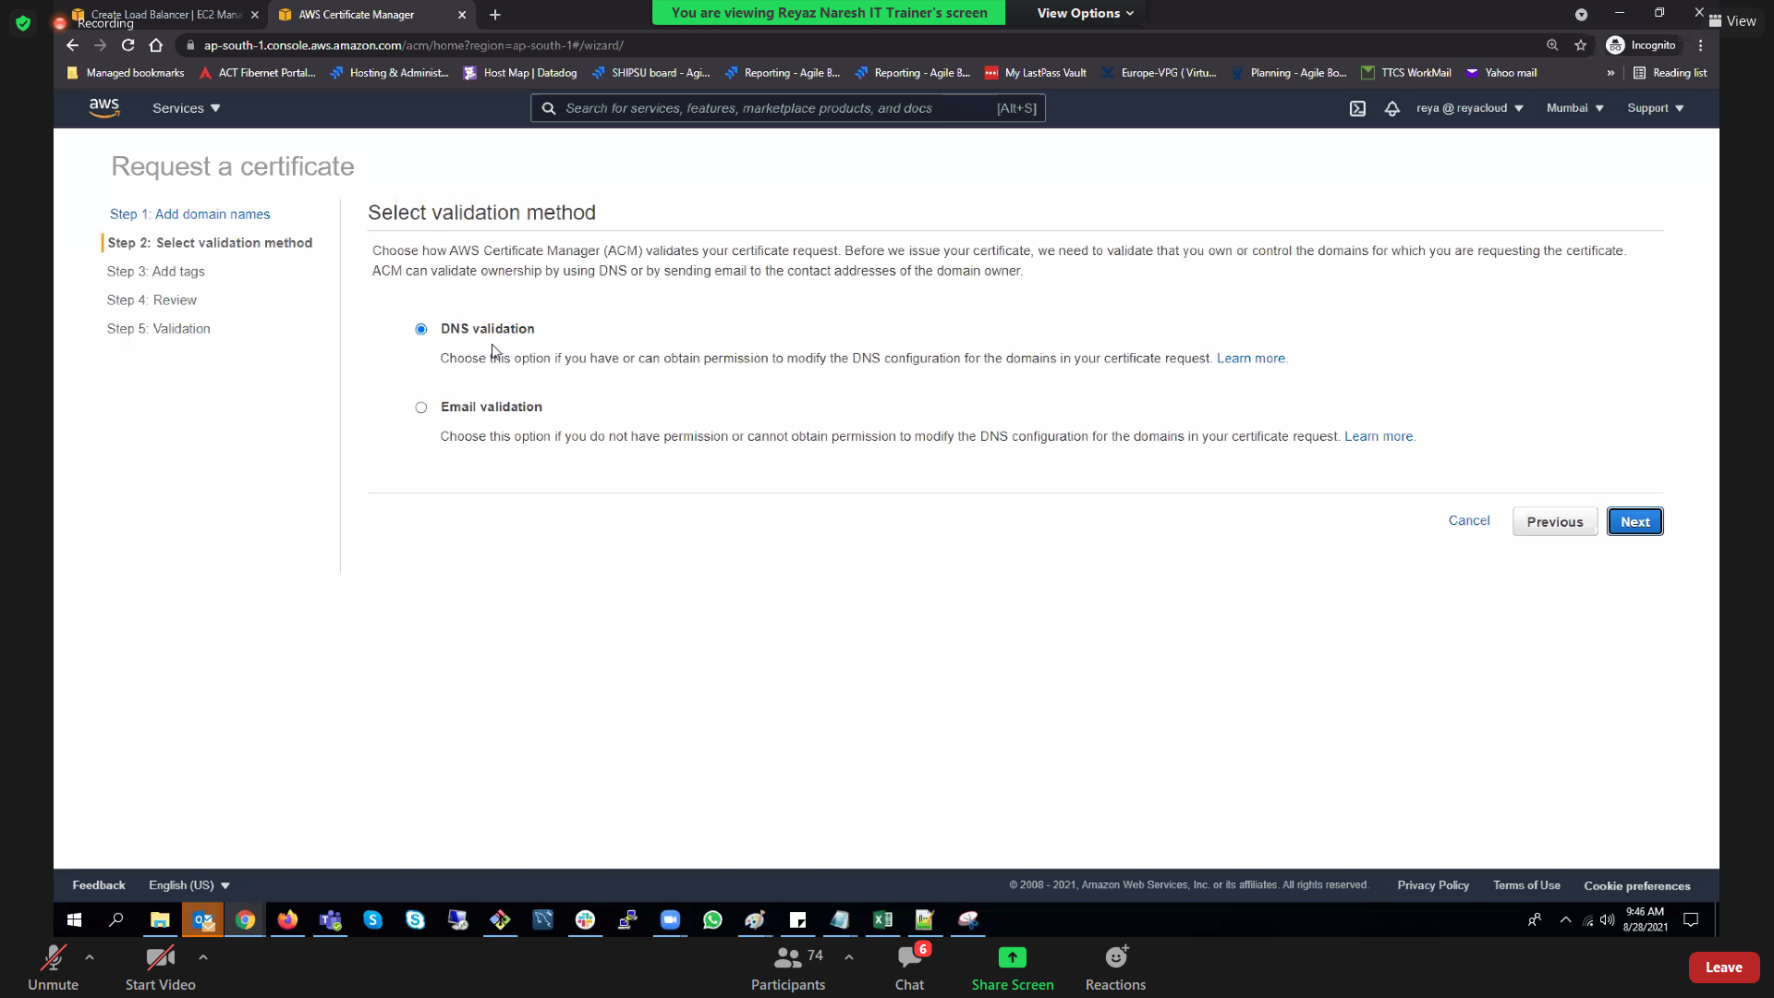

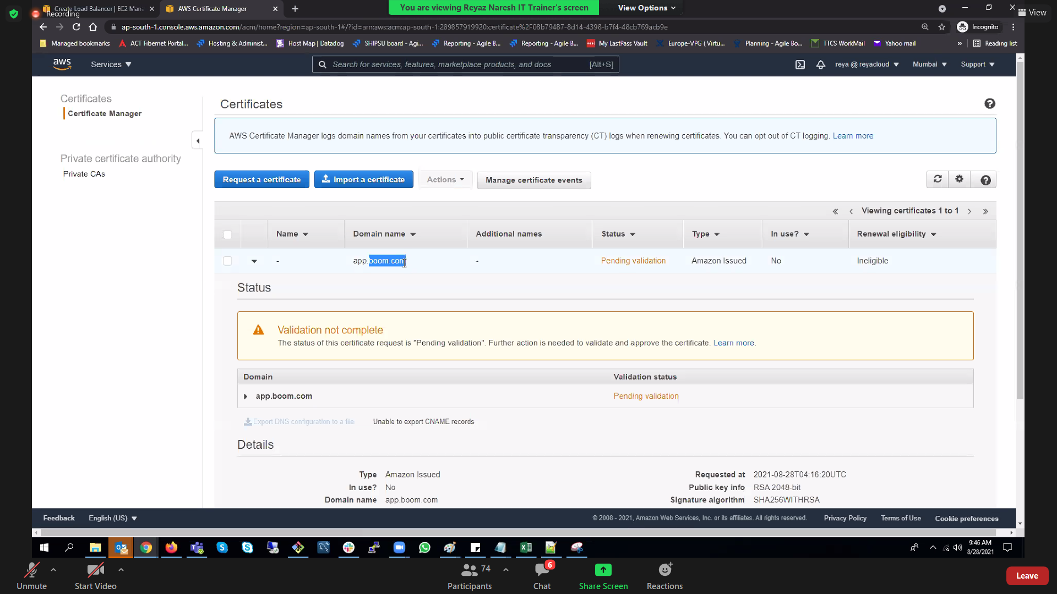

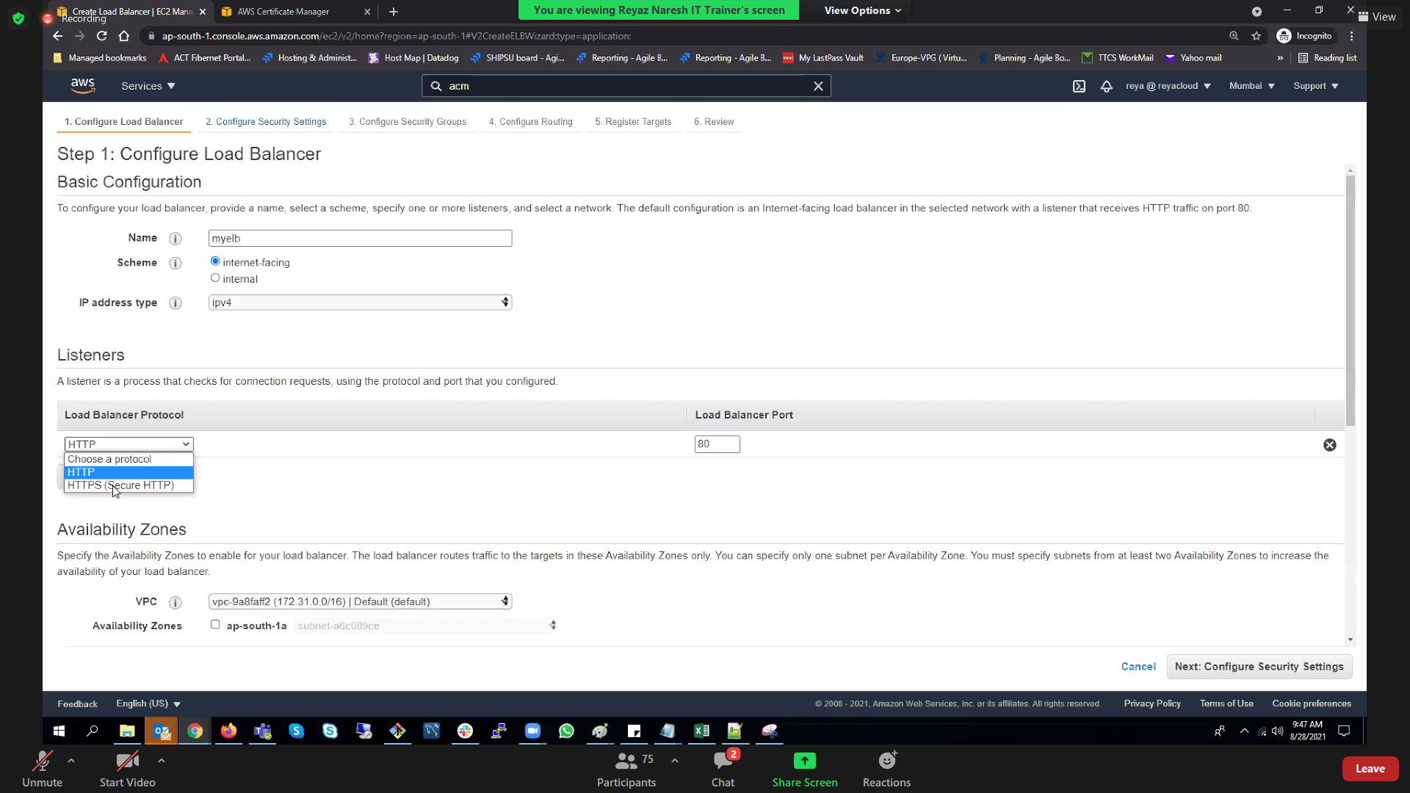

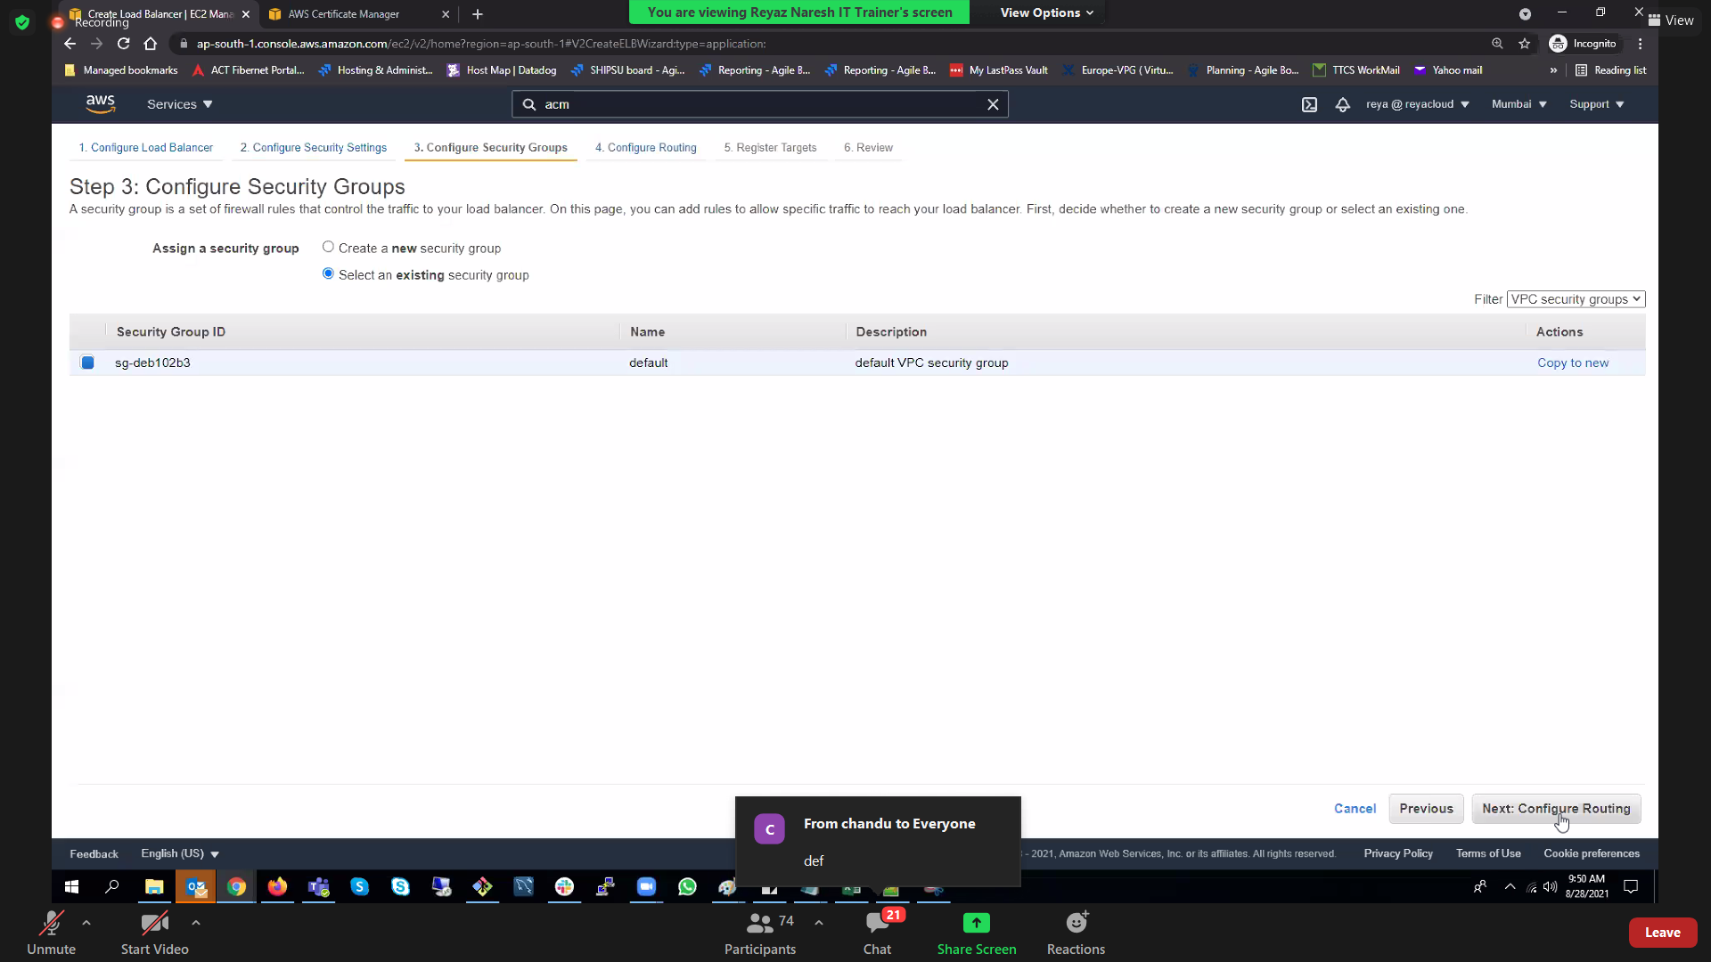

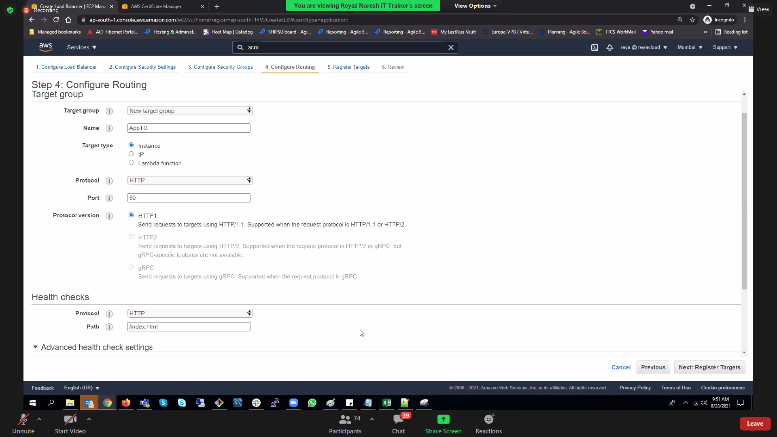

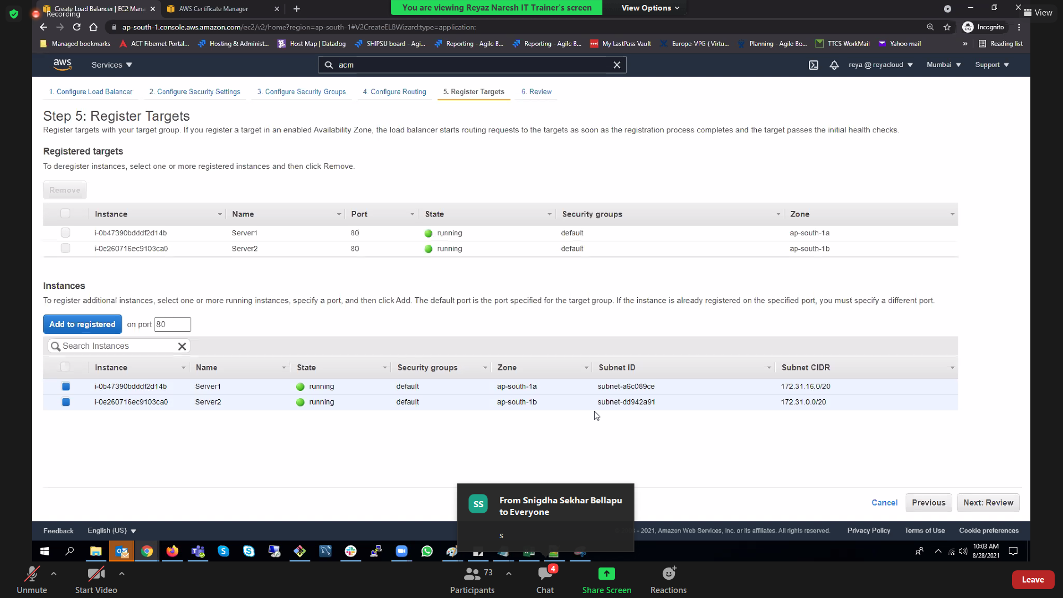

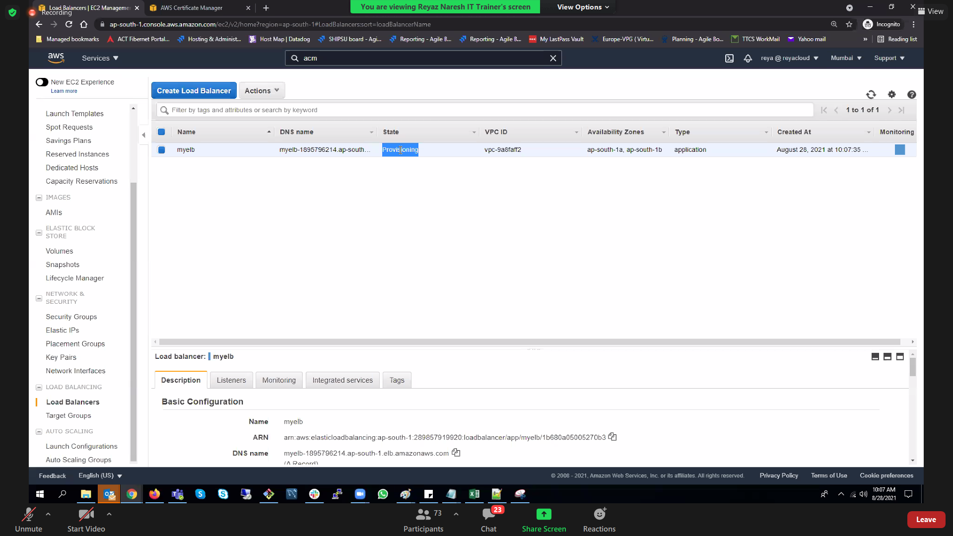

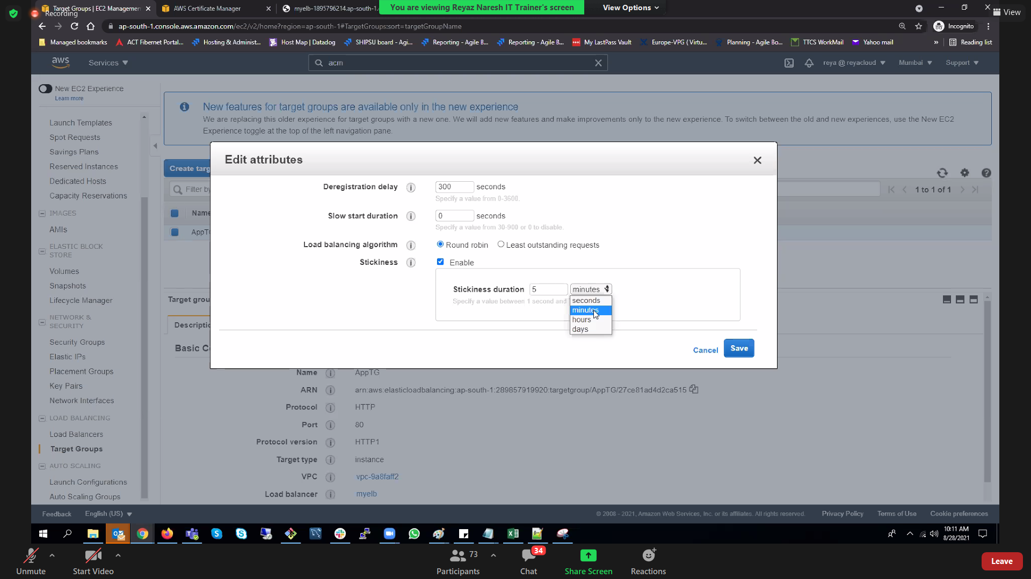

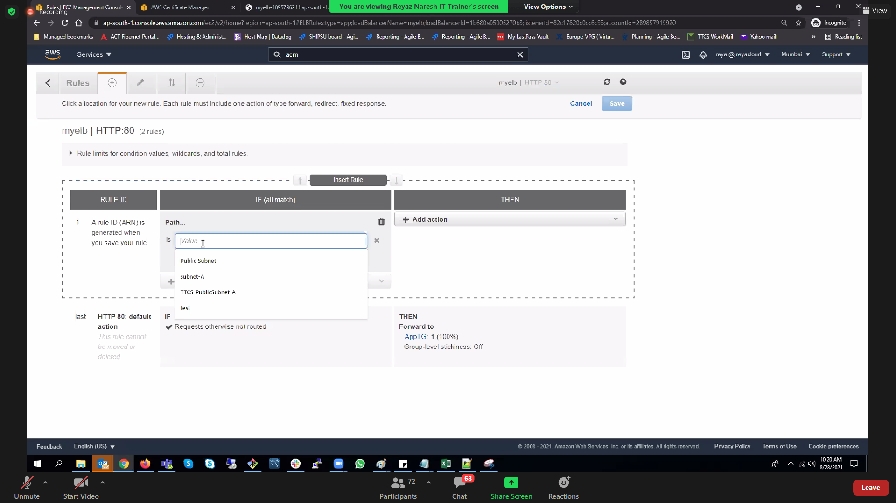

#!/bin/bash

yum install httpd -y

service httpd start

chkconfig httpd on

mkdir /var/www/html

echo 'Hey!! This is my First Website on EC2!' > /var/www/html/index.html

